 Transport Department Headquarters, 5/9, Under Hill Rd, Ludlow Castle, Civil Lines, Delhi, 110054

Delhi East District Road Safety Report Appendix



**Report by:**



**Data support by:**



**Supported by:**







# ACKNOWLEDGMENTS

This report was made possible with the support of the Transport Department, Delhi Traffic Police (DTP), Bloomberg Initiative for Global Road Safety.

Data encoding, analysis and report writing was done collectively by the Transportation Research and Injury Prevention Centre ((TRIP Centre) at IIT Delhi, Vital Strategies and the BIGRS embedded staff with inputs from BIGRS partners.

The report covers detailed proposals and budget estimates for 3 high risk locations and 1 school zone for the district. In collaboration with TRIP centre, proposals with budget estimations for selected high-risk locations have been prepared by SG Architects under the leadership of Dr. Sandeep Gandhi. Under the leadership of Ruchi Varma, HumanQind Design Foundation (HumanQind) is the lead partner of TRIP Centre, IIT Delhi to pilot the Safe School Zone Initiative with school road safety clubs in each district. HumanQind has prepared the detailed proposal and budget estimates for the school zone location.

The report was edited and compiled by Ishan Gogoi (Vital Strategies) and co-authored by Rahul Goel (TRIP Centre, IIT Delhi), Shivanshu Singh (SG Architects), Ruchi Varma and Aastha Khatri (HumanQind) under the leadership of Prof. Geetam Tiwari (TRIP Centre, IIT Delhi).

Rohit David, Divya Jindal, Kirori Lal Yadav and Farhan Shaikh from BIGRS Delhi and Archana Singh and Shyla Basu from TRIP Centre, IIT Delhi supported throughout the process.

Table of Contents

ACKNOWLEDGMENTS 3

List of Figures and Tables 6

List Of Abbreviations 7

Key Highlights 9

Introduction 10

Methodology 11

ABOUT THE DISTRICT 12

**A** **: Road safety situation and trends in East district** 13

A.1 : Road crash death trends 13

A.1.1 : Fatal Road crashes and fatalities trend. 13

A.1.2 : Road crash fatalities by road user types. 14

A.1.3 : Road crash deaths by month 15

A.1.4 : Road crash deaths by time and day of week 16

A.2 : Road crash deaths by age and gender 17

A.2.1 : Road crash deaths by gender 17

A.2.2 : Road crash deaths by age-groups and gender 17

A.3 : Road crash deaths by road user type 18

A.3.1 : Total Road crash deaths by road user type (2019, 2021, 2022) 18

A.3.2 : Timewise Road crash deaths by Road user type 19

A.3.3 : Who-hit-whom matrix 20

A.4 : Hit-and-runs in fatal road crashes 21

A.4.1 : Percentage of hit-and-run and non-hit-and-run cases 21

A.4.2 : Hit-and-run Road user types 21

A.5 : Road Crash Heatmaps 22

A.5.1 : Heatmap of all road crash deaths 22

A.5.2 : Heatmap of all pedestrian deaths 22

A.5.3 : Heatmap of all motorcycle (rider + pillion) related deaths 23

A.6 : High Risk Locations 24

A.6.1 : List of high-risk locations 24

A.6.2 : Map of all high-risk locations 24

A.6.3 : High risk corridors 25

**B** **: Data to Action** 26

B.1 : Ghazipur Roundabout 26

B.1.1 : General Description of the site 26

B.1.2 : Existing Land Use 26

B.1.3 : Land use evolution 27

B.1.4 : Existing Scenario 27

B.1.5 : Traffic Volume Count 28

B.1.6 : Peak Hour Traffic Flow 29

B.1.7 : Conflict points 30

B.1.8 : Issues Identified 30

B.1.9 : Proposed Design 32

B.1.10 : Summary budget estimates 33

B.1.11 : Detailed budget estimates 38

B.2 : Hasanpur Depot 68

B.2.1 : General description of the site: 68

B.2.2 : Existing Land Use: 68

B.2.3 : Land Use Evolution: 69

B.2.4 : Existing Scenario: 69

B.2.5 : Traffic Volume Count: 70

B.2.6 : Peak Hour Traffic Flow: 71

B.2.7 : Issues identified: 72

B.2.8 : Proposed Design: 73

B.2.9 : Summary budget estimates: 74

B.2.10 : Detailed Budget Estimates 78

B.3 : Safe School Zone: Rajkiya Sarvodaya Bal Vidyalaya (RSBV), Shakarpur 105

B.3.1 : Engagement Timeline 105

B.3.2 : General description of the site 106

B.3.3 : Existing Scenario 107

B.3.4 : Issues identified 110

B.3.5 : Activity map 112

B.3.6 : Proposed design 114

B.3.7 : Summary budget estimates 117

B.3.8 : Detailed budget estimates 121

# List of Figures and Tables

Figure 1: Fatal Road crashes and fatalities trend 13

Figure 2: Road crash fatalities by road user types 14

Figure 3: Average Road crash deaths by months 15

Figure 4: Road crash deaths over months 15

Figure 5: Road cash deaths by gender 17

Figure 6: Road crash deaths by age groups and gender 17

Figure 7: Road crash deaths by road user type (2019, 2021, 2022) 18

Figure 8: Timewise Road crash deaths by road user types 19

Figure 9: Percentage of hit-and-run and non-hit-and-run cases 21

Figure 10: Hit-and-run Road user types 21

Figure 11: Heatmap of all road crash deaths in East district 22

Figure 12: Heatmap of all pedestrian deaths in road crash deaths 22

Figure 13: Heatmap of all motorcycle related deaths due to road crashes in East District 23

Figure 14: Map of all high-risk locations intervened in East District 24

Figure 15: Vulnerable Road users on corridors 25

Figure 16: Vulnerable Road users’ death per km 25

Figure 17: Modal distribution during traffic volume count: Ghazipur roundabout 28

Figure 18: Hourly traffic flow: Ghazipur roundabout 28

Figure 19: Mode wise hourly traffic flow: Ghazipur roundabout 29

Figure 20: Modal distribution during traffic volume count: Hasanpur Depot 70

Figure 21: Hourly Traffic Flow: Hasanpur Depot 70

Figure 22: Mode-wise hourly traffic flow: Hasanpur Depot 71

Figure 23: Home to school modal distribution: Rajkiya Sarvodaya Bal Vidyalaya 107

Figure 24: School to home modal distribution: Rajkiya Sarvodaya Bal Vidyalaya 107

Figure 25:Commute distance to and from school: Rajkiya Sarvodaya Bal Vidyalaya 108

Figure 26: Infrastructure change expected: Rajkiya Sarvodaya Bal Vidyalaya 109

Table 1: Road crash deaths by time and day of the week 16

Table 2: Who-hit-whom matrix 20

Table 6‑1: List of high risk locations 24

# List Of Abbreviations

* **GNCTD** Government of National Capital Territory of Delhi
* **DM** District Magistrate
* **DMRC** Delhi Metro Rail Corporation
* **DRSC** District Road Safety Committee
* **DTC** Delhi Transport Corporation
* **DTP** Delhi Traffic Police
* **FIR** First Information Report
* **FOB** Foot Over Bridge
* **GIS** Geographic Information System
* **GT** Grand Trunk
* **HV** Heavy Vehicle
* **IACP** International Association of Chiefs of Police
* **IIT** Indian Institute of Technology
* **IPC** Indian Penal Code
* **IRC** Indian Road Congress
* **iRAD** Integrated Road Accident Database
* **ISBT** Inter State Bus Terminal
* **KM** Kilometre
* **LMV** Light Motor Vehicle
* **MACT** Motor Accident Claims Tribunal
* **MCD** Municipal Corporation of Delhi
* **MoRTH** Ministry of Road Transport and Highways
* **MPD** Master Plan for Delhi
* **MTW** Motorised Two-Wheeler
* **NCR** National Capital Region
* **NCT** National Capital Territory
* **NGO** Non-Governmental Organisation
* **NH** National Highway
* **NHAI** National Highways Authority of India
* **NIC** National Informatics Centre
* **NSP** Netaji Subhash Place
* **PCR** Police Control Room
* **QGIS** Quantum Geographic Information System
* **RSLA** Road Safety Lead Agency
* **SKV** Sarvodaya Kanya Vidyalaya
* **SOP** Standard Operating Procedure
* **TRIPC** Transportation Research and Injury Prevention Centre
* **UT** Union Territory
* **WHO** World Health Organisation

# Key Highlights

* There is a sudden increase in fatal road crashes from 50 fatal road crashes to 79 fatal road crashes from 2021 to 2022 due to the mobility restrictions during 2021.
* Pedestrians and motorcyclists have been the most affected road users at 43.8% and 38.4% respectively.
* Sundays and Fridays of timeslots 2200 to 0200 have witnessed the most road fatalities.
* The hit-and-run percentage is at 62.6% accounting a total of 127 out of 203 fatal crashes.
* Motorcyclists are mostly hit by cars and truck/tractor drivers.
* The high-risk locations of the East District are Ghazipur Chowk and Hasanpur Chowk.

# Introduction

There has been an increase of road crash fatalities in Delhi since the easing of pandemic mobility restrictions. Vulnerable road users such as pedestrians, motorised two-wheeler occupants and three-wheeler occupants are most at risk of severe injuries and - in worst case scenarios - death in a road crash. This risk which hinders the basic right of mobility for the road users warrants that effective and evidence-based road safety interventions and programs must be implemented regularly and systematically to mitigate the effects of road crashes.

In the year 2023, the Transport Department released the ‘Data to Action’ report which analysed 2019 to 2021 data and identified high-risk locations for each of the eleven districts in Delhi. The report provided detailed maps, overall analysis for the National Capital Territory (NCT) of Delhi, and general recommendations for each district. The report was presented to the District Road Safety Committees (DRSCs) to guide them in implementing road safety interventions and address the most urgent road safety risk factors in their jurisdictions. The DRSCs take the lead in drafting the district road safety plan. They are instrumental in planning road safety interventions for high-risk locations in the district, implement interventions on the ground, and disburse road safety funds.

As a next logical step, to take evidence-based action in order to reduce crashes, the Transport Department are producing these highly customised district specific road safety reports (DRSR) for the District Road Safety Committees. These reports include detailed findings on road crashes in the given district including a list of high-risk locations and provide specific recommendations to reduce crashes. The purpose of these DRSR is to guide DRSCs in implementing evidence-based interventions to reduce crash fatalities in high-risk locations and provide detailed infrastructure designs for specific locations which can be readily implemented on ground. The ultimate goal of this process is to inform and train the DRSC members in replicating the evidence-based action in the future.

# Methodology

Data Source

The District Road Safety Report (DRSRs) focused on road crash fatalities’ data in the National Capital Territory (NCT) of Delhi from the years 2019, 2021 and 2022. The data source for this report is police crash data records from the Motor Accident Claims Tribunal (MACT) cells of the districts. In addition, this data is supplemented by the FIR lists from the Delhi Traffic Police. The dataset was compiled, digitised, and cleaned at the Transport Department.

Data Analysis

The digitised datasets were compiled and analysed using MS Access to produce descriptive statistics and were mapped using Quantum Geographic Information Systems (QGIS) platform, to identify high-risk locations including high-risk corridors in each district. Similar process will be followed for producing district road safety reports for the remaining districts.

On-site Investigation of High-risk Locations and Corridors

An in-depth and on-site investigation was conducted for the identified high-risk locations. At the site, both qualitative and quantitative data were collected which informed the design of the interventions. The data collection process included the following activities:

* Inspection of the road infrastructure and land use at the site.
* Identification of hazards and conflict points, especially pedestrians’ movement, bus stop locations.
* Assessment of the type and quality of enforcement.
* Observations on road user behaviour, parked vehicles, street vendors and accessibility of vulnerable road users.
* Identification of types of road users and traffic mix and speed.

These data points were collated and presented for the selected high-risk sites, and were used to inform the design of the proposed interventions.

Report Structure

Each district has a dedicated report. There will be a total of 11 reports - one for each district in NCT Delhi. The report is divided into three parts. The first part includes the introduction of road safety in the context of the district, and methodology that was followed to produce the report. The second part covers the discussion on the road safety situation in the given district. Finally, the last part of the report provides detailed investigation and recommendations for the selected high-risk sites in the district.

# ABOUT THE DISTRICT

The District of East, Delhi is located on the other side of River Yamuna i.e. Trans-Yamuna area. It is bounded by the border of Uttar Pradesh comprising of Noida and Ghaziabad. It has an elevation of 239 Mtrs. above sea level.

Area: 64sqkm

Villages and Panchayats: 6

Tehsils: 3

Subdivisions and blocks: 3

Constituencies: 3

Courts: 2

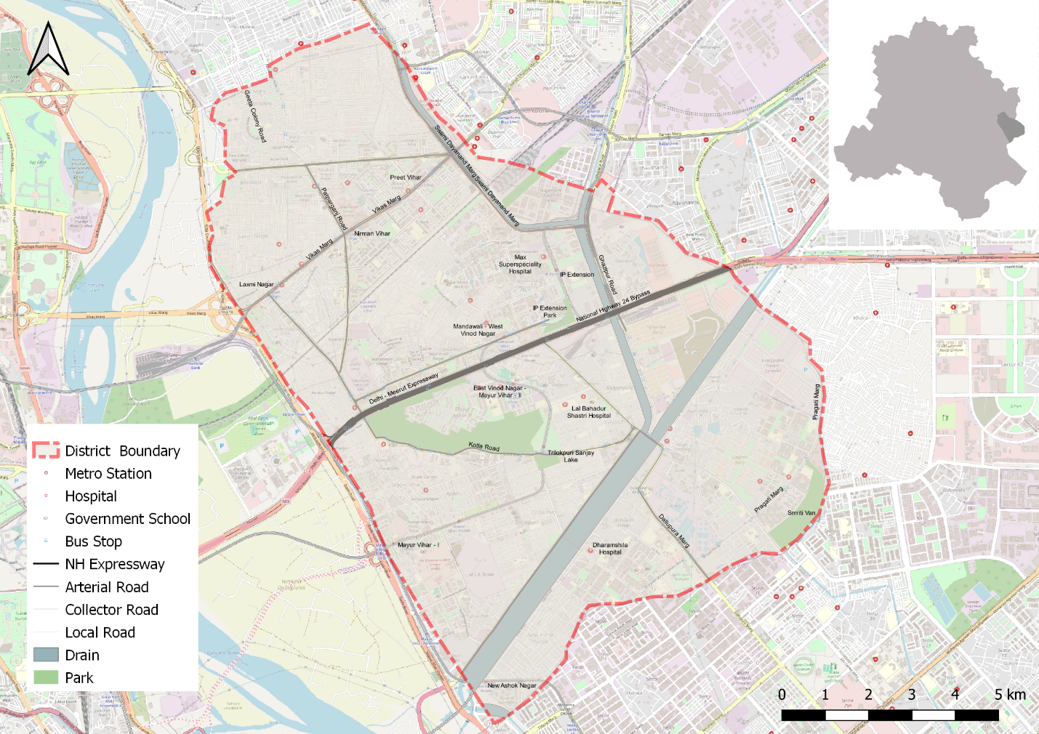

# **: Road safety situation and trends in East district**

## : Road crash death trends

### : Fatal Road crashes and fatalities trend.

Figure : Fatal Road crashes and fatalities trend

There were 79 fatal road crashes in the East District of Delhi in 2022 with 80 persons killed in these crashes. There is a 44% increase compared to the previous year 2021 which is 50. One person is killed in road crashes in the East District every four to five days.

### : Road crash fatalities by road user types.

Figure : Road crash fatalities by road user types

Motorcyclists, auto rickshaw occupants and pedestrians formed a majority of persons killed in road crashes in the East District across all three years. Between the highlighted categories, the motorcyclist and autorickshaw occupants’ fatalities surpassed the pedestrian fatalities in 2021 and 2022.

### : Road crash deaths by month

Figure : Average Road crash deaths by months

January, March and August witnessed the highest number of persons killed followed by April and October, there is no discernible pattern of fatalities by month.

Figure : Road crash deaths over months

### : Road crash deaths by time and day of week

|  |  |  |  |  |  |  |  |  |  |
| --- | --- | --- | --- | --- | --- | --- | --- | --- | --- |
|  | **Monday** | **Tuesday** | **Wednesday** | **Thursday** | **Friday** | **Saturday** | **Sunday** | **<NA>** | **Total** |
| **00:00-00:59** | 4 | 2 | 2 | 1 | 4 | 1 | 5 | 0 | 19 |
| **01:00-01:59** | 1 | 1 | 0 | 2 | 1 | 0 | 4 | 0 | 9 |
| **02:00-02:59** | 2 | 1 | 1 | 1 | 2 | 1 | 1 | 0 | 9 |
| **03:00-03:59** | 1 | 0 | 0 | 0 | 0 | 0 | 0 | 0 | 1 |
| **04:00-04:59** | 0 | 0 | 0 | 0 | 1 | 0 | 4 | 0 | 5 |
| **05:00-05:59** | 0 | 1 | 0 | 1 | 0 | 1 | 1 | 0 | 4 |
| **06:00-06:59** | 1 | 3 | 3 | 0 | 0 | 2 | 2 | 0 | 11 |
| **07:00-07:59** | 0 | 1 | 1 | 1 | 1 | 1 | 1 | 0 | 6 |
| **08:00-08:59** | 1 | 2 | 0 | 2 | 1 | 0 | 1 | 0 | 7 |
| **09:00-09:59** | 0 | 1 | 0 | 1 | 1 | 0 | 2 | 0 | 5 |
| **10:00-10:59** | 1 | 2 | 0 | 0 | 0 | 2 | 2 | 0 | 7 |
| **11:00-11:59** | 0 | 3 | 0 | 0 | 0 | 1 | 0 | 0 | 4 |
| **12:00-12:59** | 3 | 1 | 1 | 1 | 1 | 2 | 1 | 0 | 10 |
| **13:00-13:59** | 0 | 1 | 0 | 1 | 3 | 0 | 0 | 0 | 5 |
| **14:00-14:59** | 2 | 0 | 1 | 0 | 0 | 0 | 0 | 0 | 3 |
| **15:00-15:59** | 2 | 1 | 2 | 0 | 2 | 1 | 0 | 0 | 8 |
| **16:00-16:59** | 1 | 1 | 1 | 1 | 2 | 1 | 0 | 1 | 8 |
| **17:00-17:59** | 3 | 0 | 0 | 1 | 1 | 0 | 1 | 0 | 6 |
| **18:00-18:59** | 2 | 1 | 1 | 2 | 2 | 2 | 2 | 0 | 12 |
| **19:00-19:59** | 0 | 1 | 3 | 0 | 1 | 3 | 1 | 0 | 9 |
| **20:00-20:59** | 1 | 3 | 3 | 1 | 4 | 3 | 3 | 0 | 18 |
| **21:00-21:59** | 0 | 1 | 0 | 1 | 2 | 2 | 0 | 0 | 6 |
| **22:00-22:59** | 1 | 1 | 4 | 3 | 4 | 5 | 4 | 0 | 22 |
| **23:00-23:59** | 2 | 0 | 2 | 0 | 3 | 1 | 1 | 0 | 9 |
| **Total** | **28** | **28** | **25** | **20** | **36** | **29** | **36** | **1** | **203** |

Table : Road crash deaths by time and day of the week

Thirty percent of the total road crash deaths occurred at night 10:00 pm to 2:00 pm. Similarly, 38% of the total deaths occurred either on Saturdays or on Sundays.

## : Road crash deaths by age and gender

### : Road crash deaths by gender

Figure : Road cash deaths by gender

### : Road crash deaths by age-groups and gender

Figure : Road crash deaths by age groups and gender

Looking at the absolute numbers, the males had a higher number of fatalities 89% compared to females. Among the males, the fatalities were observed to be highest in the age group of 20-29 years, followed by 30-39 years.

## : Road crash deaths by road user type

### : Total Road crash deaths by road user type (2019, 2021, 2022)

Total fatalities:203

Figure : Road crash deaths by road user type (2019, 2021, 2022)

*Other includes cycle rickshaws, converted rickshaws and hand carts

Ninety percent of fatalities were among vulnerable road users (i.e., pedestrians, motorcyclists, cyclists, and auto rickshaw occupants). Among this, forty four percent of road crash deaths in the East district were among pedestrians, followed by motorcyclists (39%).

### : Timewise Road crash deaths by Road user type

Figure : Timewise Road crash deaths by road user types

*Other includes cycle rickshaws, converted rickshaws and hand carts

### : Who-hit-whom matrix

|  |  |  |  |  |  |  |  |  |  |
| --- | --- | --- | --- | --- | --- | --- | --- | --- | --- |
| **Victim Road User** | **Impacting Vehicle** | | | | | | | | |
| **Motorcycle** | **3-Wheeler** | **Car** | **Bus** | **Truck/ Tractor** | **Single Vehicle Crash** | **Other** | **Un-known** | **Total** |
| Pedestrian | 7 | 3 | 9 | 7 | 8 | 0 | 0 | 55 | 89 |
| Cyclist | 0 | 0 | 1 | 0 | 1 | 0 | 0 | 2 | 4 |
| Motorcyclist | 3 | 2 | 12 | 4 | 13 | 5 | 1 | 38 | 78 |
| 3-Wheeler Occupant | 0 | 1 | 6 | 1 | 0 | 2 | 0 | 5 | 15 |
| Car Occupant | 3 | 0 | 0 | 0 | 1 | 3 | 0 | 0 | 7 |
| Bus Occupant | 0 | 0 | 0 | 1 | 0 | 0 | 1 | 0 | 2 |
| Truck Occupant | 1 | 0 | 0 | 0 | 4 | 2 | 0 | 0 | 7 |
| Other | 1 | 0 | 0 | 0 | 0 | 0 | 0 | 0 | 1 |
| Total | 15 | 6 | 28 | 13 | 27 | 12 | 2 | 100 | 203 |

Table : Who-hit-whom matrix

Note: Other includes cycle rickshaws, converted rickshaws and hand carts

Among all fatal road crashes where the impacting vehicle was known, pedestrians and motorcyclists were found to be the most vulnerable category of road users. They were often hit by trucks and tractors. Hit-and-run crashes dominate both the categories of cases where the impacting vehicle was not known for 167 cases in case of pedestrians and 113 in case of motorcyclists.

## : Hit-and-runs in fatal road crashes

### : Percentage of hit-and-run and non-hit-and-run cases

Figure : Percentage of hit-and-run and non-hit-and-run cases

Overall, Three out of five crashes are hit-and-run cases. The high rate of hit-and-run cases is indicative of non-reporting of accused vehicles as well as non-reporting of crashes by the public.

### : Hit-and-run Road user types

Figure : Hit-and-run Road user types

## : Road Crash Heatmaps

### : Heatmap of all road crash deaths

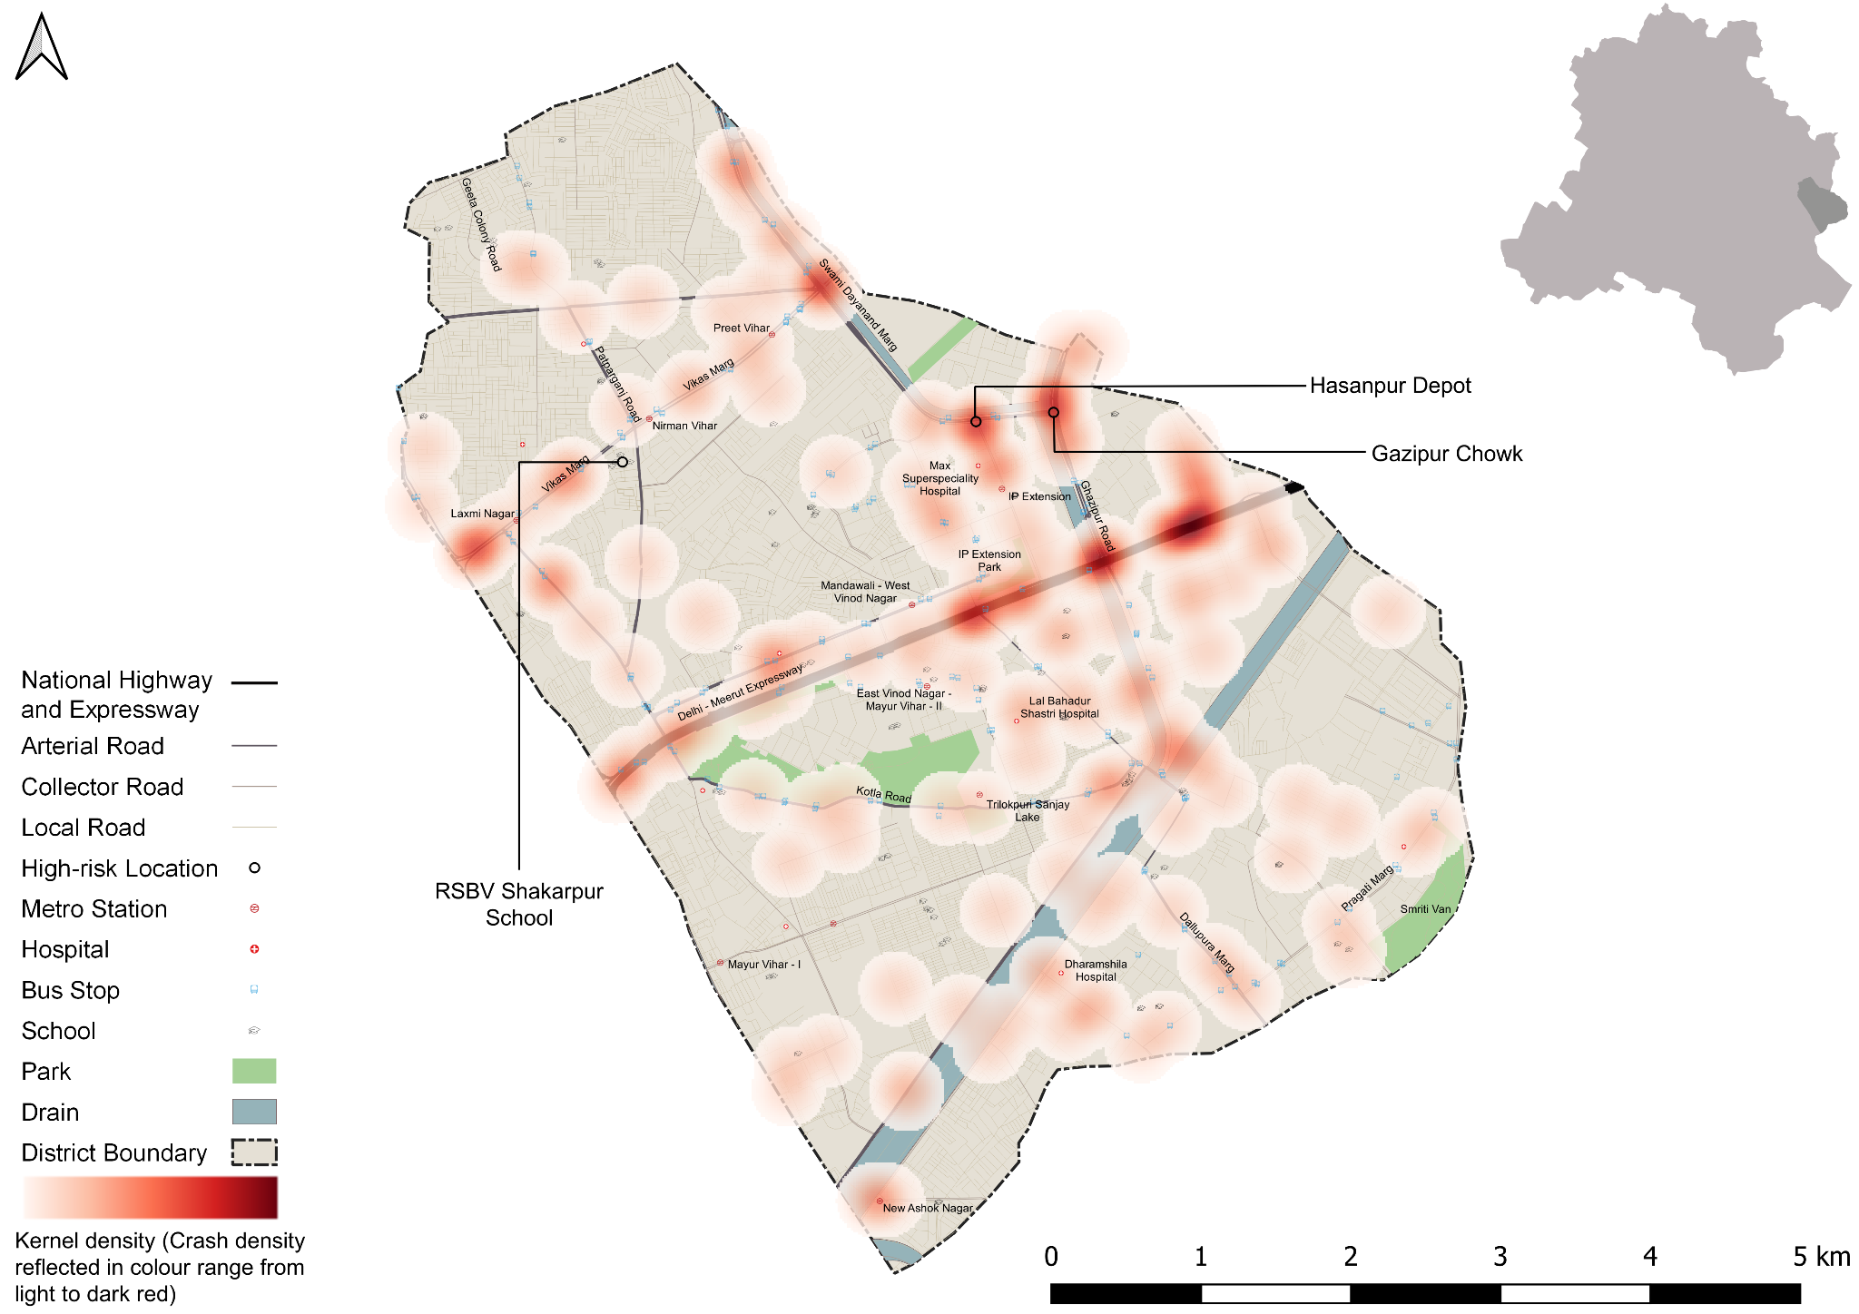

Figure : Heatmap of all road crash deaths in East district

### : Heatmap of all pedestrian deaths

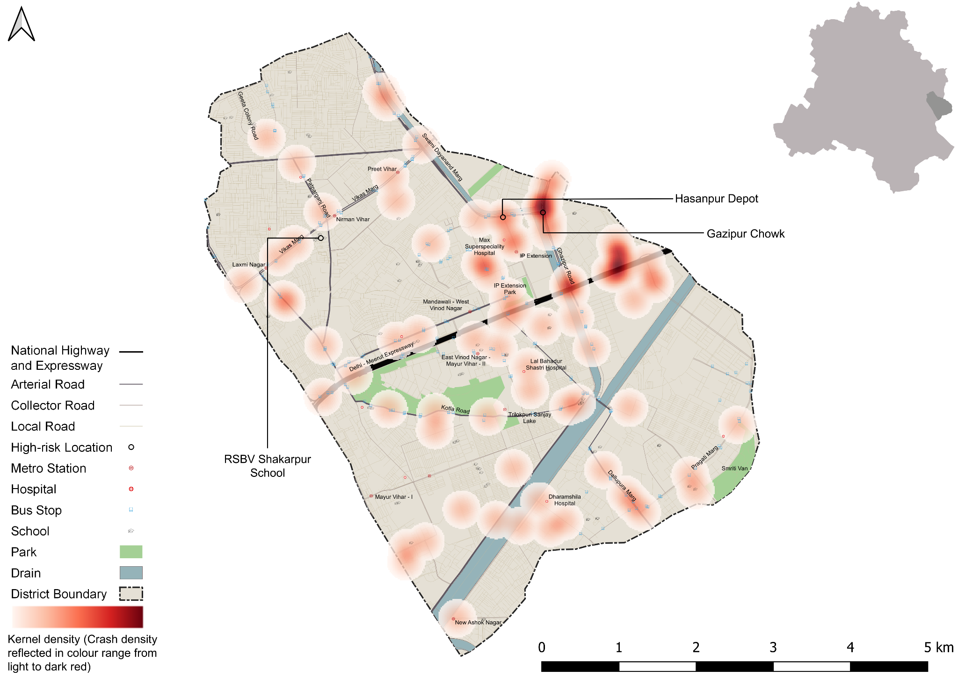

Figure : Heatmap of all pedestrian deaths in road crash deaths

### : Heatmap of all motorcycle (rider + pillion) related deaths

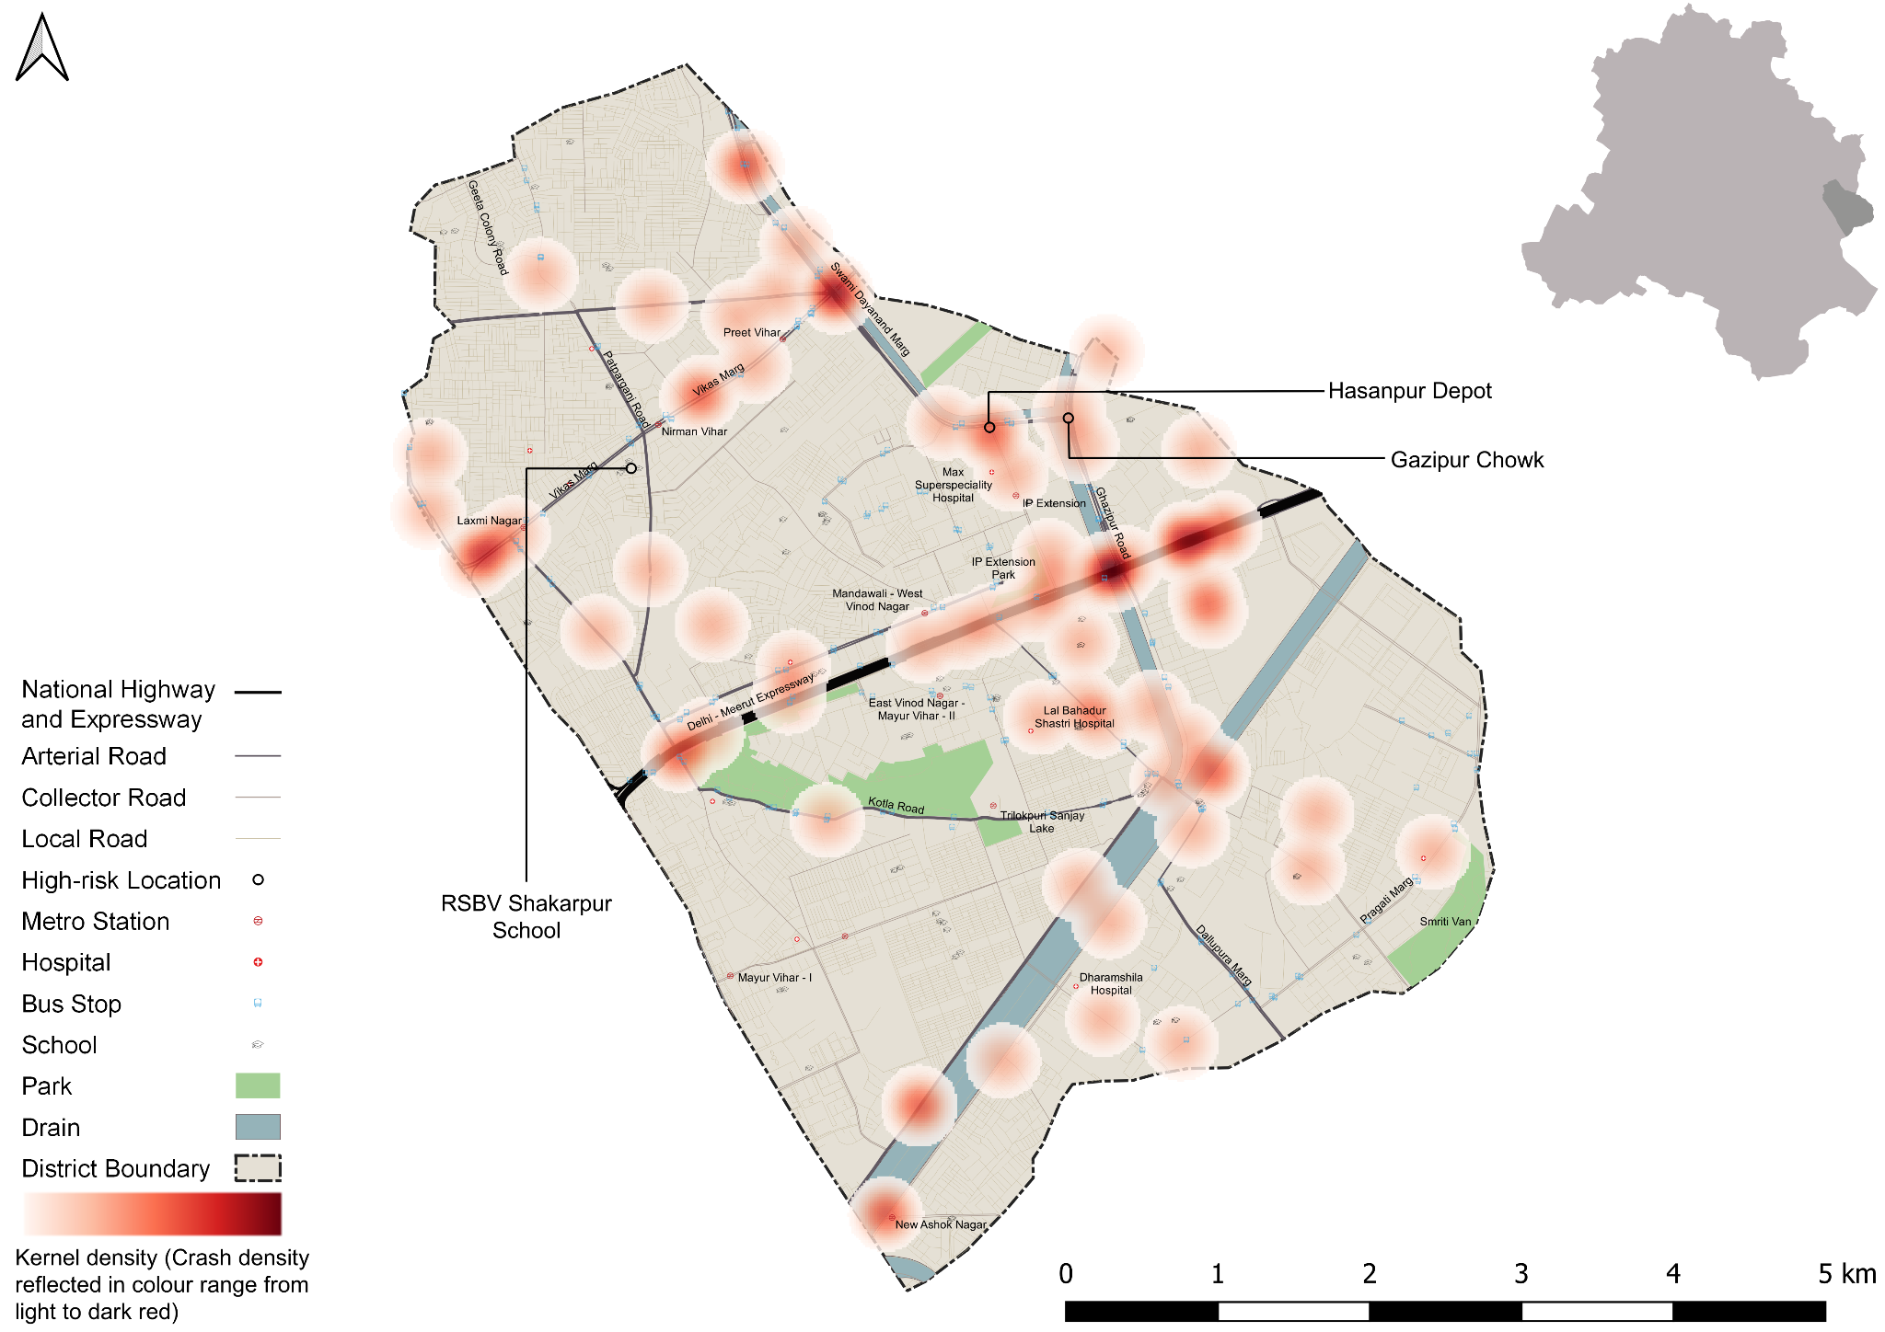

Figure : Heatmap of all motorcycle related deaths due to road crashes in East District

## : High Risk Locations

### : List of high-risk locations

The following is a list of high-risk locations in the East district which includes the number of fatal crashes, hit-and-run crashes, and deaths occurred during these crashes in years 2019, 2021 and 2022.

|  |  |  |  |
| --- | --- | --- | --- |
| **High Risk Location** | **Total fatal crashes** | **Total hit and run fatal crashes** | **Total persons killed** |
| Gazipur Chowk | 5 | 4 | 5 |
| Hasanpur Chowk | 5 | 4 | 5 |
| RSKV Shakarpur | 0 | 0 | 0 |

Table : List of high-risk locations

### : Map of all high-risk locations

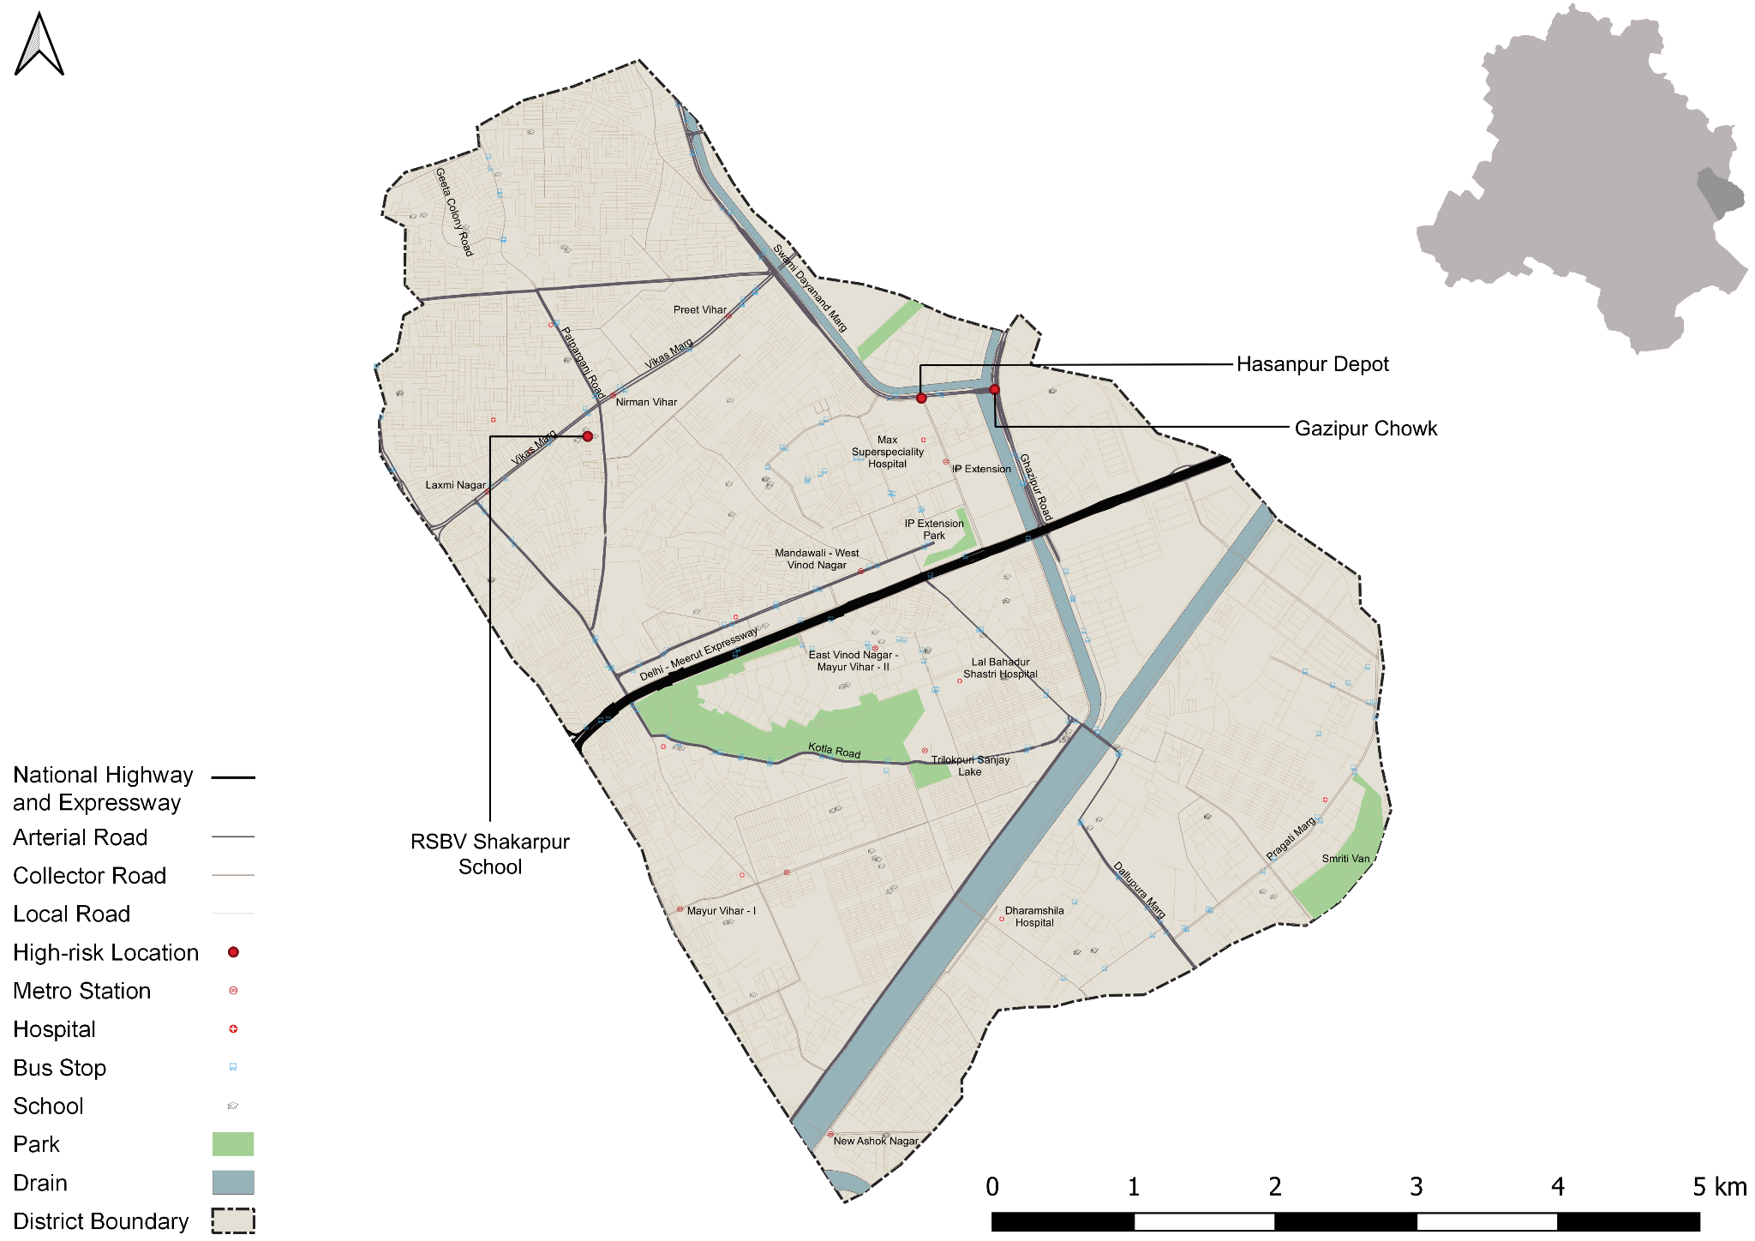

Figure : Map of all high-risk locations intervened in East District

### : High risk corridors

Figure : Vulnerable Road users on corridors

Figure : Vulnerable Road users’ death per km

# **: Data to Action**

## : Ghazipur Roundabout

### : General Description of the site

Ghazipur Chowk (Latitude: 28° 38 '11.26"N, Longitude: 77° 18' 52.30"E). It is a 3 Arm Junction which is signalised. The intersecting road names are Chaudhary Charan Singh Road (Arterial Road) and Swami Dayanand Road (Sub-Arterial Road).

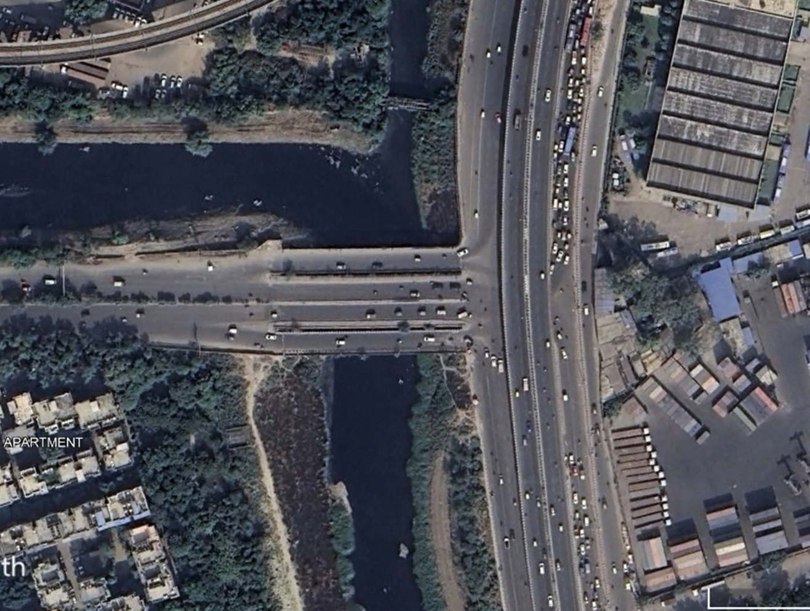

### : Existing Land Use

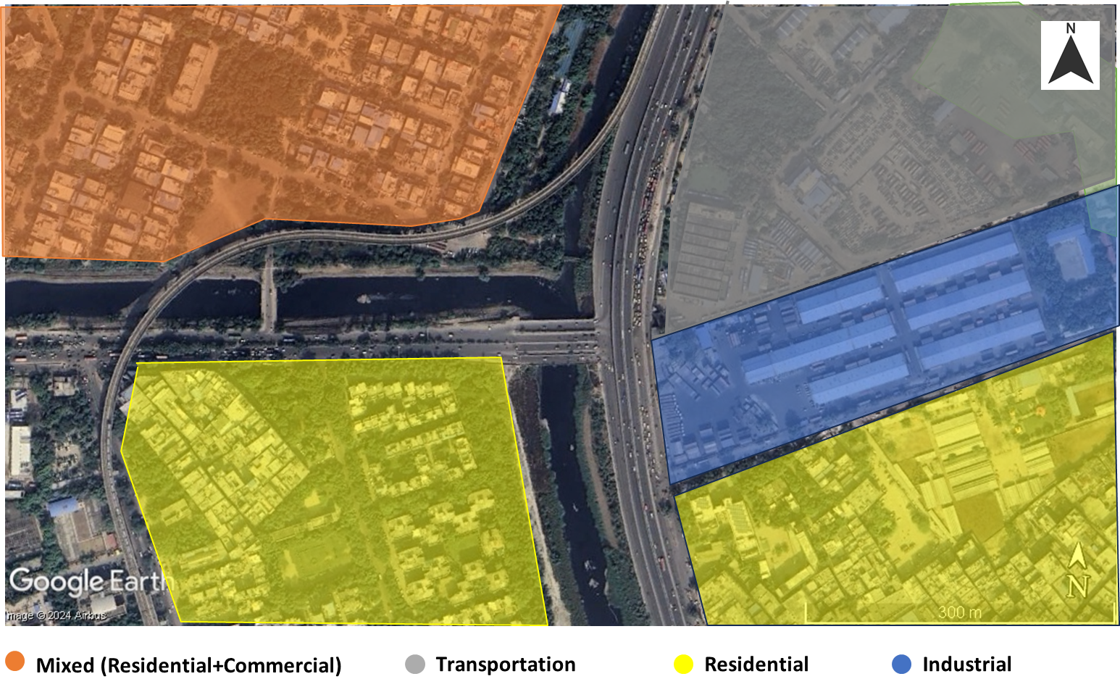

### : Land use evolution

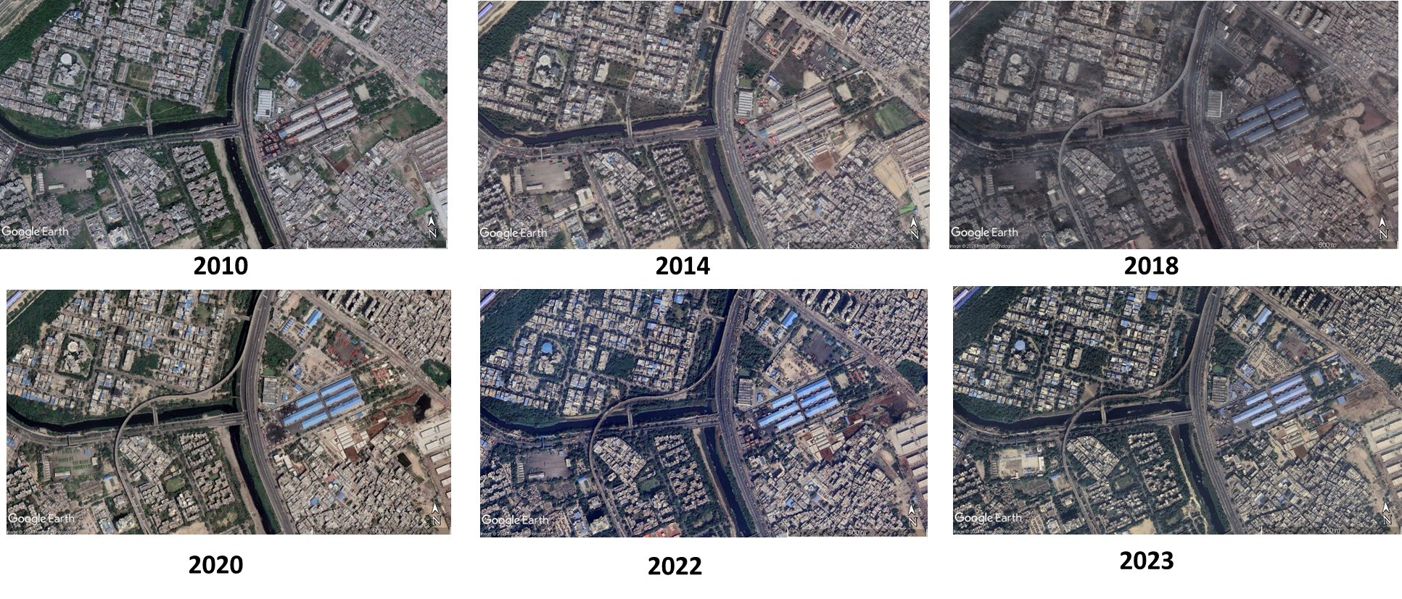

### : Existing Scenario

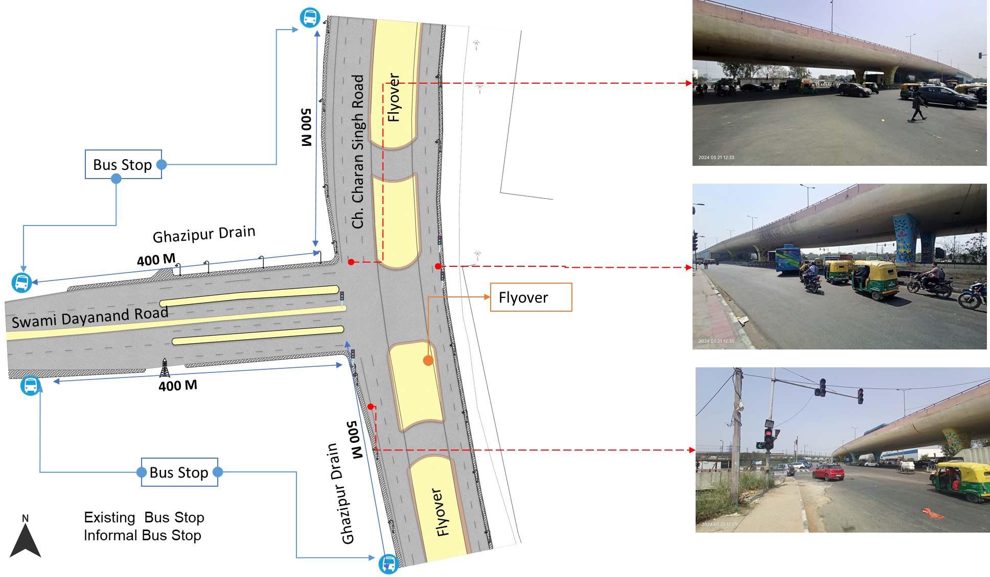

### : Traffic Volume Count

Figure : Modal distribution during traffic volume count: Ghazipur roundabout

*Note- 3 hours data (all directions combined); NMT include pedestrians & cyclists and 3W include auto & e-rickshaw

Figure : Hourly traffic flow: Ghazipur roundabout

Figure : Mode wise hourly traffic flow: Ghazipur roundabout

### : Peak Hour Traffic Flow

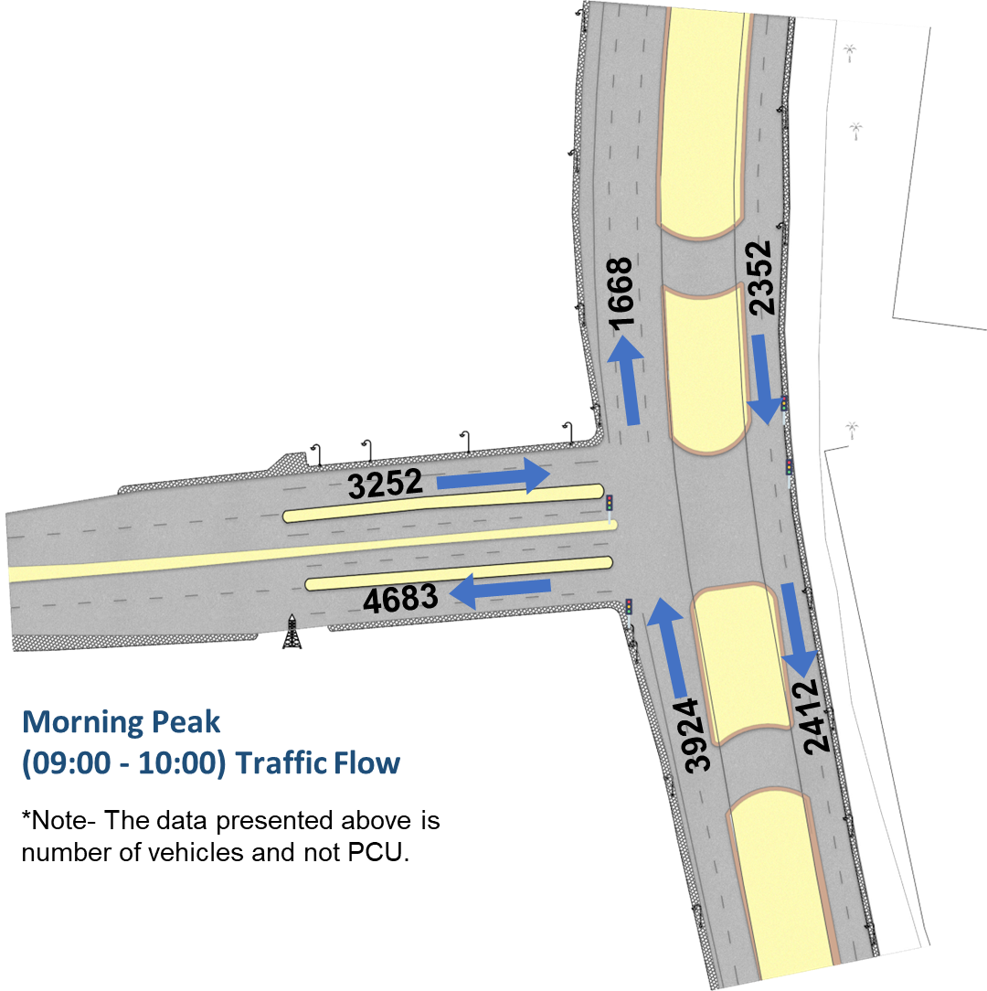

### : Conflict points

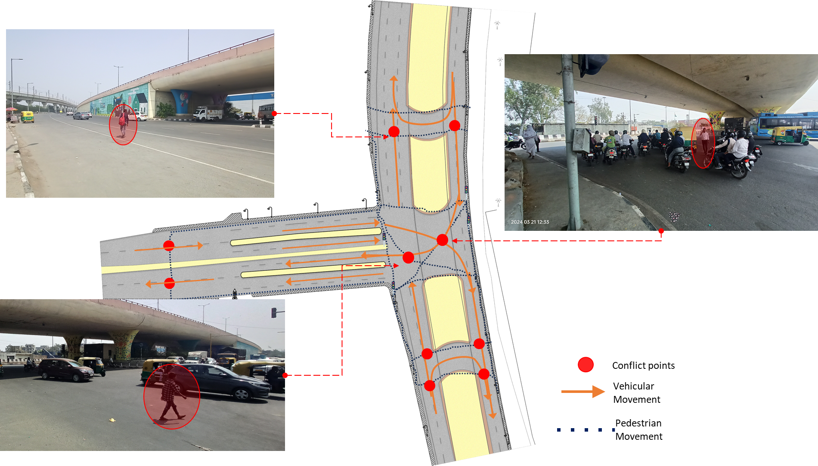

### : Issues Identified

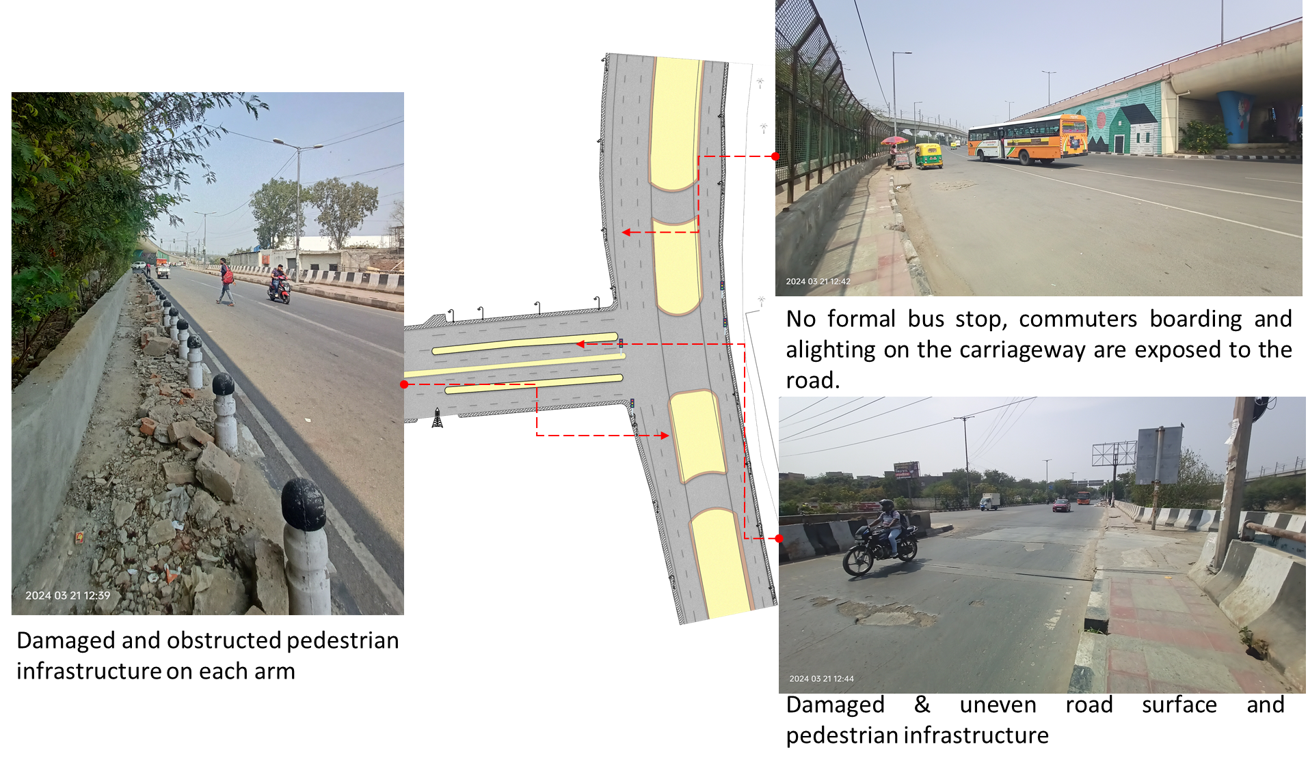

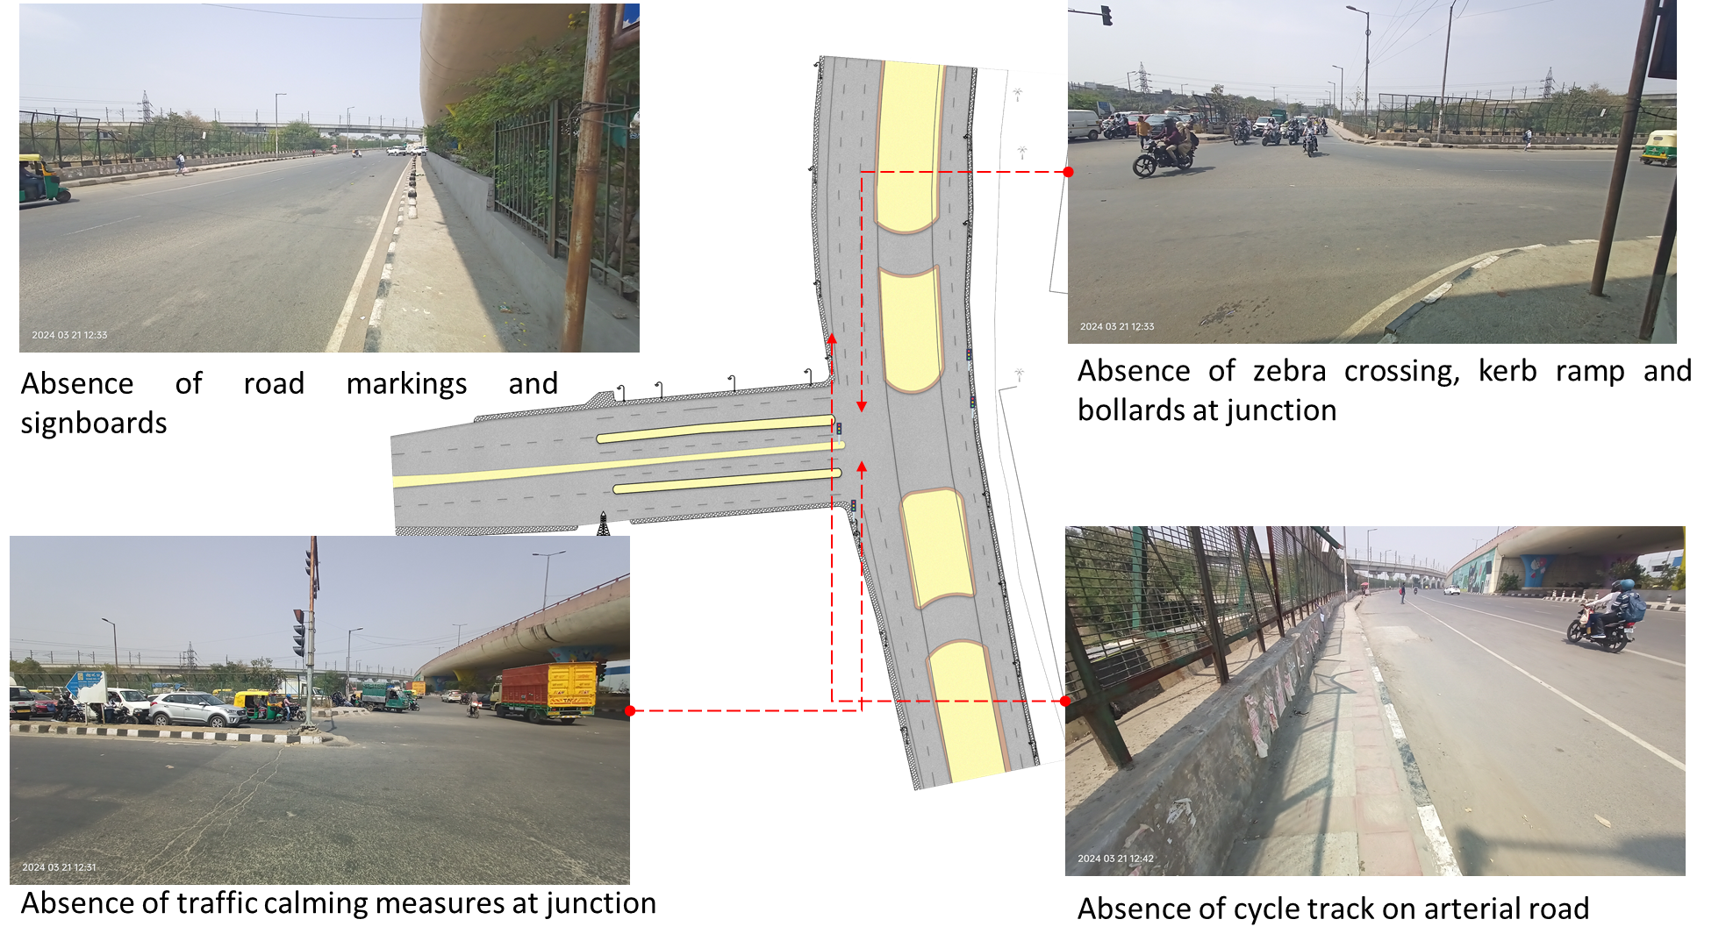

1.Absence of at-grade pedestrian infrastructure at the junction, making the pedestrians extremely vulnerable among the high-speed traffic movement.

2.Damaged and obstructed pedestrian infrastructure on each arm

3.Damaged & uneven road surface

4.Absence of tactile flooring for differently abled users.

5.Absence of traffic calming near junctions (to control the speed of vehicles).

6.Absence of road markings, signages and speed control measures at the intersection.

7.Absence of delineators and reflectors on the median and carriageway edges.

8.Absence of chevron marking and hazard markers or flexible markers at bull noses.

9.Absence of segregated cycle tracks on arterial roads.

### : Proposed Design

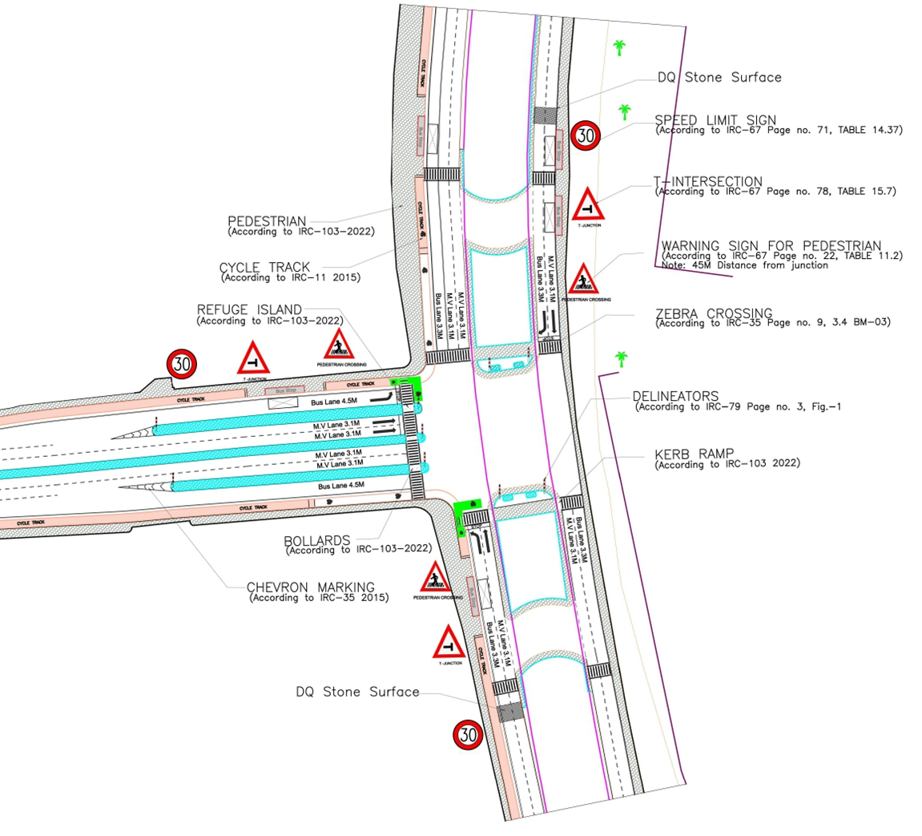

1. The junction is redesigned for the speed of 30 km/hr to ensure safety.
2. Proposed at-grade pedestrian infrastructure to increase the accessibility and safety for pedestrians
3. Proposed new bus stop near the junction to reduce the pedestrian crossing movement
4. Dedicated 2.5m wide cycle track to separate the motor traffic and the cyclists (as per IRC: 11-2015)
5. Installation of signages - Speed Limit, stop sign, pedestrian crossing and other necessary Signages on all approaching roads
6. Provision of DQ stone surface to slow down the through traffic.
7. Road Markings (as per IRC 35).
8. Provision of kerb ramps for the accessibility of differently abled users (as per IRC:103-2022).
9. Provision of chevron marking and hazard markers or flexible markers at bull noses.

### 

### : Summary budget estimates

| **S. No.** | **Component** | **Details** | **Notes** | **Rate (per sq.m.)** | **Cost (INR)** | **Cost (INR, crores)** |
| --- | --- | --- | --- | --- | --- | --- |
| A | CIVIL WORK |  |  |  |  |  |
| A.1 | Footpath (Primary, Secondary including other Flooring area) | 2m to 3m wide segregated footpath with tactile pavers | Providing and laying of footpath 2m to 3m wide, including earthwork and base layer - PCC, GSB and finishing material. | 2610 | 85,87,264 | 0.859 |
| A.2 | Raised Crossing | Raised crossing with 80mm thick pavers and DQ stone surface | Providing and laying Raised crossing with 80 mm thick pavers blocks, and DQ stone including Earth work and Base layers- PCC (M15), RCC (M30 Design mix) & GSB etc. | - | - | 0.000 |
| A.3 | Cycle Infrastructure | 2.5m wide segregated cycle track | Providing and laying cycle track (2.5mt wide segregated) including Earth work and Base layers- PCC (M15), RCC (M40 Design mix) & GSB etc. also thermoplastic paint for marking and cycle symbol and spring post etc | 3765 | 33,88,540 | 0.339 |
| A.4 | CC Items (Kerbs, Pipe, etc) | Kerb stones, Bollards, Kerb Channels etc. | Providing and fixing Kerbs, Bollards, and Kerb Channel etc. in CC. |  | 11,70,790 | 0.117 |
| A.5 | Signages | Mandatory, Cautionary and Informatory Sign Boards of different sizes | Providing and fixing Signage Mandatory, Cautionary and informatory sign board including all the fixing and labours etc. |  | 72,548 | 0.007 |
| A.6 | Marking | Thermoplastic Paint Marking (Edge lines, Centre Line, Lane Marking, Hazard Marking, Chevron, Zebra Crossing, Bar Marking, etc) | Providing and applying road marking strips (retro- reflective) of specified shade/ colour using hot thermoplastic material for road marking. | 748 | 3,23,050 | 0.032 |
| A.7 | Special Zones | Provision of Sitting Bollards, CC Benches, GRC Jali, Pergola, Dustbin etc. | Miscellaneous items- Provision of Sitting Bollards, CC Benches, GRC Jali, Pergola, Dustbin etc. complete items- including foundation and fixing etc. |  | 1,00,880 | 0.010 |
| A.8 | Brick Work |  | Brick work with common burnt clay F.P.S. (non-modular) bricks of class designation 7.5 in foundation and plinth in: Cement mortar 1:4 (1 cement: 4 coarse sand) | 7370.65/CUM | 2,94,826 | 0.029 |
| A.9 | Steel Reinforcement for RCC work |  | Steel reinforcement (in per kg) for R.C.C. work including straightening, cutting, bending, placing in position and binding all complete up to plinth level. Thermo-Mechanically Treated bars of grade Fe-500D or more | 107.85/kg | 43,140 | 0.004 |
| A.10 | Pavement Surface Dressing | Pavement of Bitumen layer on existing road surface | Surface dressing on old surface with hot bitumen of grade VG - 10 | 175.10 / sq.m | 17,42,245 | 0.174 |
| A.11 | Safety Management Equipment (as per design requirement) | Provision of Delineator Post, Spring Post, Cat eye/studs etc. | Miscellaneous items for Safety Management Equipment (as per design requirement) -Provision of Delineator Post, Spring Post, Cat eye/studs etc.- including foundation and fixing etc. |  | 1,16,365 | 0.012 |
| A.12 | Bus Shelter | 10.5mX2.5m Bus Shelter (Stainless Steel Structure) |  |  | 72,00,000 | 0.720 |
|  | SUB TOTAL CIVIL WORK (A) |  |  |  | 2,30,39,647 | 2.304 |
| B | Drainage, Irrigation & Plumbing | (Drainage items based on design proposal) | Drainage, Irrigation & Plumbing work @ 20% of the cost of Civil work | 20% | 46,07,929 | 0.461 |
| C | Electrical Work | (Light poles, junction box, other electrical works proposed based on design proposal) | Electrical work @25% of the cost of Civil work | 25% | 57,59,912 | 0.576 |
| D | Horticulture Work | (Landscape items based on design proposal) | Horticulture work @ 15% of the cost of Civil work | 15% | 34,55,947 | 0.346 |
| E | Dismantling / Demolition | -- | Dismantling work @ 15% of the cost of Civil work | 15% | 34,55,947 | 0.346 |
| F | Work Zone Safety & Management | -- | Work zone Management @ 5% of the cost of Civil work | 5% | 11,51,982 | 0.115 |
| PART 1 | SUB TOTAL PART 1 (A+B+C+D+E+F) |  |  |  | 4,14,71,365 | 4.147 |
| G | Design Services & Support | -- | Design Consultancy (Preparation of Drawings, BOQ support, Work Zone plan, Site Supervision, Community Engagement & Liaison, Change Management @ 2% - 8% of the cost of Civil work. | 2% | 8,29,427 | 0.083 |
| H | Survey Cost | -- | Survey Cost (Total Station Survey, underground services, tree demarcation, girths, level differences, steps etc @ ( 80,000 per junction - 250m on each arm ) | 80000 | 80,000 | 0.008 |
| PART 2 | SUB TOTAL PART 2 (PART 1 + G +H) |  |  |  | 4,23,80,793 | 4.238 |
| J | Contingencies '2.5% | -- | Contingencies (@2.5%) |  | 10,59,520 | 0.106 |
| I | GST ('@18%) | -- | GST @18% |  | 78,19,256 | 0.782 |
| FINAL | GRAND TOTAL (PART 2 + J + I) |  |  |  | 5,12,59,569 | 5.126 |

**Notes:**

1. This is a preliminary estimate. Final costing to be evaluated & approved by the road owning agency.
2. DSR 2023 has been followed for all rates. Market Rate and Costing from part PWD projects has been included for certain items.
3. Cost of Drainage, Irrigation, Plumbing has been calculated at 20% of the civil work cost.
4. Cost of Electrical Work can be calculated at 20% - 25 % of the civil work cost.
5. Cost of Horticulture has been calculated at 15% of the civil work cost.
6. Cost of Dismantling has been calculated at 15% of the civil work cost.
7. Cost of Work Zone Management has been calculated at 5% of the civil work cost
8. Cost for Design Support can range from 2% - 8%, can vary from site to site. This should include Technical Assistance on drawings, 3D supports, Site Supervision, Change management.
9. Bus Shelter has been calculated at 18 L per shelter; can be changed as per design specific cost.
10. In case of new items specific to design, please add relevant rows in detail budget estimation and include the same in the budget summary under relevant head

### 

### : Detailed budget estimates

| **S. No** | **Component** | **Material Description** | **Item No. (DSR 2023 / Market Rate)** | **Unit** | **Depth (m)** | **Qty** | **Unit Rate** | **Amount** | **Rate per Sq.m** |
| --- | --- | --- | --- | --- | --- | --- | --- | --- | --- |
| 1 | Footpath (Primary, Secondary including other Flooring area) |  |  |  |  |  |  |  |  |
| 1.1 | Excavation | Earth work in excavation by mechanical means (Hydraulic excavator)/ manual means over areas (exceeding 30 cm in depth, 1.5 m in width as well as 10 sqm on plan) including getting out and disposal of excavated earth lead up to 50 m and lift up to 1.5 m, as directed by Engineer-in charge. | 2.6.1 | cum | 0.85 | 3290 | 177.5 | 496378.75 |  |
| 1.2 | Construction of granular sub-base | Construction of granular sub-base by providing close graded Material conforming to specifications, mixing in a mechanical mix plant at OMC, carriage of mixed material by tippers to work site, for all leads & lifts, spreading in uniform layers of specified thickness with motor grader on prepared surface and compacting with vibratory power roller to achieve the desired density, complete as per specifications and directions of Engineer-in-Charge. With material conforming to Grade-II (size range 53 mm to 0.075 mm) having CBR Value-25 | 16.78.2, pg no. 258 | cum | 0.15 | 3290 | 2924.85 | 1443413.475 |  |
| 1.3 | Providing and laying in position cement concrete (M15) | Providing and laying in position cement concrete of specified grade excluding the cost of centering and shuttering - All work up to plinth level: 1:2:4 (1 Cement: 2 coarse sand (zone-III) derived from natural sources: 4 graded stone aggregate 40 mm nominal size derived from natural sources) | 4.1.4, pg no. 103 | cum | 0.1 | 3290 | 7780.3 | 2559718.7 |  |
| 1.4 | Tactile - Warner (300 x 300 x 9.8 mm) (20% of total tactile quantity) | Providing and laying tactile tile (for vision impaired persons as per standards) of size 300x300x9.8 mm having with water absorption less than 0.5% and conforming to IS:15622 of approved make in all colours and shades in for outdoor floors such as footpath, court yard, multi modals location etc., laid on 20 mm thick base of cement mortar 1:4 (1 cement : 4 coarse sand) in all shapes & patterns including grouting the joints with white cement mixed with matching pigments etc. complete as per direction of Engineer-in-Charge. | 16.90, pg no. 261 | sqm |  | 99 | 2017.6 | 199742.4 |  |
| 1.5 | Tactile - Guiding (300 x 300 x 9.8mm) (80% of total tactile quantity) | Providing and laying tactile tile (for vision impaired persons as per standards) of size 300x300x9.8 mm having with water absorption less than 0.5% and conforming to IS:15622 of approved make in all colours and shades in for outdoor floors such as footpath, court yard, multi modals location etc., laid on 20 mm thick base of cement mortar 1:4 (1 cement : 4 coarse sand) in all shapes & patterns including grouting the joints with white cement mixed with matching pigments etc. complete as per direction of Engineer-in-Charge. | 16.90, pg no. 261 | sqm |  | 395 | 2017.6 | 796952 |  |
| 1.6 | Flamed Finish Granite (approved size & color) (18mm thick) | Providing and laying flamed finish Granite stone flooring in required design and patterns, in linear as well as curvilinear portions of the building all complete as per the architectural drawings with 18 mm thick stone slab over 20 mm (average) thick base of cement mortar 1:4 (1 cement : 4 coarse sand) laid and jointed with cement slurry and pointing with white cement slurry admixed with pigment of matching shade including rubbing, curing and polishing etc. all complete as specified and as directed by the Engineer-in-Charge :Flamed finish granite stone slab Jet Black, Cherry Red, Elite Brown, Cat Eye or equivalent. | 11.55 pg no 198 | sqm |  |  | 3186.7 | 0 |  |
| 1.7 | Polished Granite | Providing and laying Polished Granite stone flooring in required design and patterns, in linear as well as curvilinear portions of the building all complete as per the architectural drawings with 18 mm thick stone slab over 20 mm (average) thick base of cement mortar 1:4 (1 cement : 4 coarse sand) laid and jointed with cement slurry and pointing with white cement slurry admixed with pigment of matching shade including rubbing, curing and polishing etc. all complete as specified and as directed by the Engineer-in-Charge.  Polished Granite stone slab colour of Black, Cherry/Ruby Red or equivalent | 11.56.1, Pg no 198 | sqm |  |  | 4481.3 | 0 |  |
| 1.8 | Interlocking Paver Blocks (approved size & color) (60mm thick) | Providing and laying factory made chamfered edge Cement Concrete paver blocks in footpath, parks, lawns, drive ways or light traffic parking etc, of required strength, thickness & size/ shape, made by table vibratory method using PU mould, laid in required colour & pattern over 50 mm thick compacted bed of sand, compacting and proper embedding/laying of inter locking paver blocks into the sand bedding layer through vibratory compaction by using plate vibrator, filling the joints with sand and cutting of paver blocks as per required size and pattern, finishing and sweeping extra sand. complete all as per direction of Engineer-in-Charge: 60 mm thick cement concrete paver block of M-35 grade with approved colour, design & pattern. | 16.91.1, pg no. 261 | sqm | 0.6 | 2797 | 1045.65 | 2924683.05 |  |
| 1.9 | Glass Mosaic (20mm x 20mm x 4mm) | Providing and fixing Glass mosaic tiles on finished plain wall surface of size 20 mm x 20 mm x 4 mm in all colour, design, fixing in customize design as per direction of Engineer-in- Charge. The glass mosaic tiles to be fixed on the wall surface with the help of approved adhesive applied at the rate of 2.5 kg per sqm and grouting of the same. The rate is inclusive of all operation, material and required pattern approved by Engineer-in-Charge: | 11.53 pg no 197 | sqm |  |  | 3891.15 | 0 |  |
| 1.10 | Crazy Marble Stone (18 mm thick) | Crazy marble stone flooring, including filling the gaps with light shade pigment with white cement marble powder mixture (3 parts of white cement: 1 part of marble powder) by weight in proportion of 4:7 (4 cement marble powder mix : 7 white, black or white and black marble chips of sizes from 1 mm to 4 mm nominal size by volume), with under layer 25 mm thick cement concrete 1:2:4 (1 cement: 2 coarse sand: 4 graded stone aggregate 12.5 mm nominal size), including rubbing, polishing and cement slurry etc. complete :  18 mm thick crazy marble stone white, black or as specified | As per NIT DAV Pedestrianization | sqm |  |  | 948.85 | 0 |  |
| 1.11 | Crazy Vitrified Tiles (100x100x16mm) | Providing and laying matt finished vitrified tile of size 100x100x16mm having water absorption less than 0.5% and conforming to IS: 15622 of approved make in all colours and shades in outdoor floors such as footpath, court yard multi models etc., laid on 20mm thick base of cement mortar 1:4 (1cement: 4 coarse sand) in all shapes & patterns including grouting the joints with white cement mixed with matching pigments etc. complete as direction of Engineer-in-Charge. | As per NIT DAV Pedestrianization | sqm |  |  | 842.95 | 0 |  |
| 1.12 | Delhi Quartzite (MUZ) (10x10x7.50) | Providing and fixing 10x10x7.50 cm Granite stone block hand cut and chisel dressed on top, for paving in floors, drains etc. laid over 20 mm thick base mortar 1:4 (1 cement: 4 coarse sand) with joints 10 mm wide filled with same mortar including ruled pointing etc. complete as per direction of engineer-in-charge. | 16.92 pg no 261 | sqm |  | 76 | 2189.15 | 166375.4 |  |
| 1.13 | EPDM Flooring | Providing and fixing 36 MM thick Ethylene Propylene Diene Monomer (EPDM) [30 MM SBR (Styrene- Butadiene or Styrene-butadiene Rubber) & 6 MM EPDM] safety FLOORING with the help of BASF Glue 18 adhesive for children play area complete all as per manufacturer's specification and direction of Engineer- in-charge. | As per AR (Market Rate) | Sqm |  | 0 | 3746.2 | 0 |  |
|  | SUB TOTAL |  |  |  |  |  |  | 8587263.775 | 2610.1 |

| 2 | Raised Crossing | Material Description | Item No. (DSR 2023 / Market Rate) | Unit | Depth (m) | Qty | Unit Rate | Amount | Rate per Sq.m |
| --- | --- | --- | --- | --- | --- | --- | --- | --- | --- |
| 2.1 | Excavation | Earth work in excavation by mechanical means (Hydraulic excavator)/ manual means over areas (exceeding 30 cm in depth, 1.5 m in width as well as 10 sqm on plan) including getting out and disposal of excavated earth lead up to 50 m and lift up to 1.5 m, as directed by Engineer-in charge. | 2.6.1 | cum | 0.325 | 0 | 177.5 | 0 |  |
| 2.2 | Construction of granular sub-base | Construction of granular sub-base by providing close graded Material conforming to specifications, mixing in a mechanical mix plant at OMC, carriage of mixed material by tippers to work site, for all leads & lifts, spreading in uniform layers of specified thickness with motor grader on prepared surface and compacting with vibratory power roller to achieve the desired density, complete as per specifications and directions of Engineer-in-Charge. With material conforming to Grade-II (size range 53 mm to 0.075 mm) having CBR Value-25 | 16.78.2, pg no. 258 | cum | 0.1 | 0 | 2924.85 | 0 |  |
| 2.3 | Providing and laying in position cement concrete (M15) | Providing and laying in position cement concrete of specified grade excluding the cost of centering and shuttering - All work up to plinth level: 1:2:4 (1 Cement: 2 coarse sand (zone-III) derived from natural sources: 4 graded stone aggregate 40 mm nominal size derived from natural sources) | 4.1.4, pg no. 103 | cum | 0.1 | 0 | 7780.3 | 0 |  |
| 2.4 | Providing and laying in position cement concrete (M25, Design Mix) | Providing and laying in position ready mixed or site batched design mix cement concrete for plain cement concrete work; using coarse aggregate and fine aggregate derived from natural sources, Portland Pozzolana/Ordinary Portland /Portland Slag cement, admixtures in recommended proportions as per IS: 9103 to accelerate / retard setting of concrete, to improve durability and workability without impairing strength; including pumping of concrete to site of laying, curing, carriage for all leads; but excluding the cost of centering, shuttering and finishing as per direction of the engineer-in-charge; for the following grades of concrete.  Note: Extra cement up to 10% of the minimum specified cement content in design mix shall be payable separately. In case the cement content in design mix is more than 110% of the minimum specified cement content, the contractor shall have discretion to either re-design the mix or bear the cost of extra cement. Concrete of M25 grade with minimum cement content of 300 kg /cum | 4.20.1.4, page 108 | cum | 0.125 | 0 | 9439.05 | 0 |  |
| 2.4 | Interlocking Paver Block (Red & White of approved size) 80mm thick | Providing and laying factory made chamfered edge Cement Concrete paver blocks in footpath, parks, lawns, drive ways or light traffic parking etc, of required strength, thickness & size/ shape, made by table vibratory method using PU mould, laid in required colour & pattern over 50 mm thick compacted bed of sand, compacting and proper embedding/laying of inter locking paver blocks into the sand bedding layer through vibratory compaction by using plate vibrator, filling the joints with sand and cutting of paver blocks as per required size and pattern, finishing and sweeping extra sand. complete all as per direction of Engineer-in-Charge: 80 mm thick C.C. paver block of M-35 grade with approved colour design and pattern. | 16.91.2, pg no. 261 | sqm |  | 0 | 1091.5 | 0 |  |
| 2.5 | Delhi Quartzite 10x10x7.50 | Providing and fixing 10x10x7.50 cm Granite stone block hand cut and chisel dressed on top, for paving in floors, drains etc. laid over 20 mm thick base mortar 1:4 (1 cement: 4 coarse sand) with joints 10 mm wide filled with same mortar including ruled pointing etc. complete as per direction of engineer-in-charge. | 16.92 pg no 261 | sqm |  | 0 | 2189.15 | 0 |  |
|  | SUB TOTAL |  |  |  |  |  |  | 0 | #DIV/0! |

| 3 | Cycle Infrastructure | Material Description | Item No. (DSR 2023 / Market Rate) | Unit | Depth (m) | Qty | Unit Rate | Amount | Rate per Sq.m |
| --- | --- | --- | --- | --- | --- | --- | --- | --- | --- |
| 3.1 | Excavation | Earth work in excavation by mechanical means (Hydraulic excavator)/ manual means over areas (exceeding 30 cm in depth, 1.5 m in width as well as 10 sqm on plan) including getting out and disposal of excavated earth lead up to 50 m and lift up to 1.5 m, as directed by Engineer-in charge. | 2.6.1 | cum | 0.4 | 900 | 177.5 | 63900 |  |
| 3.2 | Construction of granular sub-base | Construction of granular sub-base by providing close graded Material conforming to specifications, mixing in a mechanical mix plant at OMC, carriage of mixed material by tippers to work site, for all leads & lifts, spreading in uniform layers of specified thickness with motor grader on prepared surface and compacting with vibratory power roller to achieve the desired density, complete as per specifications and directions of Engineer-in-Charge. With material conforming to Grade-II (size range 53 mm to 0.075 mm) having CBR Value-25 | 16.78.2, pg no. 258 | cum | 0.15 | 900 | 2924.85 | 394854.75 |  |
| 3.3 | Providing and laying in position cement concrete (M15) | Providing and laying in position cement concrete of specified grade excluding the cost of centering and shuttering - All work up to plinth level: 1:2:4 (1 Cement: 2 coarse sand (zone-III) derived from natural sources: 4 graded stone aggregate 40 mm nominal size derived from natural sources) | 4.1.4, pg no. 103 | cum | 0.1 | 900 | 7780.3 | 700227 |  |
| 3.4 | Providing and laying in position cement concrete (M40, Design Mix) | Providing and laying in position ready mixed or site batched design mix cement concrete for reinforced cement concrete work; using coarse aggregate and fine aggregate derived from natural sources, Portland Pozzolana / Ordinary Portland /Portland Slag cement, admixtures in recommended proportions as per IS: 9103 to accelerate / retard setting of concrete, to improve durability and workability without impairing strength; including pumping of concrete to site of laying, curing, carriage for all leads; but excluding the cost of centering, shuttering, finishing and reinforcement as per direction of the engineer-in-charge; for the following grades of concrete. Note: Extra cement up to 10% of the minimum specified cement content in design mix shall be payable separately. In case the cement content in design mix is more than 110% of the specified minimum cement content, the contractor shall have discretion to either re-design the mix or bear the cost of extra cement: Concrete of M40 grade with minimum cement content of 390 kg/cum | 5.33.1.4, page 120 | cum | 0.15 | 900 | 9957.65 | 1344282.75 |  |
| 3.5 | Thermoplastic Paint Marking (Cycle Track - Grey Colour; Cycle Box (Green); Cycle Lane, Edge Marking) | Providing and applying 2.5 mm thick road marking strips (retro- reflective) of specified shade/ colour using hot thermoplastic material by fully/ semi-automatic thermoplastic paint applicator machine fitted with profile shoe, glass beads dispenser, propane tank heater and profile shoe heater, driven by experienced operator on road surface including cost of material, labour, T&P, cleaning the road surface of all dirt, seals, oil, grease and foreign material etc. complete as per direction of Engineer-in-charge and accordance with applicable specifications. | 16.62, pg no. 257 | sq.m |  | 1125 | 747.8 | 841275 |  |
| 3.6 | Cycle Symbol (On green box) | Providing and applying cycle symbol using thermoplastic paint as per IRC 35:2018 in cycle box at location specified | Market Rate | No.s |  | 40 | 1100 | 44000 |  |
| 3.7 | Spring Post (80mm dia 750mm high Plastic) | Providing and applying Plastic spring post 80mm dia 750mm high at location specified | Market Rate | No.s |  | 200 | 350 | 70000 |  |
|  | SUB TOTAL |  |  |  |  |  |  | 3388539.5 | 3765.0 |

|  |  |  |  |  |  |  |  |  |  |
| --- | --- | --- | --- | --- | --- | --- | --- | --- | --- |
| 4 | CC Items (Kerbs, Pipe, etc) | Material Description | Item No. (DSR 2023 / Market Rate) | Unit | Depth (m) | Qty | Unit Rate | Amount | Rate per Sq.m |
| 4.1 | Excavation | Earth work in excavation by mechanical means (Hydraulic excavator)/ manual means over areas (exceeding 30 cm in depth, 1.5 m in width as well as 10 sqm on plan) including getting out and disposal of excavated earth lead up to 50 m and lift up to 1.5 m, as directed by Engineer-in charge. | 2.6.1 | cum | 0.45 | 612 | 177.5 | 48883.5 |  |
| 4.2 | Construction of granular sub-base | Construction of granular sub-base by providing close graded Material conforming to specifications, mixing in a mechanical mix plant at OMC, carriage of mixed material by tippers to work site, for all leads & lifts, spreading in uniform layers of specified thickness with motor grader on prepared surface and compacting with vibratory power roller to achieve the desired density, complete as per specifications and directions of Engineer-in-Charge. With material conforming to Grade-II (size range 53 mm to 0.075 mm ) having CBR Value-25 | 16.78.2, pg no. 258 | cum | 0.1 | 612 | 2924.85 | 179000.82 |  |
| 4.3 | Dotted kerb stone of approved pattern of M-25 grade cement concrete (0.15x3xL) | Providing and laying at or near ground level factory made kerb stone of M-25 grade cement concrete in position to the required line, level and curvature, jointed with cement mortar 1:3 (1 cement: 3 coarse sand), including making joints with or without grooves (thickness of joints except at sharp curve shall not to more than 5 mm), including making drainage opening wherever required complete etc. as per direction of Engineering-charge (length of finished kerb edging shall be measured to calculate volume for payment). (Precast C.C. kerb stone shall be approved by Engineer-in-charge) | 16.69, pg no. 313 | cum | 0.1 | 612 | 10117.6 | 619197.12 |  |
| 4.4 | Bollards (600mm 120mm dia)  (Preferred size: 950mm high 150mm dia) | Precasting and placing in position 125 mm dia Bollards 600 mm high of required shape including providing M.S. Pipe Sleeve 50 mm dia 300 mm long in the Bollard and M.S. Pipes 40 mm dia and 450mm long with 150x150x6mm M.S. plate welded at bottom and embedded 150mm in cement concrete 1:3:6 (1 Cement : 3 coarse sand (zone-III) derived from natural sources : 6 graded stone aggregate 20 mm nominal size derived from natural sources), including necessary excavation of size 250x250x450mm deep for the same in bitumen/concrete pavement at specified spacing | 4.9, pg no. 106 | No.s |  | 150 | 929.8 | 139470 |  |
| 4.5 | Kerb Channel (L*0.3) | Providing, laying and making kerb channel 30 cm wide and 50 mm thick with cement concrete 1:3:6 (1 cement: 3 coarse sands:6 graded stone aggregate 20 mm nominal size) over 75 mm bed of dry brick ballast 40 mm nominal size, well rammed and consolidated and grouted with fine sand, including finishing the top smooth etc. complete and as per direction of Engineer-in-charge. | 16.63, pg no. 257 | sqm |  | 330 | 558.3 | 184239 |  |
|  | SUB TOTAL |  |  |  |  |  |  | 1170790.44 | 1913.1 |

|  |  |  |  |  |  |  |  |  |  |
| --- | --- | --- | --- | --- | --- | --- | --- | --- | --- |
| 5 | Signages | Material Description | Item No. (DSR 2023 / Market Rate) | Unit | Depth (m) | Qty | Unit Rate | Amount |  |
| 5.1 | Mandatory sign boards of equilateral triangular shape having each side of 900 mm with support length of 3650 mm on arterial - sub arterial roads | Manufacturing, supplying and fixing retro reflective sign boards made up of 2 mm thick aluminium sheet, face to be fully covered with high intensity encapsulated type heat activated retro reflective sheeting conforming to type - IV of ASTM-D 4956-01 in blue and silver white or other colour combination including subject matter, message (bi-lingual), symbols and borders etc. as per IRC ; 67:2001, pasted on substrate by an adhesive backing which shall be activated by applying heat and pressure conforming to class -2 of ASTM-D-4956-01 and fixing the same with suitable sized aluminium alloy rivets @ 20 cm c/c to back support frame of M.S. angle iron of size 25x25x3 mm along with theft resistant measures, mounted and fixed with 2 Nos. M.S. angles of size 35x35x5 mm to a vertical post made up to M.S. Tee section ISMT 50x50x6 mm welded with base plate of size 100x100x5 mm at the bottom end and including making holes in pipes, angles flats, providing & fixing M.S. message plate of required size, steel work to be painted with two or more coats of synthetic enamel paint of required shade and of approved brand & manufacture over priming coat of zinc chromate yellow primer (vertical MS-Tee support to be painted in black and white colours).Backside of aluminium sheet to be painted with two or more coats of epoxy paint over and including appropriate priming coat including all leads and lifts etc. complete as per drawing , specification and direction of Engineer-in-charge.:  Mandatory/ Regulatory sign boards of 900 mm diameter with support length of 3750 mm | 16.59.1 | No.s |  | 3 | 7183.35 | 21550.05 |  |
| 5.2 | Cautionary / warning sign boards of equilateral triangular shape having each side of 900 mm with support length of 3650 mm on arterial - sub arterial roads | Manufacturing, supplying and fixing retro reflective sign boards made up of 2 mm thick aluminium sheet, face to be fully covered with high intensity encapsulated type heat activated retro reflective sheeting conforming to type - IV of ASTM-D 4956-01 in blue and silver white or other colour combination including subject matter, message (bi-lingual), symbols and borders etc. as per IRC ; 67:2001, pasted on substrate by an adhesive backing which shall be activated by applying heat and pressure conforming to class -2 of ASTM-D-4956-01 and fixing the same with suitable sized aluminium alloy rivets @ 20 cm c/c to back support frame of M.S. angle iron of size 25x25x3 mm along with theft resistant measures, mounted and fixed with 2 Nos. M.S. angles of size 35x35x5 mm to a vertical post made up to M.S. Tee section ISMT 50x50x6 mm welded with base plate of size 100x100x5 mm at the bottom end and including making holes in pipes, angles flats, providing & fixing M.S. message plate of required size, steel work to be painted with two or more coats of synthetic enamel paint of required shade and of approved brand & manufacture over priming coat of zinc chromate yellow primer (vertical MS-Tee support to be painted in black and white colours).Backside of aluminium sheet to be painted with two or more coats of epoxy paint over and including appropriate priming coat including all leads and lifts etc. complete as per drawing , specification and direction of Engineer-in-charge.:: Cautionary /warning sign boards of equilateral triangular shape having each side of 900 mm with support length of 3650 mm. | 16.59.2 | No.s |  | 6 | 5559.75 | 33358.5 |  |
| 5.3 | Informatory sign boards of equilateral triangular shape having each side of 900 mm with support length of 3650 mm on arterial - sub arterial roads | Manufacturing, supplying and fixing retro reflective overhead signage boards made up of 2 mm thick aluminium sheet, face to be fully covered with high intensity and encapsulated lens type heat activated retro reflective sheeting conforming to type - III of ASTM-D-4956-01 as approved by Engineer-in-charge, letters, borders etc. as per IRC : 67-2001 in silver white with blue colour back ground and with high intensity grade, pasted on substrate by pressure sensitive adhesive backing which shall be activated by applying pressure conforming to class II of ASTM-D-4956-01 and fixing the same to the plate of structural frame work by means of suitable sized aluminium alloys, rivets or bolts & nuts @ 300 mm centre to centre all along the periphery as well as in two vertical rows along with theft resistant measures, including the cost of painting with two or more coats of epoxy paint in grey colour on the back side of aluminium sheet including appropriate priming coat. The rate includes the cost of rounding off the corners, lowering down the structural frame work from the gantry, fixing and erecting the same in position all complete as per drawings, specification and direction of the engineer-in-charge. (Structural frame work including M.S. plate to be provided separately. Rectangular area of the sheet only shall be measured for payment).  Overhead informatory road signage | 16.60.1 | No.s |  | 3 | 5879.9 | 17639.7 |  |
| 5.4 | Mandatory sign boards of equilateral triangular shape having each side of 600 mm or lower with support length of 3650 mm on distributary roads (MARKET RATE) | Manufacturing, supplying and fixing retro reflective sign boards made up of 2 mm thick aluminium sheet, face to be fully covered with high intensity encapsulated type heat activated retro reflective sheeting conforming to type - IV of ASTM-D 4956-01 in blue and silver white or other colour combination including subject matter, message (bi-lingual), symbols and borders etc. as per IRC ; 67:2001, pasted on substrate by an adhesive backing which shall be activated by applying heat and pressure conforming to class -2 of ASTM-D-4956-01 and fixing the same with suitable sized aluminium alloy rivets @ 20 cm c/c to back support frame of M.S. angle iron of size 25x25x3 mm along with theft resistant measures, mounted and fixed with 2 Nos. M.S. angles of size 35x35x5 mm to a vertical post made up to M.S. Tee section ISMT 50x50x6 mm welded with base plate of size 100x100x5 mm at the bottom end and including making holes in pipes, angles flats, providing & fixing M.S. message plate of required size, steel work to be painted with two or more coats of synthetic enamel paint of required shade and of approved brand & manufacture over priming coat of zinc chromate yellow primer (vertical MS-Tee support to be painted in black and white colours).Backside of aluminium sheet to be painted with two or more coats of epoxy paint over and including appropriate priming coat including all leads and lifts etc. complete as per drawing , specification and direction of Engineer-in-charge.: Mandatory/ Regulatory sign boards of 900 mm diameter with support length of 3750 mm | 16.59.1 (Market Rate) | No.s |  |  | 7183.35 | 0 |  |
| 5.5 | Cautionary / Warning sign boards of equilateral triangular shape having each side of 600 mm or lower with support length of 3650 mm on distributary roads (MARKET RATE) | Manufacturing, supplying and fixing retro reflective sign boards made up of 2 mm thick aluminium sheet, face to be fully covered with high intensity encapsulated type heat activated retro reflective sheeting conforming to type - IV of ASTM-D 4956-01 in blue and silver white or other colour combination including subject matter, message (bi-lingual), symbols and borders etc. as per IRC ; 67:2001, pasted on substrate by an adhesive backing which shall be activated by applying heat and pressure conforming to class -2 of ASTM-D-4956-01 and fixing the same with suitable sized aluminium alloy rivets @ 20 cm c/c to back support frame of M.S. angle iron of size 25x25x3 mm along with theft resistant measures, mounted and fixed with 2 Nos. M.S. angles of size 35x35x5 mm to a vertical post made up to M.S. Tee section ISMT 50x50x6 mm welded with base plate of size 100x100x5 mm at the bottom end and including making holes in pipes, angles flats, providing & fixing M.S. message plate of required size, steel work to be painted with two or more coats of synthetic enamel paint of required shade and of approved brand & manufacture over priming coat of zinc chromate yellow primer (vertical MS-Tee support to be painted in black and white colours).Backside of aluminium sheet to be painted with two or more coats of epoxy paint over and including appropriate priming coat including all leads and lifts etc. complete as per drawing , specification and direction of Engineer-in-charge.:: Cautionary /warning sign boards of equilateral triangular shape having each side of 900 mm with support length of 3650 mm | 16.59.2 (Market Rate) | No.s |  |  | 5550.75 | 0 |  |
| 5.6 | Informatory sign boards of equilateral triangular shape having each side of 600 mm or lower with support length of 3650 mm on distributary roads (MARKET RATE) | Manufacturing, supplying and fixing retro reflective overhead signage boards made up of 2 mm thick aluminium sheet, face to be fully covered with high intensity and encapsulated lens type heat activated retro reflective sheeting conforming to type - III of ASTM-D-4956-01 as approved by Engineer-in-charge, letters, borders etc. as per IRC : 67-2001 in silver white with blue colour back ground and with high intensity grade, pasted on substrate by pressure sensitive adhesive backing which shall be activated by applying pressure conforming to class II of ASTM-D-4956-01 and fixing the same to the plate of structural frame work by means of suitable sized aluminium alloys, rivets or bolts & nuts @ 300 mm centre to centre all along the periphery as well as in two vertical rows along with theft resistant measures, including the cost of painting with two or more coats of epoxy paint in grey colour on the back side of aluminium sheet including appropriate priming coat. The rate includes the cost of rounding off the corners, lowering down the structural frame work from the gantry, fixing and erecting the same in position all complete as per drawings, specification and direction of the engineer-in-charge. (Structural frame work including M.S. plate to be provided separately. Rectangular area of the sheet only shall be measured for payment). Overhead informatory road signage | 16.60.1 (Market Rate) | No.s |  |  | 5879.9 | 0 |  |
| 5.7 | Informatory sign - Road Signages, Road Names | Providing, installing and fixing with necessary clamps etc. retro-reflective Single Sided shoulder / gantry / cantilever mounted signboards comprising of customized modular PU Epoxy Coated. MS Tube frame work, aluminium composite panel (ACP) (both side of frame) mill finished or PVDF coated or as specified as base board, micro prismatic retro-reflective sheet and electro- cut coloured overlay film. The horizontal and vertical members of the MS frame module shall be made of MS tube 50x50x3.6mm thick as per approved drawing and each panel shall be braced diagonally (one way only) with same section. The aluminium composite panel (ACP) shall have a thickness of 4mm which including 0.5 mm thick skin of aluminium on both sides. The ACP shall be routed, folded and fixed on the MS frame with VHB tape 24mm wide and 2.3 mm thick provided throughout the length and breadth of the frame including riveting at the right-angle face of the frame with pop riveting or with self-taping SS screws 5mm dia spaced not more than 300mm centre to centre on both side of frame ensuring that no riveting is seen on either face of the frame. On the front face of the ACP, micro prismatic retro- reflective sheet conforming to Type-XI of ASTM: D 4956-09 shall be pressure fixed as background sheet (In white colour) which will be digitally printed matter, border & symbol etc with 15 years warranty and having clear film for UV protection (the reflective value should be as per IRC 67 when tested) of approved make and colour to create a desired road sign and information message. The rear side of the MS frame shall be covered with balancing ACP sheet of the same description as mentioned above and shall be fixed in similar manner as described above. The edges of the board shall be covered all-round with powder coated die cast extruded aluminium channel of required color and shade of size 68x12x2mm.  The channel shall be fixed using two rows of double sided VHB tape of above description. The channel shall further be secured by pop rivets having SS screws of 5mm dia at junctions and corners. The rate shall include all materials, labour, equipment, fabrication, transportation, erection, installation and incidental charges all complete as per direction of the Engineer-in- Charge. Only front area of the board shall be measured for payment. (All Structural steel work shall be paid separately under the relevant agreement item, except MS tube frame work and fixing arrangement with clamps for the sign boards with are included in this item). | As per AR (Market Rate) | Sq.m |  |  | 16686.2 | 0 |  |
|  | SUB TOTAL |  |  |  |  |  |  | 72548.25 |  |

|  |  |  |  |  |  |  |  |  |  |
| --- | --- | --- | --- | --- | --- | --- | --- | --- | --- |
| 6 | Marking | Material Description | Item No. (DSR 2023 / Market Rate) | Unit | Depth (m) | Qty | Unit Rate | Amount | Rate per Sq.m |
| 6.1 | Thermoplastic Paint Marking (Edge lines, Centre Line, Lane Marking, Hazard Marking, Chevron, Zebra Crossing, Bar Marking, etc) | Providing and applying 2.5 mm thick road marking strips (retro- reflective) of specified shade/ colour using hot thermoplastic material by fully/ semi-automatic thermoplastic paint applicator machine fitted with profile shoe, glass beads dispenser, propane tank heater and profile shoe heater, driven by experienced operator on road surface including cost of material, labour, T&P, cleaning the road surface of all dirt, seals, oil, grease and foreign material etc. complete as per direction of Engineer-in-charge and accordance with applicable specifications. | 16.62, pg no. 257 | sq.m |  | 432 | 747.8 | 323049.6 |  |
| 6.2 | Epoxy paint (concrete bollards, kerbs)  (Reference : For Segment Length 250m - Qty =150sq.m) | Finishing with Epoxy paint (two or more coats) at all locations prepared and applied as per manufacturer’s specifications including appropriate priming coat, preparation of surface, etc. complete:  On concrete work | 13.52, pg no. 221 | sqm |  |  | 235.15 | 0 |  |
| 6.3 | Synthetic Enamel Paint | Painting with synthetic enamel paint of approved brand and manufacture of required colour to give an even shade : Two or more coats on new work over an under coat of suitable shade with ordinary paint of approved brand and manufacture | 13.62.1, pg no. 222 | sqm |  |  | 226.25 | 0 |  |
|  | SUB TOTAL |  |  |  |  |  |  | 323049.6 | 747.8 |

| **7** | **Special Zones** | **Material Description** | **Item No. (DSR 2023 / Market Rate)** | **Unit** | **Depth (m)** | **Qty** | **Unit Rate** | **Amount** |
| --- | --- | --- | --- | --- | --- | --- | --- | --- |
| 7.1 | Seating Bollards (450mm dia, 400mm high) | Providing & Fixing Position precast reinforced cement concrete cylindrical bollard cum stool of size 400mm top dia, 300mm bottom dia, 475mm overall height, 150mm stem height and concrete grade M-30 as per approved design/drawing. The bollard shall be fixed in C.C. block mix 1:2:4 (1 Cement: 2 coarse sand: 4 graded stone aggregate 20mm nominal size) 300 mm dia and 150 mm deep including earth work in excavation, painting etc. complete as per direction and instruction of Engineer-in-Charge. | As per AR (Market Rate) | No |  | 10 | 4258.98 | 42589.8 |
| 7.2 | Benches (CC bences) | Providing and placing of precast RCC benches (chair bench with back Rest) using m-30 grade of concrete consisting of 2 no. L-shaped base support of thickness 100 mm having Back height 1000mm, front height 450mm and Base width 620mm having 5 No. of RCC planks 1500x100x50 mm and one number plank of size 1500x200x50mm in the approved colour and shade. The minimum weight of MS reinforcement bar in the base support will be 3.40 kg having 4 nos. 8mm dia M.S. Bar distributed alone the section and periphery of the legs with sufficient No. of 4mm dia MS stirrups. Each base support will have 3 nos. 12mm dia (2 Nos. 40mm and one number 65 mm long) galvanized coupling nuts welded suitably to the main reinforcement at appropriate locations so as to receive bolts for fixing of seats of concrete planks on base support and 3 holes to received carriage bolts for fixing back rest planks. The minimum weight of MS reinforcement bar in the plank of 200mm wide will be 4.4kg and of 100mm wide 2.90kg. All the RCC planks will have 2 holes of 14mm dia at appropriate locations, so as to receive 12mm dia galvanized bolts for fixing on the base support. One of the planks of size 1500x100x50mm shall be engraved in the centre at the back with letter PWD, 2 plank of size 1500x100x50mm will be bolted to coupling nuts provided in the base support on both sides with 2 numbers of 12mm dia and 65mm long galvanised steel CSR bolt and one Eva washer for each bolt to form a seat 3 planks of size 1500x100x50mm will be bolted to coupling nuts provided in both the base support to form backrest with 6 nos. (Two nos. in each plank) half threaded carriage bolts and nuts of size 165mm long and 8mm dia with Eva and steel washers. The holes visible at the back side of the bench will be sealed with cement mortar after assembling sides edges of all the planks shall be painted with acrylic base paint of approved colour and shade and front portion of seating and back rest planks shall be polished to given glossy finish complete as per direction of Engineer-in-charge | As per AR (Market Rate) | No |  | 10 | 5829 | 58290 |
| 7.3 | GRC Jali | Providing and fixing Uni-Stone make or equivalent Glass Reinforced Concrete (G.R.C.) Screens casted with Spray Mix concrete design in approved size, Patten, thickness of 50mm on the outer Border & 25-30mm for internal member and shade. The Screens should be made from 53 grade White Portland Cement manufactured by JK Cement or Birla White, White Quartz fine graded sieved silica Sand, Alkali Resistant Glass Fiber Manufactured by NEG Japan, Owen Corning Saint Gobain or equivalent, Super Plasticizers manufactured by Karochem or equivalent, polymers manufactured by Nova Polychem or equivalent and U.V. resistant Synthetic inorganic pigments should be used for pigmentation manufactured by Phenochem industries or equivalent. The Screens casting shall take place with layering methodology using Direct Power Spray machines. The GRC Screens flexural strength average L.O.P. should be above or equivalent to 6 N/mm2 & M.O.R. Should be above or equivalent to 15 N/mm2 for tests done on 28 days cured samples. The fixing of Screens should be done using Dry fixing method onto structural support members i.e. R.C.C., Brick work, MS Framework. SS/MS Galvanised Clamps & Pins fasteners to be used of Worth, Hilti & Fischer or equivalent. All cast in Socket to be Epoxy primer Coated. Electrodes to be used of Advani, Mangalam, Esab or Victor brand or equivalent, all as per manufacturer's specification and direction of Engineer- in-charge. Vendor shall submit shop drawings of the same, the drawings to be duly approved from Engineer-in- charge at site. | As per AR (Market Rate) | Sqm |  | 0 | 8190.85 | 0 |
| 7.4 | EPDM Flooring | Providing and fixing 36 MM thick Ethylene Propylene Diene Monomer (EPDM) [30 MM SBR (Styrene- Butadiene or Styrene-butadiene Rubber) & 6 MM EPDM] safety FLOORING with the help of BASF Glue 18 adhesive for children play area complete all as per manufacturer's specification and direction of Engineer- in-charge. | As per AR (Market Rate) | Sqm |  | 0 | 3746.2 | 0 |
| 7.5 | Exposed Brick Masonry (Seater with exp including putty, plaster, earth work, including foundation with steel for RCC etc) | Brick work with common burnt clay selected F.P.S. (non-modular) bricks of class designation 7.5 in exposed brick work including making horizontal and vertical grooves 10 mm wide 12 mm deep complete in cement mortar 1:6 (1 cement: 6 coarse sand):  **Above plinth level up to floor V level** | 6.26.2, pg no. 129 | cum |  | 0 | 9439.75 | 0 |
| 7.6 | Street Art Wall (wall putty) | Providing and applying plaster of Paris putty of 2 mm thickness over plastered surface to prepare the surface even and smooth complete. | 13.26, pg no. 218 | Sqm |  |  | 262.7 | 0 |
| 7.7 | Street Art Wall (exterior paint, etc) | Finishing walls with Premium Acrylic Smooth exterior paint with Silicone additives of required shade:  **New work (Two or more coats applied @ 1.43 ltr/10 sqm over**  **and including priming coat of exterior primer applied @ 0.90**  **litre/10 sqm)** | 13.47.1, pg. no. 220 | Sq.m |  |  | 171.1 | 0 |
| 7.8 | Metal Pergola | Steel work in built up tubular (round, square or rectangular hollow tubes etc.) trusses etc., including cutting, hoisting, fixing in position and applying a priming coat of approved steel primer, including welding and bolted with special shaped washers etc. complete.  **Hot finished welded type tubes** | As per AR (Market Rate) | kg |  |  | 90.25 | 0 |
| 7.9 | Polycarbonate sheet |  | As per AR (Market Rate) | Sq.m |  |  | 1300 | 0 |
| 7.10 | CNC metal cut column / marker |  | As per AR (Market Rate) | sq.m |  |  | 3000 | 0 |
| 7.11 | Play / Gym Equipment | Providing designing and fixing play equipment as per size, shape and material s per design. All complete as per direction and approval of engineer-in-charge regarding material, shape of equipment, colour on metal, fixing of equipment etc(the cement concrete and excavation work shall be paid separately) | As per AR (Market Rate) | lump sum |  |  | 40000 | 0 |
| 7.12 | Dustbin |  | As per AR (Market Rate) | No |  |  | 10000 | 0 |
| 7.13 | Sculpture |  | As per AR (Market Rate) | lump sum |  |  |  | 0 |
|  | **SUB TOTAL** |  |  |  |  |  |  | **100879.8** |

|  |  |  |  |  |  |  |  |  |
| --- | --- | --- | --- | --- | --- | --- | --- | --- |
| 8 | **Brick Work** | **Material Description** | **Item No. (DSR 2023 / Market Rate)** | **Unit** | **Depth (m)** | **Qty** | **Unit Rate** | **Amount** |
| 8.1 | Brick Work (1 cum for 1m) | Brick work with common burnt clay F.P.S. (non-modular) bricks of class designation 7.5 in superstructure above plinth level up to floor V level in all shapes and sizes in : | 6.1.1 pg no. 127 | cum | 0.1 | 400 | 7370.65 | 294826 |
|  | **SUB TOTAL** |  |  |  |  |  |  | **294826** |

|  |  |  |  |  |  |  |  |  |
| --- | --- | --- | --- | --- | --- | --- | --- | --- |
| 9 | **Steel Reinforcement for RCC work** | **Material Description** | **Item No. (DSR 2023 / Market Rate)** | **Unit** | **Depth (m)** | **Qty** | **Unit Rate** | **Amount** |
| 9.1 | **Thermo-Mechanically Treated bars of grade Fe-500D or more** | Steel reinforcement for R.C.C. work including straightening, cutting, bending, placing in position and binding all complete up to plinth level.: | 5.22.6, pg no. | kg |  | 400 | 107.85 | 43140 |
|  | **SUB TOTAL** |  |  |  |  |  |  | **43140** |

|  |  |  |  |  |  |  |  |  |
| --- | --- | --- | --- | --- | --- | --- | --- | --- |
| 10 | **Pavement Surface Dressing** | **Material Description** | **Item No. (DSR 2023 / Market Rate)** | **Unit** | **Depth (m)** | **Qty** | **Unit Rate** | **Amount** |
| 10.1 | Bituminous- Top Layer | Surface dressing on old surface with hot bitumen of grade VG - 10 of approved quality using 1.95 kg of bitumen per sqm with 1.50 cum of stone chippings 11.2 mm nominal size per 100 sqm of road surface, including consolidation with road roller of 6 to 8 tonne capacity, etc. complete. | 16.27 Page 249 | sqm |  | 9950 | 175.1 | 1742245 |
|  | **SUB TOTAL** |  |  |  |  |  |  | **1742245** |

|  |  |  |  |  |  |  |  |  |
| --- | --- | --- | --- | --- | --- | --- | --- | --- |
| 11 | **Safety Management Equipment (as per design requirement)** | **Material Description** | **Item No. (DSR 2023 / Market Rate)** | **Unit** | **Depth (m)** | **Qty** | **Unit Rate** | **Amount** |
| 11.1 | Delineator | Providing and fixing post delineators made of ABS round body fitted with 2 nos 100 mm dia high reflective reflectors and mounted on MS pipe of 65 mm dia duly powder coated anti-rust and anti-theft steel to be installed as per direction of Engineer-in-charge | 16.65, Page 257 | No |  | 25 | 904.2 | 22605 |
| 11.2 | Spring Post (80mm dia 750mm high Plastic) | Providing and applying Plastic spring post 80mm dia 750mm high at location specified | As per AR (Market Rate) | No |  | 150 | 350 | 52500 |
| 11.3 | Road Studs/Cat eye | Providing and fixing Glow studs of size 100 x 20 mm made of heavy duty body shall be moulded ASA (Acrylic styrene Acrylonitrile ) or HIP (High impact polystyrene) or ABS having electronically welded micro- prismatic lens with abrasion resistant coating as approved by Engineer in charge. The glow stud shall support a load of 13635 kg tested in accordance with ASTM D4280. The slope of retro- reflective surface shall be 35 (+/- 5) degrees to base. The reflective panels on both sides with at least 12 cm of reflective area up each side. The luminance intensity should be as per the specification and shall be tested as described in ASTM I: 809 as recommended in BS: 873 part 4: 1973. The studs shall be fixed to the Road surface using the adhesive conforming to IS, as per procedure recommended by the manufacturer complete and as per direction of Engineer-in-charge. | 16.50, Pg no. 253 | No |  | 200 | 206.3 | 41260 |
|  | **SUB TOTAL** |  |  |  |  |  |  | **116365** |

|  |  |  |  |  |  |  |  |  |
| --- | --- | --- | --- | --- | --- | --- | --- | --- |
| 12 | **Bus Stops** | **Material Description** | **Item No. (DSR 2023 / Market Rate)** | **Unit** | **Depth (m)** | **Qty** | **Unit Rate** | **Amount** |
| 12.1 | Bus Shelter (10.5mX2.5m) | Stainless Steel Structure | As per AR (Market Rate) | No |  | 4 | 1800000 | 7200000 |
|  | **SUB TOTAL** |  |  |  |  |  |  | **7200000** |

## : Hasanpur Depot

### : General description of the site:

Hasanpur Depot Intersection (Latitude: 28°38'9.56"N, Longitude: 77°18'32.76"E). It is a 3-arm signalised junction. This intersection is intersecting Swami Dayanand Road (Sub-Arterial Road) and Road Number 57A (Collector Road).

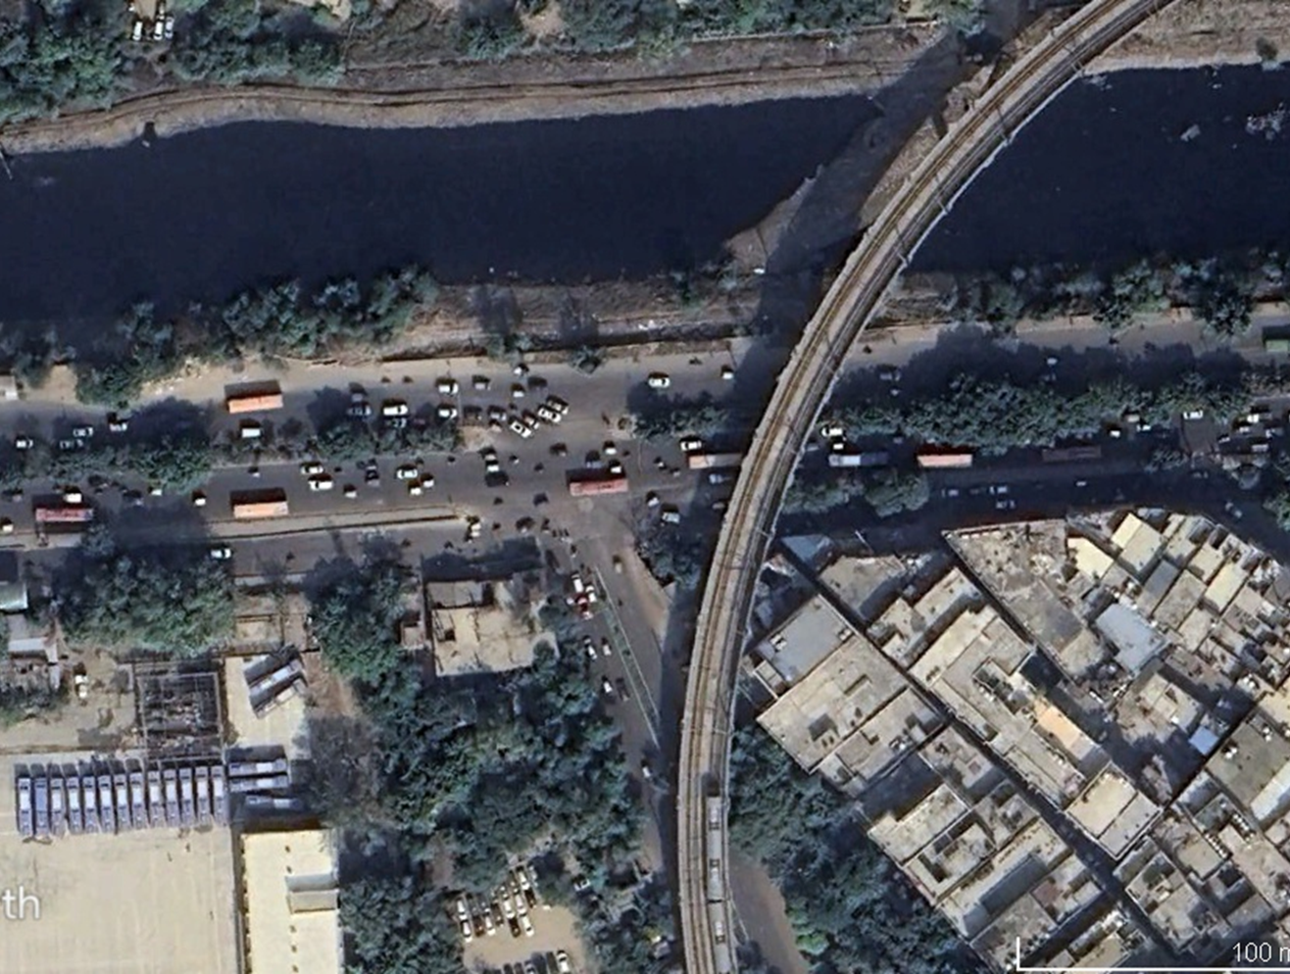

### : Existing Land Use:

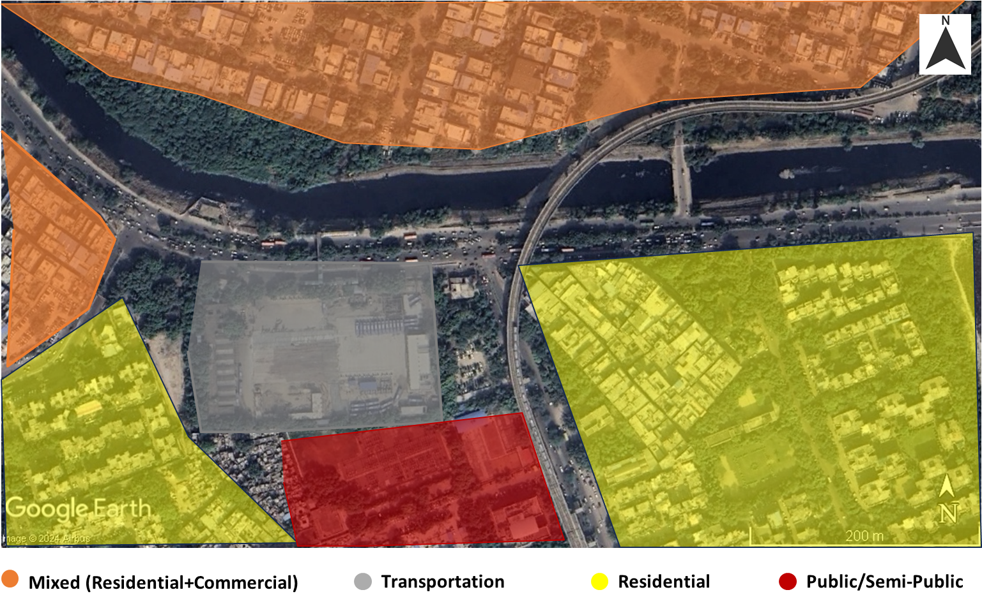

### : Land Use Evolution:

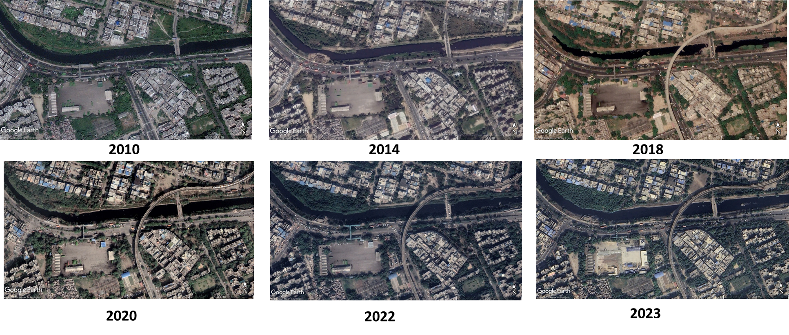

### : Existing Scenario:

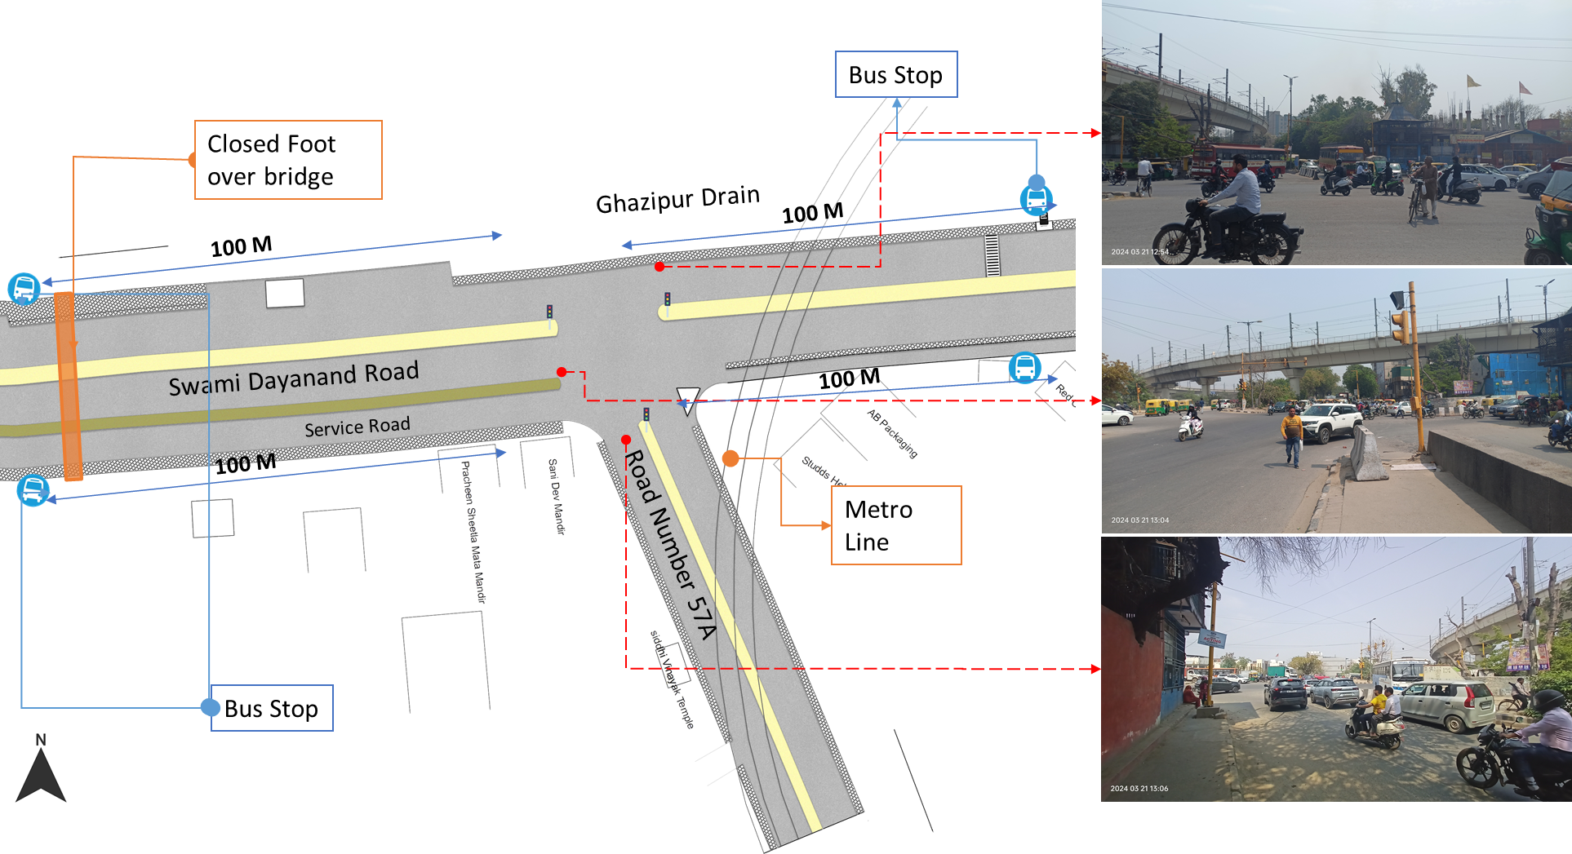

### : Traffic Volume Count:

Figure : Modal distribution during traffic volume count: Hasanpur Depot

*Note-3 hours data (all directions combined); NMT include pedestrians & cyclists and 3W include auto & e-rickshaw

Figure : Hourly Traffic Flow: Hasanpur Depot

Figure : Mode-wise hourly traffic flow: Hasanpur Depot

### : Peak Hour Traffic Flow:

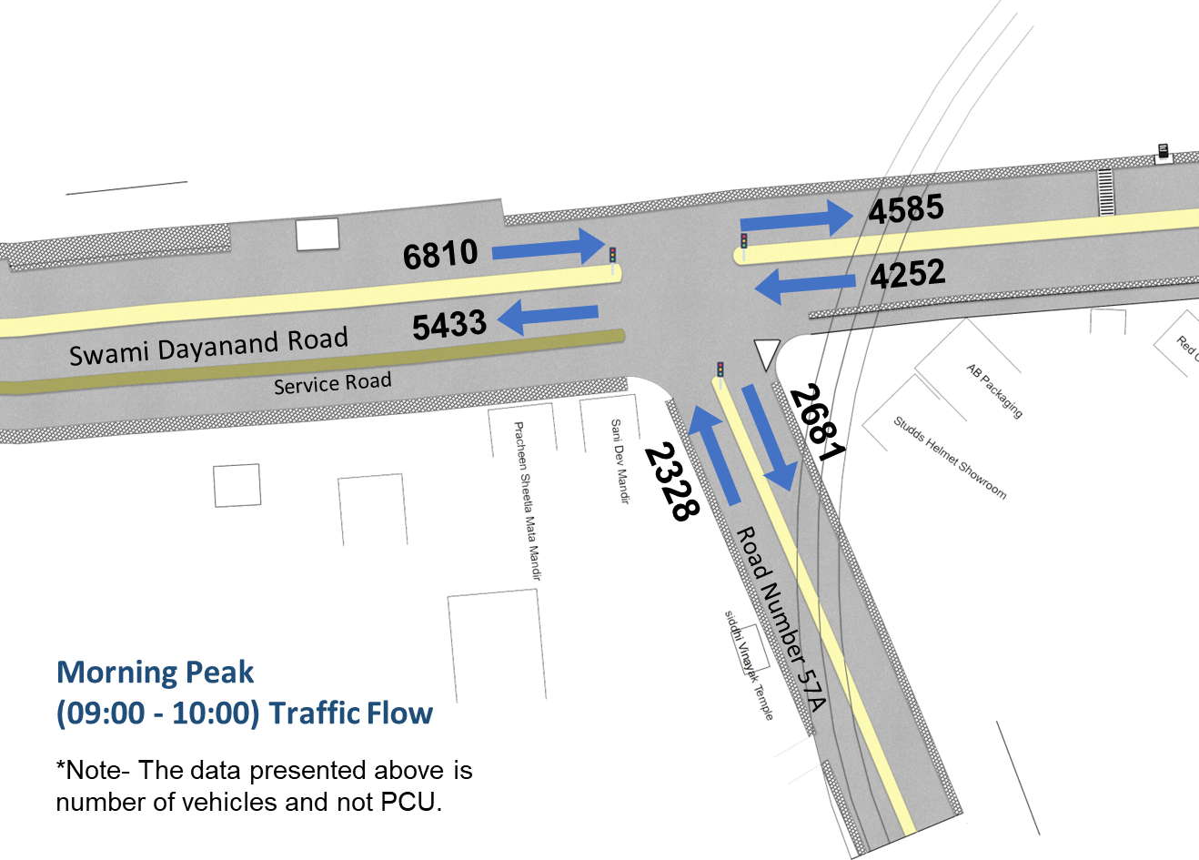

### : Issues identified:

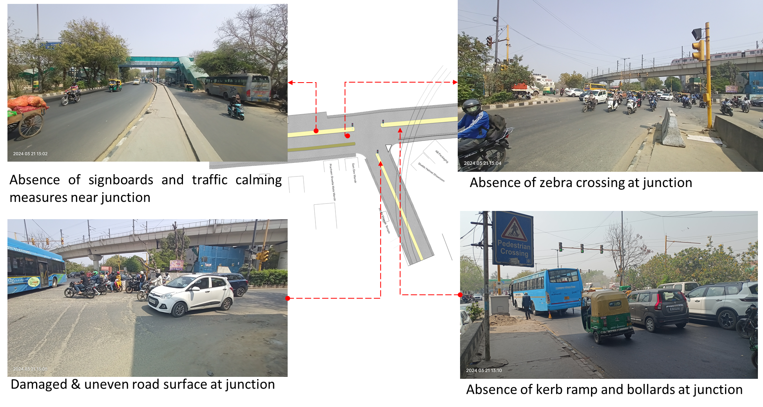

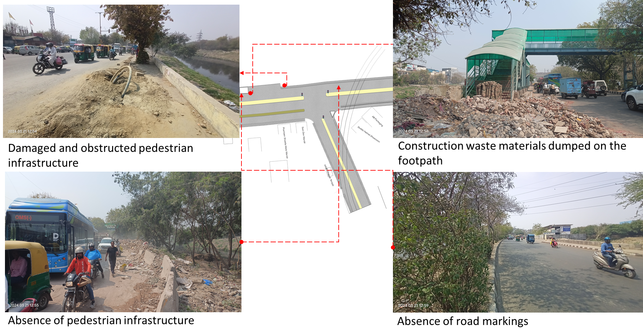

1.Absence of at-grade pedestrian infrastructure at the junction, making the pedestrians extremely vulnerable among the high-speed traffic movement.

2.Damaged and obstructed pedestrian infrastructure on each arm with dumped construction waste.

3.Damaged & uneven road surface

4.Absence of kerb ramp and tactile flooring for differently abled users.

5.Absence of traffic calming near junctions (to control the speed of vehicles).

6.Absence of road markings, signages and speed control measures at the intersection.

7.Absence of delineators and reflectors on the median and carriageway edges.

8.Absence of chevron marking and hazard markers or flexible markers at bull noses.

9.Absence of segregated cycle tracks on sub-arterial roads.

### : Proposed Design:

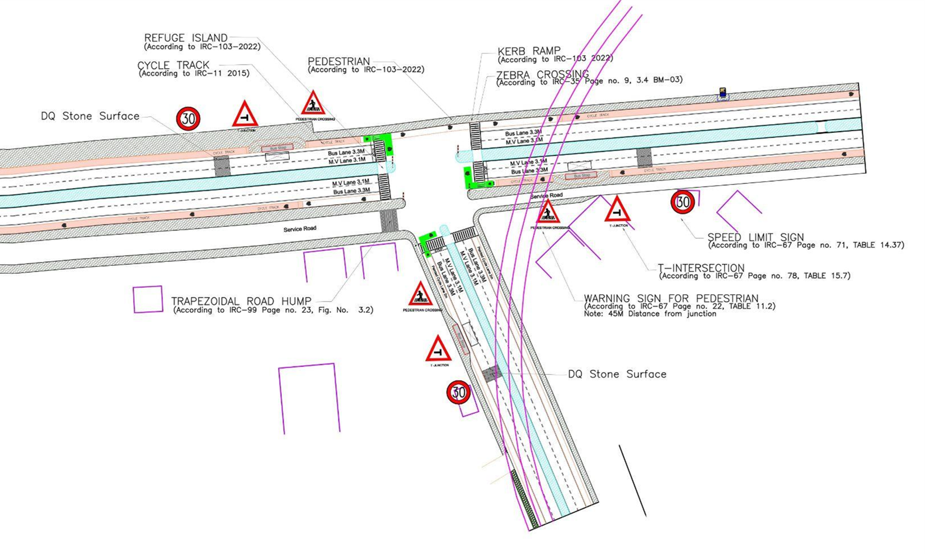

1. The junction is redesigned for the speed of 30 km/hr to ensure safety.
2. The junction is redesigned for the speed of 30 km/hr to ensure safety.
3. Proposed new bus stop near the junction to reduce the pedestrian crossing movement.
4. Dedicated 2.5m wide cycle track and cycle lane to separate the motor traffic and the cyclists (as per IRC: 11-2015).
5. Installation of signages - Speed Limit, stop sign, pedestrian crossing and other necessary Signages on all approaching roads.
6. Provision of DQ stone surface to slow down the approaching traffic.
7. Road Markings (as per IRC 35).
8. Provision of kerb ramps for the accessibility of differently abled users (as per IRC:103-2022).
9. Provision of trapezoidal humps and speed humps on the service road access.

### 

### : Summary budget estimates:

| **S.No** | **Component** | **Details** | **Notes** | **Rate (per sq.m)** | **Cost (INR)** | **Cost (INR, crores)** |
| --- | --- | --- | --- | --- | --- | --- |
| **A** | **CIVIL WORK** |  |  |  |  |  |
| A.1 | Footpath (Primary, Secondary including other Flooring area) | 2m to 3m wide segregated footpath with tactile pavers | Providing and laying of footpath 2m to 3m wide, including earthwork and base layer - PCC, GSB and finishing material. | 2618 | 10,339,739 | 1.034 |
| A.2 | Raised Crossing | Raised crossing with 80mm thick pavers and DQ stone surface | Providing and laying Raised crossing with 80 mm thick pavers blocks, and DQ stone including Earth work and Base layers- PCC (M15), RCC (M30 Design mix) & GSB etc. | 3843 | 199,829 | 0.020 |
| A.3 | Cycle Infrastructure | 2.5m wide segregated cycle track | Providing and laying cycle track (2.5mt wide segregated) including Earth work and Base layers- PCC (M15), RCC (M40 Design mix) & GSB etc. also thermoplastic paint for marking and cycle symbol and spring post etc | 4048 | 5,214,343 | 0.521 |
| A.4 | CC Items (Kerbs, Pipe, etc) | Kerb stones, Bollards, Kerb Channels etc. | Providing and fixing Kerbs, Bollards, and Kerb Channel etc. in CC. |  | 1,457,092 | 0.146 |
| A.5 | Signages | Mandatory, Cautionary and Informatory Sign Boards of different sizes | Providing and fixing Signage Mandatory, Cautionary and informatory sign board including all the fixing and labours etc. |  | 72,548 | 0.007 |
| A.6 | Marking | Thermoplastic Paint Marking (Edge lines, Centre Line, Lane Marking, Hazard Marking, Chevron, Zebra Crossing, Bar Marking, etc) | Providing and applying road marking strips (retro- reflective) of specified shade/ colour using hot thermoplastic material for road marking. | 748 | 323,050 | 0.032 |
| A.7 | Special Zones | Provision of Sitting Bollards, CC Benches, GRC Jali, Pergola, Dustbin etc. | Miscellaneous items- Provision of Sitting Bollards, CC Benches, GRC Jali, Pergola, Dustbin etc. complete items- including foundation and fixing etc. |  | 100,880 | 0.010 |
| A.8 | Brick Work |  | Brick work with common burnt clay F.P.S. (non-modular) bricks of class designation 7.5 in foundation and plinth in: Cement mortar 1:4 (1 cement: 4 coarse sand) | 7370.65/CUM | 294,826 | 0.029 |
| A.9 | Steel Reinforcement for RCC work |  | Steel reinforcement (in per kg) for R.C.C. work including straightening, cutting, bending, placing in position and binding all complete up to plinth level. Thermo-Mechanically Treated bars of grade Fe-500D or more | 107.85/kg | 43,140 | 0.004 |
| A.10 | Pavement Surface Dressing | Pavement of Bitumen layer on existing road surface | Surface dressing on old surface with hot bitumen of grade VG - 10 | 175.10 / sq.m | 262,650 | 0.026 |
| A.11 | Safety Management Equipment (as per design requirement) | Provision of Delineator Post, Spring Post, Cat eye/studs etc. | Miscellaneous items for Safety Management Equipment (as per design requirement) -Provision of Delineator Post, Spring Post, Cat eye/studs etc.- including foundation and fixing etc. |  | 97,961 | 0.010 |
|  | **SUBTOTAL CIVIL WORK (A)** |  |  |  | **18,406,057** | 1.841 |
| **B** | Drainage, Irrigation & Plumbing | (Drainage items based on design proposal) | Drainage, Irrigation & Plumbing work @ 20% of the cost of Civil work | 20% | **3,681,211** | 0.368 |
| **C** | Electrical Work | (Light poles, junction box, other electrical works proposed based on design proposal) | Electrical work @25% of the cost of Civil work | 25% | **4,601,514** | 0.460 |
| **D** | Horticulture Work | (Landscape items based on design proposal) | Horticulture work @ 15% of the cost of Civil work | 15% | **2,760,908** | 0.276 |
| **E** | Dismantling / Demolition | -- | Dismantling work @ 15% of the cost of Civil work | 15% | **2,760,908** | 0.276 |
| **F** | Work Zone Safety & Management | -- | Work zone Management @ 5% of the cost of Civil work | 5% | **920,303** | 0.092 |
| **PART 1** | **SUBTOTAL PART 1 (A+B+C+D+E+F)** |  |  |  | **33,130,902** | 3.313 |
| **G** | Design Services & Support | -- | Design Consultancy (Preparation of Drawings, BOQ support, Work Zone plan, Site Supervision, Community Engagement & Liaison, Change Management @ 2% - 8% of the cost of Civil work. | **2%** | **662,618** | 0.066 |
| **H** | Survey Cost | -- | Survey Cost (Total Station Survey, underground services, tree demarcation, girths, level differences, steps etc @ (80,000 per junction - 250m on each arm) | 80000 | **80,000** | 0.008 |
| **PART 2** | **SUBTOTAL PART 2 (PART 1 + G +H)** |  |  |  | **33,873,520** | 3.387 |
| **J** | Contingencies '2.5% | -- | Contingencies (@2.5%) |  | **846,838** | 0.085 |
| **I** | GST ('@18%) | -- | GST @18% |  | **6,249,664** | 0.625 |
| **FINAL** | **GRAND TOTAL (PART 2 + J + I)** |  |  |  | **40,970,022** | 4.097 |

**Notes:**

1. This is a preliminary estimate. Final costing to be evaluated & approved by the road owning agency.
2. DSR 2023 has been followed for all rates. Market Rate and Costing from part PWD projects has been included for certain items.
3. Cost of Drainage, Irrigation, Plumbing has been calculated at 20% of the civil work cost.
4. Cost of Electrical Work can be calculated at 20% - 25 % of the civil work cost.
5. Cost of Horticulture has been calculated at 15% of the civil work cost.
6. Cost of Dismantling has been calculated at 15% of the civil work cost.
7. Cost of Work Zone Management has been calculated at 5% of the civil work cost
8. Cost for Design Support can range from 2% - 8%, and can vary from site to site . This should include Technical Assistance on drawings, 3D supports, Site Supervision, Change management.
9. Bus Shelter has been calculated at 18 L per shelter; can be changed as per design specific cost.
10. In case of new items specific to design, please add relevant rows in detail budget estimation and include the same in the budget summary under relevant head.

### : Detailed Budget Estimates

| **S. No** | **Component** | **Material Description** | **Item No. (DSR 2023 / Market Rate)** | **Unit** | **Depth (m)** | **Qty** | **Unit Rate** | **Amount** | **Rate per Sq.m** |
| --- | --- | --- | --- | --- | --- | --- | --- | --- | --- |
| 1 | Footpath (Primary, Secondary including other Flooring area) |  |  |  |  |  |  |  |  |
| 1.1 | Excavation | Earth work in excavation by mechanical means (Hydraulic excavator)/ manual means over areas (exceeding 30 cm in depth, 1.5 m in width as well as 10 sqm on plan) including getting out and disposal of excavated earth lead up to 50 m and lift up to 1.5 m, as directed by Engineer-in charge. | 2.6.1 | cum | 0.85 | 3950 | 177.5 | 595956.25 |  |
| 1.2 | Construction of granular sub-base | Construction of granular sub-base by providing close graded Material conforming to specifications, mixing in a mechanical mix plant at OMC, carriage of mixed material by tippers to work site, for all leads & lifts, spreading in uniform layers of specified thickness with motor grader on prepared surface and compacting with vibratory power roller to achieve the desired density, complete as per specifications and directions of Engineer-in-Charge. With material conforming to Grade-II (size range 53 mm to 0.075 mm) having CBR Value-25 | 16.78.2, pg no. 258 | cum | 0.15 | 3950 | 2924.85 | 1732973.625 |  |
| 1.3 | Providing and laying in position cement concrete (M15) | Providing and laying in position cement concrete of specified grade excluding the cost of centering and shuttering - All work up to plinth level :1:2:4 (1 Cement : 2 coarse sand (zone-III) derived from natural sources : 4 graded stone aggregate 40 mm nominal size derived from natural sources) | 4.1.4, pg no. 103 | cum | 0.1 | 3950 | 7780.3 | 3073218.5 |  |
| 1.4 | Tactile - Warner (300 x 300 x 9.8 mm ) (20% of total tactile quantity) | Providing and laying tactile tile (for vision impaired persons as per standards) of size 300x300x9.8 mm having with water absorption less than 0.5% and conforming to IS:15622 of approved make in all colours and shades in for outdoor floors such as footpath, court yard, multi modals location etc., laid on 20 mm thick base of cement mortar 1:4 (1 cement : 4 coarse sand) in all shapes & patterns including grouting the joints with white cement mixed with matching pigments etc. complete as per direction of Engineer-in-Charge. | 16.90, pg no. 261 | sqm |  | 119 | 2017.6 | 240094.4 |  |
| 1.5 | Tactile - Guiding (300 x 300 x 9.8mm ) (80% of total tactile quantity) | Providing and laying tactile tile (for vision impaired persons as per standards) of size 300x300x9.8 mm having with water absorption less than 0.5% and conforming to IS:15622 of approved make in all colours and shades in for outdoor floors such as footpath, court yard, multi modals location etc., laid on 20 mm thick base of cement mortar 1:4 (1 cement : 4 coarse sand) in all shapes & patterns including grouting the joints with white cement mixed with matching pigments etc. complete as per direction of Engineer-in-Charge. | 16.90, pg no. 261 | sqm |  | 474 | 2017.6 | 956342.4 |  |
| 1.6 | Flamed Finish Granite (approved size & color) (18mm thick) | Providing and laying flamed finish Granite stone flooring in required design and patterns, in linear as well as curvilinear portions of the building all complete as per the architectural drawings with 18 mm thick stone slab over 20 mm (average) thick base of cement mortar 1:4 (1 cement : 4 coarse sand) laid and jointed with cement slurry and pointing with white cement slurry admixed with pigment of matching shade including rubbing, curing and polishing etc. all complete as specified and as directed by the Engineer-in-Charge :Flamed finish granite stone slab Jet Black, Cherry Red, Elite  Brown, Cat Eye or equivalent. | 11.55 pg no 198 | sqm |  |  | 3186.7 | 0 |  |
| 1.7 | Polished Granite | Providing and laying Polished Granite stone flooring in required design and patterns, in linear as well as curvilinear portions of the building all complete as per the architectural drawings with 18 mm thick stone slab over 20 mm (average) thick base of cement mortar 1:4 (1 cement : 4 coarse sand) laid and jointed with cement slurry and pointing with white cement slurry admixed with pigment of matching shade including rubbing, curing and polishing etc. all complete as specified and as directed by the Engineer-in-Charge.  Polished Granite stone slab colour of Black, Cherry/Ruby Red or equivalent | 11.56.1, Pg no 198 | sqm |  |  | 4481.3 | 0 |  |
| 1.8 | Interlocking Paver Blocks (approved size & colour) (60mm thick) | Providing and laying factory made chamfered edge Cement Concrete paver blocks in footpath, parks, lawns, drive ways or light traffic parking etc, of required strength, thickness & size/ shape, made by table vibratory method using PU mould, laid in required colour & pattern over 50 mm thick compacted bed of sand, compacting and proper embedding/laying of inter locking paver blocks into the sand bedding layer through vibratory compaction by using plate vibrator, filling the joints with sand and cutting of paver blocks as per required size and pattern, finishing and sweeping extra sand. complete all as per direction of Engineer-in-Charge: 60 mm thick cement concrete paver block of M-35 grade with approved colour, design & pattern. | 16.91.1, pg no. 261 | sqm | 0.6 | 3358 | 1045.65 | 3511292.7 |  |
| 1.9 | Glass Mosaic (20mm x 20mm x 4mm) | Providing and fixing Glass mosaic tiles on finished plain wall surface of size 20 mm x 20 mm x 4 mm in all colour, design, fixing in customize design as per direction of Engineer-in- Charge. The glass mosaic tiles to be fixed on the wall surface with the help of approved adhesive applied at the rate of 2.5 kg per sqm and grouting of the same. The rate is inclusive of all operation, material and required pattern approved by Engineer-in-Charge: | 11.53 pg no 197 | sqm |  |  | 3891.15 | 0 |  |
| 1.10 | Crazy Marble Stone (18 mm thick) | Crazy marble stone flooring, including filling the gaps with light shade pigment with white cement marble powder mixture (3 parts of white cement: 1 part of marble powder) by weight in proportion of 4:7 (4 cement marble powder mix : 7 white, black or white and black marble chips of sizes from 1 mm to 4 mm nominal size by volume), with under layer 25 mm thick cement concrete 1:2:4 (1 cement: 2 coarse sand: 4 graded stone aggregate 12.5 mm nominal size), including rubbing, polishing and cement slurry etc. complete : 18 mm thick crazy marble stone white, black or as specified | As per NIT DAV Pedestrianization | sqm |  |  | 948.85 | 0 |  |
| 1.11 | Crazy Vitrified Tiles (100x100x16mm) | Providing and laying matt finished vitrified tile of size 100x100x16mm having water absorption less than 0.5% and conforming to IS: 15622 of approved make in all colours and shades in outdoor floors such as footpath, court yard multi models etc., laid on 20mm thick base of cement mortar 1:4 (1cement: 4 coarse sand) in all shapes & patterns including grouting the joints with white cement mixed with matching pigments etc. complete as direction of Engineer-in-Charge. | As per NIT DAV Pedestrianization | sqm |  |  | 842.95 | 0 |  |
| 1.12 | Delhi Quartzite (MUZ) (10x10x7.50) | Providing and fixing 10x10x7.50 cm Granite stone block hand cut and chisel dressed on top, for paving in floors, drains etc. laid over 20 mm thick base mortar 1:4 (1 cement: 4 coarse sand) with joints 10 mm wide filled with same mortar including ruled pointing etc. complete as per direction of engineer-in-charge. | 16.92 pg no 261 | sqm |  | 105 | 2189.15 | 229860.75 |  |
| 1.13 | EPDM Flooring | Providing and fixing 36 MM thick Ethylene Propylene Diene Monomer (EPDM) [30 MM SBR (Styrene- Butadiene or Styrene-butadiene Rubber) & 6 MM EPDM] safety FLOORING with the help of BASF Glue 18 adhesive for children play area complete all as per manufacturer's specification and direction of Engineer- in-charge. | As per AR (Market Rate) | Sqm |  | 0 | 3746.2 | 0 |  |
|  | SUB TOTAL |  |  |  |  |  |  | 10339738.63 | 2617.7 |

| **2** | **Raised Crossing** | **Material Description** | **Item No. (DSR 2023 / Market Rate)** | **Unit** | **Depth (m)** | **Qty** | **Unit Rate** | **Amount** | **Rate per Sq.m** |
| --- | --- | --- | --- | --- | --- | --- | --- | --- | --- |
| 2.1 | Excavation | Earth work in excavation by mechanical means (Hydraulic excavator)/ manual means over areas (exceeding 30 cm in depth, 1.5 m in width as well as 10 sqm on plan) including getting out and disposal of excavated earth lead up to 50 m and lift up to 1.5 m, as directed by Engineer-in charge. | 2.6.1 | cum | 0.325 | 52 | 177.5 | 2999.75 |  |
| 2.2 | Construction of granular sub-base | Construction of granular sub-base by providing close graded Material conforming to specifications, mixing in a mechanical mix plant at OMC, carriage of mixed material by tippers to work site, for all leads & lifts, spreading in uniform layers of specified thickness with motor grader on prepared surface and compacting with vibratory power roller to achieve the desired density, complete as per specifications and directions of Engineer-in-Charge. With material conforming to Grade-II (size range 53 mm to 0.075 mm) having CBR Value-25 | 16.78.2, pg no. 258 | cum | 0.1 | 52 | 2924.85 | 15209.22 |  |
| 2.3 | Providing and laying in position cement concrete (M15) | Providing and laying in position cement concrete of specified grade excluding the cost of centering and shuttering - All work up to plinth level: 1:2:4 (1 Cement: 2 coarse sand (zone-III) derived from natural sources: 4 graded stone aggregate 40 mm nominal size derived from natural sources) | 4.1.4, pg no. 103 | cum | 0.1 | 52 | 7780.3 | 40457.56 |  |
| 2.4 | Providing and laying in position cement concrete (M25, Design Mix) | Providing and laying in position ready mixed or site batched design mix cement concrete for plain cement concrete work; using coarse aggregate and fine aggregate derived from natural sources, Portland Pozzolana/Ordinary Portland /Portland Slag cement, admixtures in recommended proportions as per IS: 9103 to accelerate / retard setting of concrete, to improve durability and workability without impairing strength; including pumping of concrete to site of laying, curing, carriage for all leads; but excluding the cost of centering, shuttering and finishing as per direction of the engineer-in-charge; for the following grades of concrete.  Note: Extra cement up to 10% of the minimum specified cement content in design mix shall be payable separately. In case the cement content in design mix is more than 110% of the minimum specified cement content, the contractor shall have discretion to either re-design the mix or bear the cost of extra cement.  Concrete of M25 grade with minimum cement content of 300 kg /cum | 4.20.1.4, page 108 | cum | 0.125 | 52 | 9439.05 | 61353.825 |  |
| 2.4 | Interlocking Paver Block (Red & White of approved size) 80mm thick | Providing and laying factory made chamfered edge Cement Concrete paver blocks in footpath, parks, lawns, drive ways or light traffic parking etc, of required strength, thickness & size/ shape, made by table vibratory method using PU mould, laid in required colour & pattern over 50 mm thick compacted bed of sand, compacting and proper embedding/laying of inter locking paver blocks into the sand bedding layer through vibratory compaction by using plate vibrator, filling the joints with sand and cutting of paver blocks as per required size and pattern, finishing and sweeping extra sand. complete all as per direction of Engineer-in-Charge: 80 mm thick C.C. paver block of M-35 grade with approved colour design and pattern. | 16.91.2, pg no. 261 | sqm |  | 31 | 1091.5 | 33836.5 |  |
| 2.5 | Delhi Quartzite 10x10x7.50 | Providing and fixing 10x10x7.50 cm Granite stone block hand cut and chisel dressed on top, for paving in floors, drains etc. laid over 20 mm thick base mortar 1:4 (1 cement: 4 coarse sand) with joints 10 mm wide filled with same mortar including ruled pointing etc. complete as per direction of engineer-in-charge. | 16.92 pg no 261 | sqm |  | 21 | 2189.15 | 45972.15 |  |
|  | SUB TOTAL |  |  |  |  |  |  | 199829.005 | 3842.9 |

| **3** | **Cycle Infrastructure** | **Material Description** | **Item No. (DSR 2023 / Market Rate)** | **Unit** | **Depth (m)** | **Qty** | **Unit Rate** | **Amount** | **Rate per Sq.m** |
| --- | --- | --- | --- | --- | --- | --- | --- | --- | --- |
| 3.1 | Excavation | Earth work in excavation by mechanical means (Hydraulic excavator)/ manual means over areas (exceeding 30 cm in depth, 1.5 m in width as well as 10 sqm on plan) including getting out and disposal of excavated earth lead up to 50 m and lift up to 1.5 m, as directed by Engineer-in charge. | 2.6.1 | cum | 0.4 | 1288 | 177.5 | 91448 |  |
| 3.2 | Construction of granular sub-base | Construction of granular sub-base by providing close graded Material conforming to specifications, mixing in a mechanical mix plant at OMC, carriage of mixed material by tippers to work site, for all leads & lifts, spreading in uniform layers of specified thickness with motor grader on prepared surface and compacting with vibratory power roller to achieve the desired density, complete as per specifications and directions of Engineer-in-Charge. With material conforming to Grade-II (size range 53 mm to 0.075 mm) having CBR Value-25 | 16.78.2, pg no. 258 | cum | 0.15 | 1288 | 2924.85 | 565081.02 |  |
| 3.3 | Providing and laying in position cement concrete (M15) | Providing and laying in position cement concrete of specified grade excluding the cost of centering and shuttering - All work up to plinth level: 1:2:4 (1 Cement: 2 coarse sand (zone-III) derived from natural sources: 4 graded stone aggregate 40 mm nominal size derived from natural sources) | 4.1.4, pg no. 103 | cum | 0.1 | 1288 | 7780.3 | 1002102.64 |  |
| 3.4 | Providing and laying in position cement concrete (M40, Design Mix) | Providing and laying in position ready mixed or site batched design mix cement concrete for reinforced cement concrete work; using coarse aggregate and fine aggregate derived from natural sources, Portland Pozzolana / Ordinary Portland /Portland Slag cement, admixtures in recommended proportions as per IS: 9103 to accelerate / retard setting of concrete, to improve durability and workability without impairing strength; including pumping of concrete to site of laying, curing, carriage for all leads; but excluding the cost of centering, shuttering, finishing and reinforcement as per direction of the engineer-in-charge; for the following grades of concrete. Note: Extra cement up to 10% of the minimum specified cement content in design mix shall be payable separately. In case the cement content in design mix is more than 110% of the specified minimum cement content, the contractor shall have discretion to either re-design the mix or bear the cost of extra cement:  Concrete of M40 grade with minimum cement content of 390 kg/cum | 5.33.1.4, page 120 | cum | 0.15 | 1288 | 9957.65 | 1923817.98 |  |
| 3.5 | Thermoplastic Paint Marking (Cycle Track - Grey Colour; Cycle Box (Green); Cycle Lane, Edge Marking) | Providing and applying 2.5 mm thick road marking strips (retro- reflective) of specified shade/ colour using hot thermoplastic material by fully/ semi-automatic thermoplastic paint applicator machine fitted with profile shoe, glass beads dispenser, propane tank heater and profile shoe heater, driven by experienced operator on road surface including cost of material, labour, T&P, cleaning the road surface of all dirt, seals, oil, grease and foreign material etc. complete as per direction of Engineer-in-charge and accordance with applicable specifications. | 16.62, pg no. 257 | sq.m |  | 2094 | 747.8 | 1565893.2 |  |
| 3.6 | Cycle Symbol (On green box) | Providing and applying cycle symbol using thermoplastic paint as per IRC 35:2018 in cycle box at location specified | Market Rate | No.s |  | 60 | 1100 | 66000 |  |
| 3.7 | Spring Post (80mm dia 750mm high Plastic) | Providing and applying Plastic spring post 80mm dia 750mm high at location specified | Market Rate | No.s |  | 500 | 350 | 175000 |  |
|  | SUB TOTAL |  |  |  |  |  |  | 5214342.84 | 4048.4 |

| **4** | **CC Items (Kerbs, Pipe, etc)** | **Material Description** | **Item No. (DSR 2023 / Market Rate)** | **Unit** | **Depth (m)** | **Qty** | **Unit Rate** | **Amount** | **Rate per Sq.m** |
| --- | --- | --- | --- | --- | --- | --- | --- | --- | --- |
| 4.1 | Excavation | Earth work in excavation by mechanical means (Hydraulic excavator)/ manual means over areas (exceeding 30 cm in depth, 1.5 m in width as well as 10 sqm on plan) including getting out and disposal of excavated earth lead up to 50 m and lift up to 1.5 m, as directed by Engineer-in charge. | 2.6.1 | cum | 0.45 | 839 | 177.5 | 67015.125 |  |
| 4.2 | Construction of granular sub-base | Construction of granular sub-base by providing close graded Material conforming to specifications, mixing in a mechanical mix plant at OMC, carriage of mixed material by tippers to work site, for all leads & lifts, spreading in uniform layers of specified thickness with motor grader on prepared surface and compacting with vibratory power roller to achieve the desired density, complete as per specifications and directions of Engineer-in-Charge. With material conforming to Grade-II (size range 53 mm to 0.075 mm) having CBR Value-25 | 16.78.2, pg no. 258 | cum | 0.1 | 839 | 2924.85 | 245394.915 |  |
| 4.3 | Dotted kerb stone of approved pattern of M-25 grade cement concrete (0.15x3xL) | Providing and laying at or near ground level factory made kerb stone of M-25 grade cement concrete in position to the required line, level and curvature, jointed with cement mortar 1:3 (1 cement: 3 coarse sand), including making joints with or without grooves (thickness of joints except at sharp curve shall not to more than 5 mm), including making drainage opening wherever required complete etc. as per direction of Engineering-charge (length of finished kerb edging shall be measured to calculate volume for payment). (Precast C.C. kerb stone shall be approved by Engineer-in-charge) | 16.69, pg no. 313 | cum | 0.1 | 839 | 10117.6 | 848866.64 |  |
| 4.4 | Bollards (600mm 120mm dia)  (Preferred size: 950mm high 150mm dia) | Pre-casting and placing in position 125 mm dia Bollards 600 mm high of required shape including providing M.S. Pipe Sleeve 50 mm dia 300 mm long in the Bollard and M.S. Pipes 40 mm dia and 450mm long with 150x150x6mm M.S. plate welded at bottom and embedded 150mm in cement concrete 1:3:6 (1 Cement : 3 coarse sand (zone-III) derived from natural sources : 6 graded stone aggregate 20 mm nominal size derived from natural sources), including necessary excavation of size 250x250x450mm deep for the same in bitumen/concrete pavement at specified spacing | 4.9, pg no. 106 | No.s |  | 120 | 929.8 | 111576 |  |
| 4.5 | Kerb Channel (L*0.3) | Providing, laying and making kerb channel 30 cm wide and 50 mm thick with cement concrete 1:3:6 (1 cement: 3 coarse sands:6 graded stone aggregate 20 mm nominal size) over 75 mm bed of dry brick ballast 40 mm nominal size, well rammed and consolidated and grouted with fine sand, including finishing the top smooth etc. complete and as per direction of Engineer-in-charge. | 16.63, pg no. 257 | sqm |  | 330 | 558.3 | 184239 |  |
|  | SUB TOTAL |  |  |  |  |  |  | 1457091.68 | 1736.7 |

| **5** | **Signages** | **Material Description** | **Item No. (DSR 2023 / Market Rate)** | **Unit** | **Depth (m)** | **Qty** | **Unit Rate** | **Amount** |
| --- | --- | --- | --- | --- | --- | --- | --- | --- |
| 5.1 | Mandatory sign boards of equilateral triangular shape having each side of 900 mm with support length of 3650 mm on arterial - sub arterial roads | Manufacturing, supplying and fixing retro reflective sign boards made up of 2 mm thick aluminium sheet, face to be fully covered with high intensity encapsulated type heat activated retro reflective sheeting conforming to type - IV of ASTM-D 4956-01 in blue and silver white or other colour combination including subject matter, message (bi-lingual), symbols and borders etc. as per IRC ; 67:2001, pasted on substrate by an adhesive backing which shall be activated by applying heat and pressure conforming to class -2 of ASTM-D-4956-01 and fixing the same with suitable sized aluminium alloy rivets @ 20 cm c/c to back support frame of M.S. angle iron of size 25x25x3 mm along with theft resistant measures, mounted and fixed with 2 Nos. M.S. angles of size 35x35x5 mm to a vertical post made up to M.S. Tee section ISMT 50x50x6 mm welded with base plate of size 100x100x5 mm at the bottom end and including making holes in pipes, angles flats, providing & fixing M.S. message plate of required size, steel work to be painted with two or more coats of synthetic enamel paint of required shade and of approved brand & manufacture over priming coat of zinc chromate yellow primer (vertical MS-Tee support to be painted in black and white colours).Backside of aluminium sheet to be painted with two or more coats of epoxy paint over and including appropriate priming coat including all leads and lifts etc. complete as per drawing , specification and direction of Engineer-in-charge.:  Mandatory/ Regulatory sign boards of 900 mm diametre with support length of 3750 mm | 16.59.1 | No.s |  | 3 | 7183.35 | 21550.05 |
| 5.2 | Cautionary / warning sign boards of equilateral triangular shape having each side of 900 mm with support length of 3650 mm on arterial - sub arterial roads | Manufacturing, supplying and fixing retro reflective sign boards made up of 2 mm thick aluminium sheet, face to be fully covered with high intensity encapsulated type heat activated retro reflective sheeting conforming to type - IV of ASTM-D 4956-01 in blue and silver white or other colour combination including subject matter, message (bi-lingual), symbols and borders etc. as per IRC ; 67:2001, pasted on substrate by an adhesive backing which shall be activated by applying heat and pressure conforming to class -2 of ASTM-D-4956-01 and fixing the same with suitable sized aluminium alloy rivets @ 20 cm c/c to back support frame of M.S. angle iron of size 25x25x3 mm along with theft resistant measures, mounted and fixed with 2 Nos. M.S. angles of size 35x35x5 mm to a vertical post made up to M.S. Tee section ISMT 50x50x6 mm welded with base plate of size 100x100x5 mm at the bottom end and including making holes in pipes, angles flats, providing & fixing M.S. message plate of required size, steel work to be painted with two or more coats of synthetic enamel paint of required shade and of approved brand & manufacture over priming coat of zinc chromate yellow primer (vertical MS-Tee support to be painted in black and white colours).Backside of aluminium sheet to be painted with two or more coats of epoxy paint over and including appropriate priming coat including all leads and lifts etc. complete as per drawing , specification and direction of Engineer-in-charge.:: Cautionary /warning sign boards of equilateral triangular shape having each side of 900 mm with support length of 3650 mm | 16.59.2 | No.s |  | 6 | 5559.75 | 33358.5 |
| 5.3 | Informatory sign boards of equilateral triangular shape having each side of 900 mm with support length of 3650 mm on arterial - sub arterial roads | Manufacturing, supplying and fixing retro reflective overhead signage boards made up of 2 mm thick aluminium sheet, face to be fully covered with high intensity and encapsulated lens type heat activated retro reflective sheeting conforming to type - III of ASTM-D-4956-01 as approved by Engineer-in-charge, letters, borders etc. as per IRC : 67-2001 in silver white with blue colour back ground and with high intensity grade, pasted on substrate by pressure sensitive adhesive backing which shall be activated by applying pressure conforming to class II of ASTM-D-4956-01 and fixing the same to the plate of structural frame work by means of suitable sized aluminium alloys, rivets or bolts & nuts @ 300 mm centre to centre all along the periphery as well as in two vertical rows along with theft resistant measures, including the cost of painting with two or more coats of epoxy paint in grey colour on the back side of aluminium sheet including appropriate priming coat. The rate includes the cost of rounding off the corners, lowering down the structural frame work from the gantry, fixing and erecting the same in position all complete as per drawings, specification and direction of the engineer-in-charge. (Structural frame work including M.S. plate to be provided separately. Rectangular area of the sheet only shall be measured for payment). Overhead informatory road signage | 16.60.1 | No.s |  | 3 | 5879.9 | 17639.7 |
| 5.4 | Mandatory sign boards of equilateral triangular shape having each side of 600 mm or lower with support length of 3650 mm on distributory roads (MARKET RATE) | Manufacturing, supplying and fixing retro reflective sign boards made up of 2 mm thick aluminium sheet, face to be fully covered with high intensity encapsulated type heat activated retro reflective sheeting conforming to type - IV of ASTM-D 4956-01 in blue and silver white or other colour combination including subject matter, message (bi-lingual), symbols and borders etc. as per IRC ; 67:2001, pasted on substrate by an adhesive backing which shall be activated by applying heat and pressure conforming to class -2 of ASTM-D-4956-01 and fixing the same with suitable sized aluminium alloy rivets @ 20 cm c/c to back support frame of M.S. angle iron of size 25x25x3 mm along with theft resistant measures, mounted and fixed with 2 Nos. M.S. angles of size 35x35x5 mm to a vertical post made up to M.S. Tee section ISMT 50x50x6 mm welded with base plate of size 100x100x5 mm at the bottom end and including making holes in pipes, angles flats, providing & fixing M.S. message plate of required size, steel work to be painted with two or more coats of synthetic enamel paint of required shade and of approved brand & manufacture over priming coat of zinc chromate yellow primer (vertical MS-Tee support to be painted in black and white colours).Backside of aluminium sheet to be painted with two or more coats of epoxy paint over and including appropriate priming coat including all leads and lifts etc. complete as per drawing , specification and direction of Engineer-in-charge.:  Mandatory/ Regulatory sign boards of 900 mm diameter with support length of 3750 mm | 16.59.1 (Market Rate) | No.s |  |  | 7183.35 | 0 |
| 5.5 | Cautionary / Warning sign boards of equilateral triangular shape having each side of 600 mm or lower with support length of 3650 mm on distributary roads (MARKET RATE) | Manufacturing, supplying and fixing retro reflective sign boards made up of 2 mm thick aluminium sheet, face to be fully covered with high intensity encapsulated type heat activated retro reflective sheeting conforming to type - IV of ASTM-D 4956-01 in blue and silver white or other colour combination including subject matter, message (bi-lingual), symbols and borders etc. as per IRC ; 67:2001, pasted on substrate by an adhesive backing which shall be activated by applying heat and pressure conforming to class -2 of ASTM-D-4956-01 and fixing the same with suitable sized aluminium alloy rivets @ 20 cm c/c to back support frame of M.S. angle iron of size 25x25x3 mm along with theft resistant measures, mounted and fixed with 2 Nos. M.S. angles of size 35x35x5 mm to a vertical post made up to M.S. Tee section ISMT 50x50x6 mm welded with base plate of size 100x100x5 mm at the bottom end and including making holes in pipes, angles flats, providing & fixing M.S. message plate of required size, steel work to be painted with two or more coats of synthetic enamel paint of required shade and of approved brand & manufacture over priming coat of zinc chromate yellow primer (vertical MS-Tee support to be painted in black and white colours).Backside of aluminium sheet to be painted with two or more coats of epoxy paint over and including appropriate priming coat including all leads and lifts etc. complete as per drawing , specification and direction of Engineer-in-charge.:: Cautionary /warning sign boards of equilateral triangular shape having each side of 900 mm with support length of 3650 mm | 16.59.2 (Market Rate) | No.s |  |  | 5550.75 | 0 |
| 5.6 | Informatory sign boards of equilateral triangular shape having each side of 600 mm or lower with support length of 3650 mm on distributary roads (MARKET RATE) | Manufacturing, supplying and fixing retro reflective overhead signage boards made up of 2 mm thick aluminium sheet, face to be fully covered with high intensity and encapsulated lens type heat activated retro reflective sheeting conforming to type - III of ASTM-D-4956-01 as approved by Engineer-in-charge, letters, borders etc. as per IRC : 67-2001 in silver white with blue colour back ground and with high intensity grade, pasted on substrate by pressure sensitive adhesive backing which shall be activated by applying pressure conforming to class II of ASTM-D-4956-01 and fixing the same to the plate of structural frame work by means of suitable sized aluminium alloys, rivets or bolts & nuts @ 300 mm centre to centre all along the periphery as well as in two vertical rows along with theft resistant measures, including the cost of painting with two or more coats of epoxy paint in grey colour on the back side of aluminium sheet including appropriate priming coat. The rate includes the cost of rounding off the corners, lowering down the structural frame work from the gantry, fixing and erecting the same in position all complete as per drawings, specification and direction of the engineer-in-charge. (Structural frame work including M.S. plate to be provided separately. Rectangular area of the sheet only shall be measured for payment). Overhead informatory road signage | 16.60.1 (Market Rate) | No.s |  |  | 5879.9 | 0 |
| 5.7 | Informatory sign - Road Signages, Road Names | Providing, installing and fixing with necessary clamps etc. retro-reflective Single Sided shoulder / gantry / cantilever mounted signboards comprising of customized modular PU Epoxy Coated. MS Tube frame work, aluminium composite panel (ACP) (both side of frame) mill finished or PVDF coated or as specified as base board, micro prismatic retro-reflective sheet and electro- cut coloured overlay film. The horizontal and vertical members of the MS frame module shall be made of MS tube 50x50x3.6mm thick as per approved drawing and each panel shall be braced diagonally (one way only) with same section. The aluminium composite panel (ACP) shall have a thickness of 4mm which including 0.5 mm thick skin of aluminium on both sides. The ACP shall be routed, folded and fixed on the MS frame with VHB tape 24mm wide and 2.3 mm thick provided throughout the length and breadth of the frame including riveting at the right-angle face of the frame with pop riveting or with self-taping SS screws 5mm dia spaced not more than 300mm centre to centre on both side of frame ensuring that no riveting is seen on either face of the frame. On the front face of the ACP, micro prismatic retro- reflective sheet conforming to Type-XI of ASTM: D 4956-09 shall be pressure fixed as background sheet (In white colour) which will be digitally printed matter, border & symbol etc with 15 years warranty and having clear film for UV protection (the reflective value should be as per IRC 67 when tested) of approved make and colour to create a desired road sign and information message. The rear side of the MS frame shall be covered with balancing ACP sheet of the same description as mentioned above and shall be fixed in similar manner as described above. The edges of the board shall be covered all-round with powder coated die cast extruded aluminium channel of required colour and shade of size 68x12x2mm.  The channel shall be fixed using two rows of double sided VHB tape of above description. The channel shall further be secured by pop rivets having SS screws of 5mm dia at junctions and corners. The rate shall include all materials, labour, equipment, fabrication, transportation, erection, installation and incidental charges all complete as per direction of the Engineer-in- Charge. Only front area of the board shall be measured for payment. (All Structural steel work shall be paid separately under the relevant agreement item, except MS tube frame work and fixing arrangement with clamps for the sign boards with are included in this item). | As per AR (Market Rate) | Sq.m |  |  | 16686.2 | 0 |
|  | SUB TOTAL |  |  |  |  |  |  | 72548.25 |

|  |  |  |  |  |  |  |  |  |  |
| --- | --- | --- | --- | --- | --- | --- | --- | --- | --- |
| **6** | **Marking** | **Material Description** | **Item No. (DSR 2023 / Market Rate)** | **Unit** | **Depth (m)** | **Qty** | **Unit Rate** | **Amount** | **Rate per Sq.m** |
| 6.1 | Thermoplastic Paint Marking (Edge lines, Centre Line, Lane Marking, Hazard Marking, Chevron, Zebra Crossing, Bar Marking, etc) | Providing and applying 2.5 mm thick road marking strips (retro- reflective) of specified shade/ colour using hot thermoplastic material by fully/ semi-automatic thermoplastic paint applicator machine fitted with profile shoe, glass beads dispenser, propane tank heater and profile shoe heater, driven by experienced operator on road surface including cost of material, labour, T&P, cleaning the road surface of all dirt, seals, oil, grease and foreign material etc. complete as per direction of Engineer-in-charge and accordance with applicable specifications. | 16.62, pg no. 257 | sq.m |  | 432 | 747.8 | 323049.6 |  |
| 6.2 | Epoxy paint (concrete bollards, kerbs)  (Reference: For Segment Length 250m - Qty =150sq.m) | Finishing with Epoxy paint (two or more coats) at all locations prepared and applied as per manufacturer’s specifications including appropriate priming coat, preparation of surface, etc. complete: On concrete work | 13.52, pg no. 221 | sqm |  |  | 235.15 | 0 |  |
| 6.3 | Synthetic Enamel Paint | Painting with synthetic enamel paint of approved brand and manufacture of required colour to give an even shade : Two or more coats on new work over an under coat of suitable shade with ordinary paint of approved brand and manufacture | 13.62.1, pg no. 222 | sqm |  |  | 226.25 | 0 |  |
|  | SUB TOTAL |  |  |  |  |  |  | 323049 | 747.8 |

| **7** | **Special Zones** | **Material Description** | **Item No. (DSR 2023 / Market Rate)** | **Unit** | **Depth (m)** | **Qty** | **Unit Rate** | **Amount** |
| --- | --- | --- | --- | --- | --- | --- | --- | --- |
| 7.1 | Seating Bollards (450mm dia, 400mm high) | Providing & Fixing Position precast reinforced cement concrete cylindrical bollard cum stool of size 400mm top dia, 300mm bottom dia, 475mm overall height, 150mm stem height and concrete grade M-30 as per approved design/drawing. The bollard shall be fixed in C.C. block mix 1:2:4 (1 Cement: 2 coarse sands: 4 graded stone aggregate 20mm nominal size) 300 mm dia and 150 mm deep including earth work in excavation, painting etc. complete as per direction and instruction of Engineer-in-Charge. | As per AR (Market Rate) | No |  | 10 | 4258.98 | 42589.8 |
| 7.2 | Benches (CC benches) | Providing and placing of precast RCC benches (chair bench with backrest) using m-30 grade of concrete consisting of 2 no. L-shaped base support of thickness 100 mm having Back height 1000mm, front height 450mm and Base width 620mm having 5 No. of RCC planks 1500x100x50 mm and one number plank of size 1500x200x50mm in the approved colour and shade. The minimum weight of MS reinforcement bar in the base support will be 3.40 kg having 4 nos. 8mm dia M.S. Bar distributed alone the section and periphery of the legs with sufficient No. of 4mm dia MS stirrups. Each base support will have 3 nos. 12mm dia (2 Nos. 40mm and one number 65 mm long) galvanized coupling nuts welded suitably to the main reinforcement at appropriate locations so as to receive bolts for fixing of seats of concrete planks on base support and 3 holes to received carriage bolts for fixing back rest planks. The minimum weight of MS reinforcement bar in the plank of 200mm wide will be 4.4kg and of 100mm wide 2.90kg. All the RCC planks will have 2 holes of 14mm dia at appropriate location, so as to receive 12mm dia galvanized bolts for fixing on the base support. One of the planks of size 1500x100x50mm shall be engraved in the centre at the back with letter PWD, 2 plank of size 1500x100x50mm will be bolted to coupling nuts provided in the base support on both sides with 2 numbers of 12mm dia and 65mm long galvanized steel CSR bolt and one Eva washer for each bolt to form a seat 3 planks of size 1500x100x50mm will be bolted to coupling nuts provided in both the base support to form back rest with 6nos. (Two nos. in each plank) half threaded carriage bolts and nuts of size 165mm long and 8mm dia with Eva and steel washers. The holes visible at the back side of the bench will be sealed with cement mortar after assembling sides edges of all the planks shall be painted with acrylic base paint of approved colour and shade and front portion of seating and back rest planks shall be polished to given glossy finish complete as per direction of Engineer-in-charge | As per AR (Market Rate) | No |  | 10 | 5829 | 58290 |
| 7.3 | GRC Jali | Providing and fixing Uni-Stone make or equivalent Glass Reinforced Concrete (G.R.C.) Screens casted with Spray Mix concrete design in approved size, Patten, thickness of 50mm on the outer Boarder & 25-30mm for internal member and shade. The Screens should be made from 53 grade White Portland Cement manufactured by JK Cement or Birla White, White Quartz fine graded sieved silica Sand, Alkali Resistant Glass Fiber Manufactured by NEG Japan, Owen Corning Saint Gobain or equivalent, Super Plasticizers manufactured by Karochem or equivalent, polymers manufactured by Nova Polychem or equivalent and U.V. resistant Synthetic inorganic pigments should be used for pigmentation manufactured by Phenochem industries or equivalent. The Screens casting shall take place with layering methodology using Direct Power Spray machines. The GRC Screens flexural strength average L.O.P. should be above or equivalent to 6 N/mm2 & M.O.R. Should be above or equivalent to 15 N/mm2 for tests done on 28 days cured samples. The fixing of Screens should be done using Dry fixing method onto structural support members i.e., R.C.C., Brick work, MS Framework. SS/MS Galvanized Clamps & Pins fasteners to be used of Worth, Hilti & Fischer or equivalent. All cast in Socket to be Epoxy primer Coated. Electrodes to be used of Advani, Mangalam, Esab or Victor brand or equivalent, all as per manufacturer's specification and direction of Engineer- in-charge. Vendor shall submit shop drawings of same, the drawings to be duly approved from Engineer-in- charge at site. | As per AR (Market Rate) | Sqm |  | 0 | 8190.85 | 0 |
| 7.4 | EPDM Flooring | Providing and fixing 36 MM thick Ethylene Propylene Diene Monomer (EPDM) [30 MM SBR (Styrene- Butadiene or Styrene-butadiene Rubber) & 6 MM EPDM] safety FLOORING with the help of BASF Glue 18 adhesive for children play area complete all as per manufacturer's specification and direction of Engineer- in-charge. | As per AR (Market Rate) | Sqm |  | 0 | 3746.2 | 0 |
| 7.5 | Exposed Brick Masonry (Seater with exp including putty, plaster, earth work, including foundation with steel for RCC etc) | Brick work with common burnt clay selected F.P.S. (non-modular) bricks of class designation 7.5 in exposed brick work including making horizontal and vertical grooves 10 mm wide 12 mm deep complete in cement mortar 1:6 (1 cement: 6 coarse sand):  Above plinth level up to floor V level | 6.26.2, pg no. 129 | cum |  | 0 | 9439.75 | 0 |
| 7.6 | Street Art Wall (wall putty) | Providing and applying plaster of Paris putty of 2 mm thickness over plastered surface to prepare the surface even and smooth complete. | 13.26, pg no. 218 | Sqm |  |  | 262.7 | 0 |
| 7.7 | Street Art Wall (exterior paint, etc) | Finishing walls with Premium Acrylic Smooth exterior paint with Silicone additives of required shade:  New work (Two or more coats applied @ 1.43 litre/10 sqm over and including priming coat of exterior primer applied @ 0.90 litre/10 sqm) | 13.47.1, pg. no. 220 | Sq.m |  |  | 171.1 | 0 |
| 7.8 | Metal Pergola | Steel work in built up tubular (round, square or rectangular hollow tubes etc.) trusses etc., including cutting, hoisting, fixing in position and applying a priming coat of approved steel primer, including welding and bolted with special shaped washers etc. complete.  Hot finished welded type tubes | As per AR (Market Rate) | kg |  |  | 90.25 | 0 |
| 7.9 | Polycarbonate sheet |  | As per AR (Market Rate) | Sq.m |  |  | 1300 | 0 |
| 7.10 | CNC metal cut column / marker |  | As per AR (Market Rate) | sq.m |  |  | 3000 | 0 |
| 7.11 | Play / Gym Equipment | Providing designing and fixing play equipment as per size, shape and material s per design. All complete as per direction and approval of engineer-in-charge regarding material, shape of equipment, colour on metal, fixing of equipment etc (the cement concrete and excavation work shall be paid separately) | As per AR (Market Rate) | lump sum |  |  | 40000 | 0 |
| 7.12 | Dustbin |  | As per AR (Market Rate) | No |  |  | 10000 | 0 |
| 7.13 | Sculpture |  | As per AR (Market Rate) | lump sum |  |  |  | 0 |
|  | SUB TOTAL |  |  |  |  |  |  | 100879.8 |

|  |  |  |  |  |  |  |  |  |
| --- | --- | --- | --- | --- | --- | --- | --- | --- |
| **8** | **Brick Work** | **Material Description** | **Item No. (DSR 2023 / Market Rate)** | **Unit** | **Depth (m)** | **Qty** | **Unit Rate** | **Amount** |
| 8.1 | Brick Work (1 cum for 1m) | Brick work with common burnt clay F.P.S. (non-modular) bricks of class designation 7.5 in superstructure above plinth level up to floor V level in all shapes and sizes in: | 6.1.1 pg no. 127 | cum | 0.1 | 400 | 7370.65 | 294826 |
|  | SUB TOTAL |  |  |  |  |  |  | 294826 |

|  |  |  |  |  |  |  |  |  |
| --- | --- | --- | --- | --- | --- | --- | --- | --- |
| **9** | **Steel Reinforcement for RCC work** | **Material Description** | **Item No. (DSR 2023 / Market Rate)** | **Unit** | **Depth (m)** | **Qty** | **Unit Rate** | **Amount** |
| 9.1 | Thermo-Mechanically Treated bars of grade Fe-500D or more | Steel reinforcement for R.C.C. work including straightening, cutting, bending, placing in position and binding all complete up to plinth level.: | 5.22.6, pg no. | kg |  | 400 | 107.85 | 43140 |
|  | SUB TOTAL |  |  |  |  |  |  | 43140 |

|  |  |  |  |  |  |  |  |  |  |
| --- | --- | --- | --- | --- | --- | --- | --- | --- | --- |
| 10 | Pavement Surface Dressing | Material Description | Item No. (DSR 2023 / Market Rate) | Unit | Depth (m) | Qty | Unit Rate | Amount | Rate per Sq.m |
| 10.1 | Bituminous- Top Layer | Surface dressing on old surface with hot bitumen of grade VG - 10 of approved quality using 1.95 kg of bitumen per sqm with 1.50 cum of stone chippings 11.2 mm nominal size per 100 sqm of road surface, including consolidation with road roller of 6 to 8 tonne capacity, etc. complete. | 16.27 Page 249 | sqm |  | 1500 | 175.1 | 262650 |  |
|  | SUB TOTAL |  |  |  |  |  |  | 262650 | 175.1 |

|  |  |  |  |  |  |  |  |  |
| --- | --- | --- | --- | --- | --- | --- | --- | --- |
| **11** | **Safety Management Equipment (as per design requirement)** | **Material Description** | **Item No. (DSR 2023 / Market Rate)** | **Unit** | **Depth (m)** | **Qty** | **Unit Rate** | **Amount** |
| 11.1 | Delineator | Providing and fixing post delineators made of ABS round body fitted with 2 no’s 100 mm dia high reflective reflectors and mounted on MS pipe of 65 mm dia duly powder coated anti-rust and anti-theft steel to be installed as per direction of Engineer-in-charge | 16.65, Page 257 | No |  | 24 | 904.2 | 21700.8 |
| 11.2 | Spring Post (80mm dia 750mm high Plastic) | Providing and applying Plastic spring post 80mm dia 750mm high at location specified | As per AR (Market Rate) | No |  | 100 | 350 | 35000 |
| 11.3 | Road Studs/Cat eye | Providing and fixing Glow studs of size 100x20 mm made of heavy-duty body shall be moulded ASA (Acrylic styrene Acryloretrite) or HIP (High impact polystyrene) or ABS having electronically welded micro- prismatic lens with abrasion resistant coating as approved by Engineer in charge. The glow stud shall support a load of 13635 kg tested in accordance with ASTM D4280. The slope of retro- reflective surface shall be 35 (+/- 5) degrees to base. The reflective panels on both sides with at least 12 cm of reflective area up each side. The luminance intensity should be as per the specification and shall be tested as described in ASTM I: 809 as recommended in BS: 873 part 4 : 1973. The studs shall be fixed to the Road surface using the adhesive conforming to IS, as per procedure recommended by the manufacturer complete and as per direction of Engineer-in-charge. | 16.50, Pg no. 253 | No |  | 200 | 206.3 | 41260 |
|  | SUB TOTAL |  |  |  |  |  |  | 97960.8 |

|  |  |  |  |  |  |  |  |  |
| --- | --- | --- | --- | --- | --- | --- | --- | --- |
| **12** | **Bus Stops** | **Material Description** | **Item No. (DSR 2023 / Market Rate)** | **Unit** | **Depth (m)** | **Qty** | **Unit Rate** | **Amount** |
| 12.1 | Bus Shelter (10.5mX2.5m) | Stainless Steel Structure | As per AR (Market Rate) | No |  | 3 | 1800000 | 5400000 |
|  | SUB TOTAL |  |  |  |  |  |  | 5400000 |

## : Safe School Zone: Rajkiya Sarvodaya Bal Vidyalaya (RSBV), Shakarpur

**SAFER SCHOOL ZONE PROJECT**

The Transport Department is the Lead Agency for Road Safety in Delhi. Safer School Zones was launched as part of High Impact Project in 2022 initiating a focus on school and school travel safety in partnership with HumanQind as the lead partner of the Transportation Research and Injury Prevention Centre (TRIP C) at Indian Institute of Technology, Delhi. Road Safety Clubs were established in all schools by the Directorate of Education in November 2022. As part of the High Impact Project, 11 model school zones, one every district of Delhi. The project has brought all school members including students to discuss and plan long term traffic safety and school accessibility blueprint based on data and collaborative action with District Road Safety Committees.

The road safety club are core teams constituting a representative group of the school community including students and alumni, school staff, parents, and head of school. The primary objective of this club is to promote traffic safety, especially in how users get to and from school.

### : Engagement Timeline

|  |  |  |  |  |  |
| --- | --- | --- | --- | --- | --- |
| **STAGE 1**  **Orientation** | **STAGE 2 Data Collection** | **STAGE 3**  **Design Collaboration** | **STAGE 4 Exhibition** | **STAGE 5 Implementation** | **STAGE 6 Management** |
| Focus the school towards safer commuting to school for all-parents, staff, students, SMC/PTA. | Conduct school accessibility audits and traffic safety assessment for evidence-based planning and understanding the school community. | Conduct co-design workshops with students, staff and parents to prepare safe school zone plan, design and management-including circulation and parking. | Organise periodic exhibitions on school zones and road safety with decision makers and the school community. | Involve the government to implement the safe school zone plan. | Enable the Road safety club to manage the school zone and organise talks and interviews with experts. |
| Sep 22 | Dec 22 - Jan 23 | Nov 22 -Dec 22 | July 23 | Current Stage |  |

### : General description of the site

*Land Use Map of Rajkiya Sarvodaya Bal Vidyalaya and School Zone Data (AY 22-23)*

|  |  |  |  |  |  |  |
| --- | --- | --- | --- | --- | --- | --- |
| District | Co-ed | School Shift | Shared Campus | Cluster of Schools | Total No. of Students: | ROW |
| East | No | Morning | Yes | Yes | 1829 | 22m - 24m |

Length of Intervention (all arms, in metres): 450

Situated at the Patparganj Road between the Nirman Vihar and Acharya Nagraj Marg intersection, the Rajkiya Sarvodaya Bal Vidyalaya (RSBV) is the pilot safe school site in the East district. With a cluster of 3 schools, the site was identified as a potential crash location as per the Action to data report 2022-23. The school is surrounded in the vicinity with the land use predominantly commercial in nature and other schools. The school has a total of two gates. Both gate no. 1, and 2 opens at the Patparganj road. RSBV is a shift school with a total enrolment of 1829 students from class I to XII (age 7 to age 17). With a varied wing distribution of 20.2% in junior, 27.3% in middle and 52.4% in senior secondary, the school thus has children from age 5 to 17 travelling to and from school. The larger modes of transport observed in the school surroundings are walk and public transport.

### : Existing Scenario

As per a travel survey conducted in Dec ‘22, response from 267 students (15% of total school population) was mapped to understand travel patterns and socio-emotional data relevant to school journeys.

Figure : Home to school modal distribution: Rajkiya Sarvodaya Bal Vidyalaya

Figure : School to home modal distribution: Rajkiya Sarvodaya Bal Vidyalaya

*Source: HumanQind School Travel Survey 22-23*

* Walking is the single most common mode of transport for the students both in the afternoon and evening.
* 24% in the afternoon and 20% of the students in the evening travel by public transport.
* Private vehicles and auto rickshaws are one of the least commonly used modes.
* Between afternoon and evening there is a minor modal shift between the walking students and those using public transport although their total numbers remain nearly the same.

Figure :Commute distance to and from school: Rajkiya Sarvodaya Bal Vidyalaya

*Source: HumanQind School Travel Survey 22-23*

* 76% of the students stay within 2 km of the school, and nearly 40% live within 1 km of the school.
* Only 8% of the students come from more than 2 km.

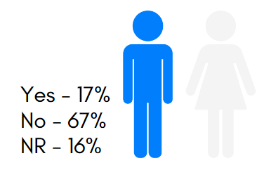

Figure : Infrastructure change expected: Rajkiya Sarvodaya Bal Vidyalaya

*Source: HumanQind School Travel Survey 22-23*

* 17% of the students reported fear while travelling to and back from the school.
* 67% of the students reported they felt safe and 16% gave no reply to the question.
* Amongst the modes public transport and bicycles were reported as the modes where the students felt the most unsafe; with an average 30% and 27% reporting they felt fear while travelling respectively.
* In other modes, less than 15% of the students reported feeling unsafe.

**Infrastructure Interventions and its Impact on Social and Emotional Learning**

When asked what infrastructural changes both in the school surroundings and their travel routes will have a positive impact on them.89% of students preferred traffic lights and safe crossings, 87% suggested a footpath for walking will be beneficial to them. There are also a significant number of students who opted for comfortable waiting spaces, organised entry and exit and vehicle-free streets outside the schools (84%, 69% and 46% respectively). Infrastructure not only provides a change in the environment but also serves a psychological purpose of providing safety and comfort which affects the sense of belonging and emotions around a public space. (Source: HumanQind School Travel Survey 22-23)

**Infrastructure Interventions and Academic Performance**

The students were also surveyed about what are the factors they believe will enhance their learning and academic performance. 82% of students reported availability of school transport and less walking time. Long and cumbersome commutes to school can hamper the readiness for learning and the exhaustion of learning. Noise is also a major factor in learning and concentration and can have an impact on the attention process as 78% opted for lesser noise outside school. (Source: HumanQind School Travel Survey 22-23).

### : Issues identified

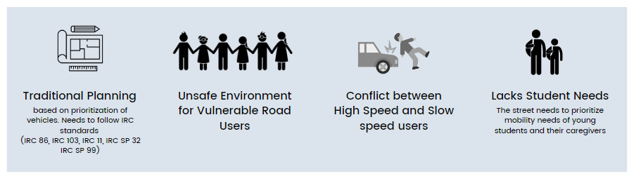

**Observations on Road Infrastructure:** Due to the traditional vehicle centric planning approach, the road infrastructure does not adhere to safety principles as per IRCs. This leads to an unsafe environment for the vulnerable road users. There have been observations about high speeding and wrong side driving because of the lack of any traffic calming devices, signages and marking conducive to school zones. With that, there is a lack of provision in the pedestrian and cyclist infrastructure though a good number of students commute to school and back home by walking. Some additional infrastructure issues with high demand value includes, lack of dedicated parking zones, waiting areas, dedicated drop off and pick off areas and vendor/hawkers’ zone within the school zone and better planning of utilities.

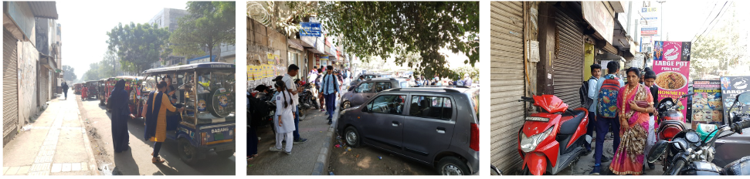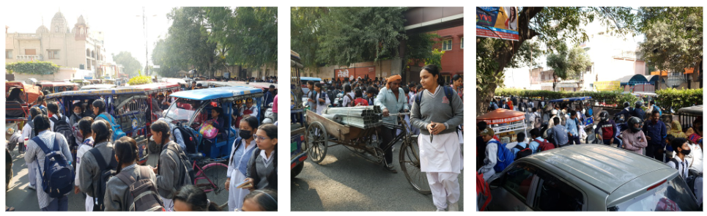

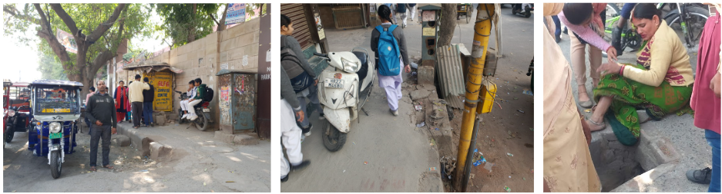

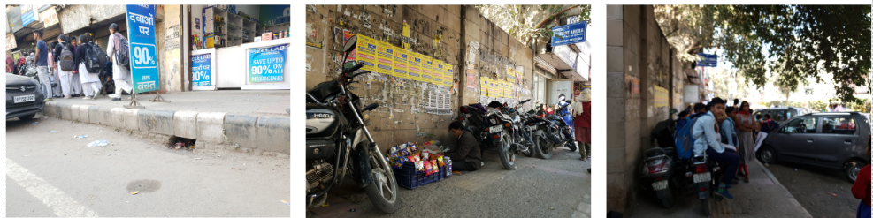

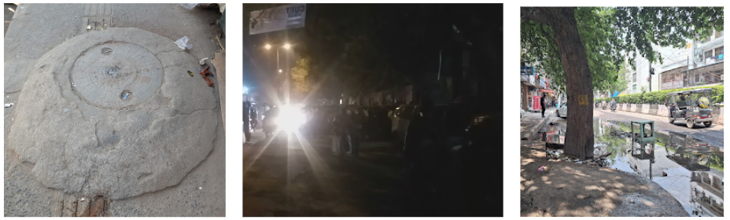

*Site Photographs : Rajkiya Sarvodya Bal Vidyala*

**Type and Quality of Enforcement**

Lack of traffic personnel in the school vicinity leads to an uncontrolled environment and circumstances. Over speeding and wrong side driving is observed to be a common phenomenon. Especially during the active school hours, this results in conflict with vulnerable road users.

**Road Users Behaviour and mobility patterns**

To understand the regular patterns of movements and conflicts in the school vicinity, HumanQind conducted activity mapping during the active school hours for Rajkiya Sarvodaya Bal Vidyalaya. Observations were made twice in a day. First, for the morning hours i.e., to derive Home to school patterns of students. Second, in the afternoon hours i.e., to derive school to home patterns of students.

### : Activity map

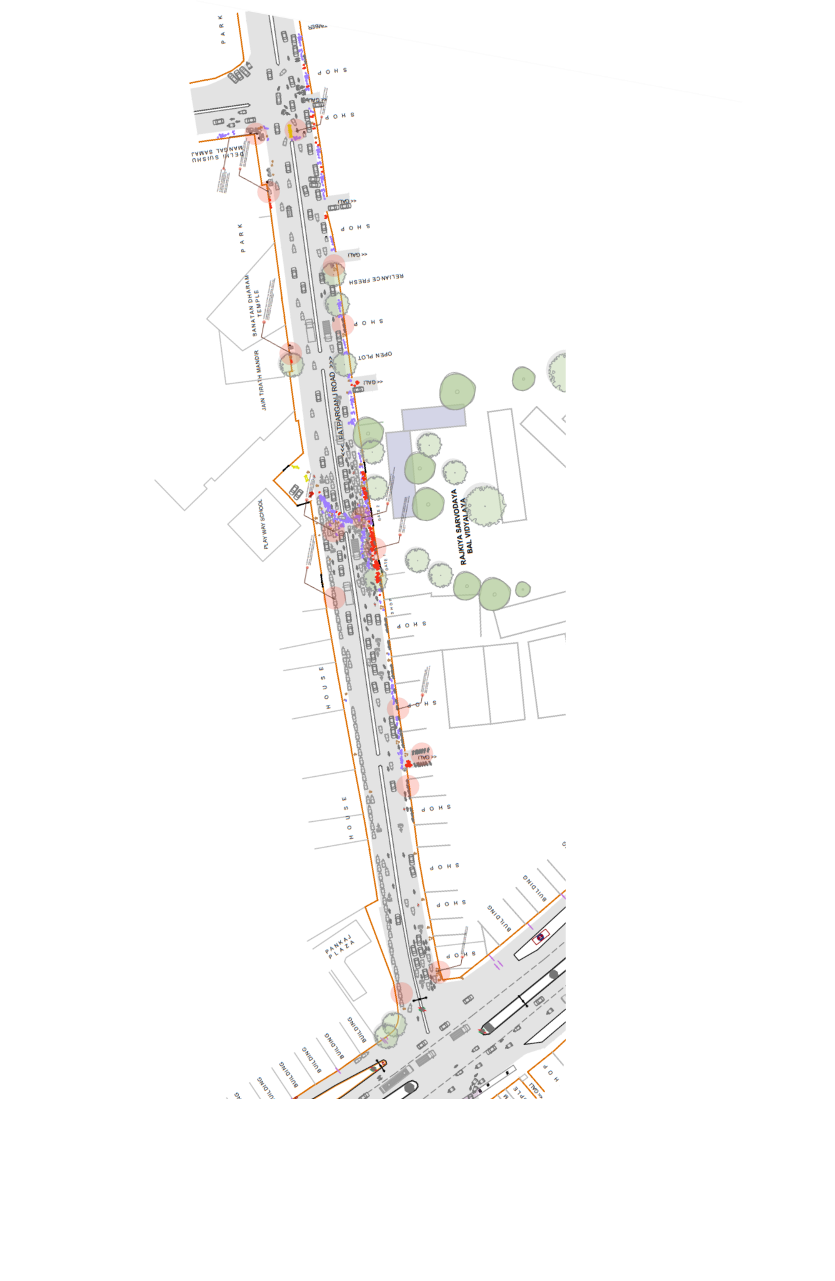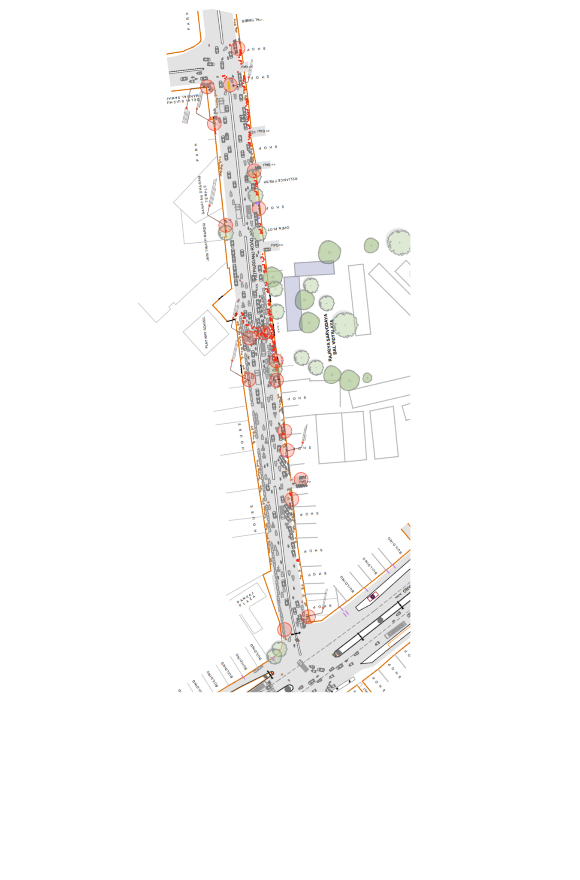

*Activity Mapping*

**Key Findings:**

|  |  |
| --- | --- |
| **Afternoon : Home to School**   * Crowding and Haphazard movement in front of gates in the afternoon hour for shift change. * There are no waiting areas near the school gate and with the insufficient capacity of footpath this leads to a chaotic situation at the school front. * E-rickshaws and private vehicles are parked near the school gate, students find it difficult to navigate their way through. * High conflict between students and motorised vehicles is observed during the school active hours. | **Evening : School to Home**   * Students find it difficult to walk in the evening hours as there is a lack of street lighting. * High conflict between students and motorised traffic is observed in the evening hours. * Students have to cross the road in an unsafe environment. |

### : Proposed design

The School Zone plan addressed by school road safety clubs is titled ‘Surakshit Sapna’ strictly adheres to IRC guidelines and principles of traffic safety and management around schools. The design takes into consideration some of the specific problems and challenges identified together. Students embrace a slow zone, promote walkability, extend limits to the intersection, propose an integrated plan with public transport and incorporate their visible needs. The proposed design covers 450 m length of streets and adheres to 20 km/h or lower in the school zone promoting walkability and designated spaces for parking to avoid conflicts. The area in front of gates including the Nirman Vihar and Acharya Nagraj Marg intersection have been made safer with surface texture change and wide prominent crossings for all road users.

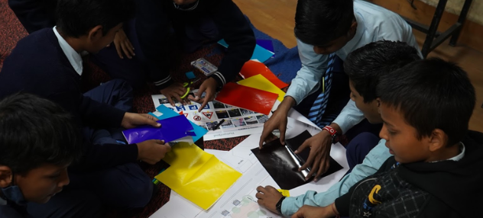

*School Road Safety Club design safety interventions for school zone*

**Advantages of the proposed design:**

Designed with students, the proposed design prioritises the needs of the students and vulnerable users and incorporates efficient sharing of streets for all. It includes the following:

* Provision of pedestrian infrastructure as per IRC 103
* Provision of cyclist infrastructure as per IRC 11
* Provision of traffic calming devices
* Provision of Signages and Markings conducive to school zone requirements.
* Provision of waiting areas and dedicated vendor zones
* Better planning of utilities, and street furniture
* Student friendly street elements and details
* Reduction of Conflict Area: Segregated and continuous footpaths have been provided along with texture change and raised crossings at intersections. Cycle lanes have been segregated using safety spring posts.
* Safer Junctions - Both the intersections are textured with provision of pedestrian crossing, signages and markings as per the school zone requirements
* Safe and efficient traffic movement - Provision of dedicated Motorised Vehicle lanes are incorporated with markings and signages to ensure safe and efficient traffic movement.
* Safe and accessible pedestrian movement- Dedicated pedestrian infrastructure all along the school stretch provided with required markings, signages and universal accessibility features.
* Safer speeds - In accordance to Design speed of 20kmph as per IRC 86:2018 and IRC SP 32

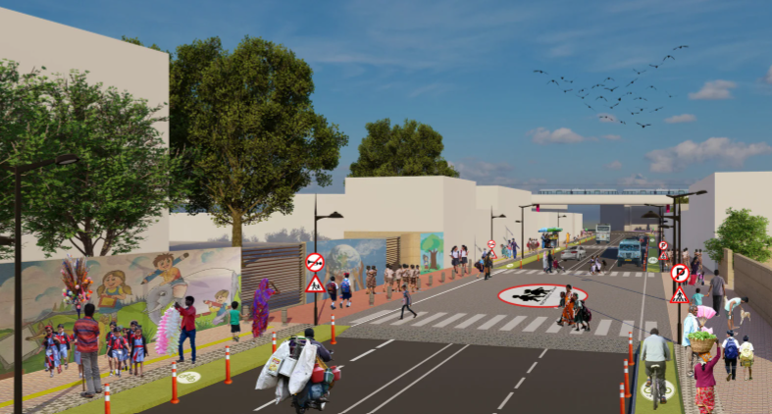

**Surakshit Sapna - Proposed Render of Patparganj Road of Rajkiya Sarvodaya Bal Vidyalaya**

**Design Interventions:**

The proposal prepared by road safety clubs (Refer Safer Delhi through Road Safety Clubs) is called ‘Surakshit Sapna’ aligning to pedestrian first approach, traffic safety principles, UN Sustainable Development Goals and Ladder of Children Participation. ‘Surakshit Sapna’ is an area plan connecting 3 schools and the neighbourhood to 450m of school zone development. The entire plan is in adherence to Indian Road Congress Guidelines. To reduce speeds and conflicts, the school zone has been designed as per 20km/h or lower speed, promoting walkability, safe mobility. Continuous footpaths with designated boarding areas and drop off zones have been proposed. All streets are collector streets and cycle lanes with bollards have been planned. The area in front of gates, including the Nirman Vihar and Acharya Nagraj intersection have been made safer with Table top crossings, change of surface texture and prominent markings to highlight school zones for all road users.

* 2.5-2.8m accessible and segregated footpaths on both sides
* 1.2 m segregated cycle lane on one side. (as per IRC 11: 2015)
* 1.0 m of Multi-Utility Zone for Services such as lighting and drainage.
* Traffic calming designed in front of entry/exits and school gates.
* Low medians to increase visibility.
* Designated boarding areas and drop off zones
* Integrated waiting spaces, vendor spaces and street furniture integrated
* School specific signage and marking
* Continuous carriageway 2 lanes each direction on Patparganj Road

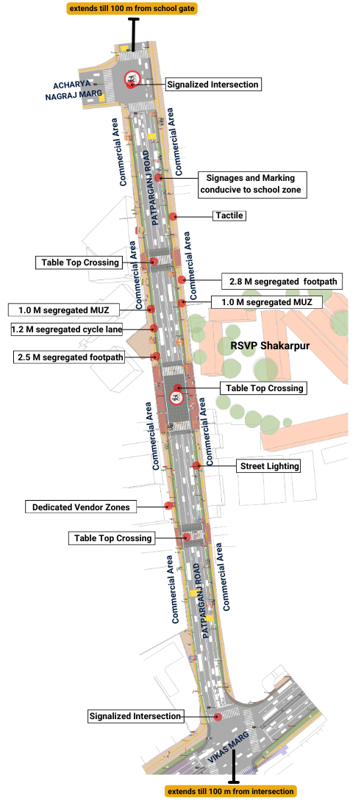

*Figure B.3.6: Proposed Design for School Zone Rajkiya Sarvodya Bal Vidyalaya, Shakarpur*

### 

### : Summary budget estimates

| **S.No** | **Component** | **Details** | **Notes** | **Rate (per sq.m)** | **Cost (INR)** | **Cost (INR, crores)** |
| --- | --- | --- | --- | --- | --- | --- |
| **A** | **CIVIL WORK** |  |  |  |  |  |
| A.1 | Footpath (Primary, Secondary including other Flooring area) | 2.5m segregated footpath with tactile pavers in both directions | Providing and laying of footpath 2m to 3m wide, including earthwork and base layer - PCC, GSB and finishing material. | 2695 | 10199375 | 1.020 |
| A.2 | Raised Crossing | Traffic calming in front of school gate 1, intersection of som bazar road and | Providing and laying Raised crossing with 80 mm thick pavers blocks, and DQ stone including Earth work and Base layers- PCC (M15), RCC (M30 Design mix) & GSB etc. | 3587 | 3787537 | 0.379 |
| A.3 | Cycle Infrastructure | 1.5m cycle lane both sides | Providing and laying cycle track (2.5mt wide segregated) including Earth work and Base layers- PCC (M15), RCC (M40 Design mix) & GSB etc. also thermoplastic paint for marking and cycle symbol and spring post etc | 0 | 815730 | 0.082 |
| A.4 | CC Items (Kerbs, Pipe, etc) | Provision of bollards, kerbs - mountable, kerb channels, etc | Providing and fixing Kerbs, Bollards, and Kerb Channel etc. in CC. |  | 619655 | 0.062 |
| A.5 | Signages | Provision of signages as per IRC 67 for school zone & 20 km/h | Providing and fixing Signage Mandatory, Cautionary and informatory sign board including all the fixing and labours etc. |  | 384227 | 0.038 |
| A.6 | Marking | Provision of signages as per IRC 35 for school zone & 20 km/h | Providing and applying road marking strips (retro- reflective) of specified shade/ colour using hot thermoplastic material for road marking. | 1375 | 412460 | 0.041 |
| A.7 | Special Zones | Provision of seating areas, vendor spaces and play integrated with design proposal | Miscellaneous items- Provision of Sitting Bollards, CC Benches, GRC Jali, Pargola, Dustbin etc. complete items- including foundation and fixing etc. |  | 64959 | 0.006 |
| A.8 | Brick Work | -- | Brick work with common burnt clay F.P.S. (non-modular) bricks of class designation 7.5 in foundation and plinth in: Cement mortar 1:4 (1 cement : 4 coarse sand) | 7370.65/CUM | 316938 | 0.032 |
| A.9 | Steel Reinforcement for RCC work | -- | Steel reinforcement (in per kg) for R.C.C. work including straightening, cutting, bending, placing in position and binding all complete up to plinth level. Thermo-Mechanically Treated bars of grade Fe-500D or more | 107.85/kg | 107850 | 0.011 |
| A.10 | Pavement Surface Dressing | Pavement of Bitumen layer on existing road surface | Surface dressing on old surface with hot bitumen of grade VG - 10 | 175.10 / sq.m | 0 | 0.000 |
| A.11 | Safety Management Equipment (as per design requirement) | Provision of Delineator Post, Spring Post, Cat eye/studs etc. | Miscellaneous items for Safety Management Equipment ( as per design requirement) -Provision of Delineator Post, Spring Post, Cat eye/studs etc.- including foundation and fixing etc. |  | 0 | 0.000 |
| A.12 | Bus Shelter | -- | Provision of new bus shelter. |  | 0 |  |
|  | **SUBTOTAL CIVIL WORK (A)** |  |  |  | **16708731** | 1.671 |
| **B** | Drainage, Irrigation & Plumbing | Details promoting a catch pit along the footpath linked to existing manholes. Bell mouths are not recommended. Details to be finalised with PWD | Drainage, Irrigation & Plumbing work @ 20% of the cost of Civil work | 20% | **3341746** | 0.334 |
| **C** | Electrical Work | 5m and 10m light poles have been located alongside the footpath / MUZ. Details to be finalised with PWD. | Electrical work @25% of the cost of Civil work | 25% | **4177183** | 0.418 |
| **D** | Horticulture Work | To increase green cover and shade, landscape plans promote ground cover and trees for seasonal variation and colour. Irrigation plan to be finalised with PWD. | Horticulture work @ 15% of the cost of Civil work | 15% | **2506310** | 0.251 |
| **E** | Dismantling / Demolition | -- | Dismantling work @ 15% of the cost of Civil work | 15% | **2506310** | 0.251 |
| **F** | Work Zone Safety & Management | -- | Work zone Management @ 5% of the cost of Civil work | 5% | **835437** | 0.084 |
| **PART 1** | **SUB TOTAL PART 1 (A+B+C+D+E+F)** |  |  |  | **30075715** | 3.008 |
| **G** | Design Services & Support | -- | Design Consultancy (Preparation of Drawings, BOQ support, Work Zone plan, Site Supervision, Community Engagement & Liaison, Change Management @ 2% - 8% of the cost of Civil work. | **5%** | **1503786** | 0.150 |
| **H** | Survey Cost | -- | Survey Cost (Total Station Survey, underground services, tree demarcation, girths , level differences, steps etc @ ( 80,000 per junction - 250m on each arm ) | 0 | **0** | 0.000 |
| **PART 2** | **SUB TOTAL PART 2 ( PART 1 + G +H)** |  |  |  | **31579501** | 3.158 |
| **J** | Contingencies '2.5% | -- | Contingencies (@2.5% ) |  | **789488** | 0.079 |
| **I** | GST ('@18%) | -- | GST @18% |  | **5826418** | 0.583 |
| **FINAL** | **GRAND TOTAL (PART 2 + J + I)** |  |  |  | **38195407** | **3.820** |

**Notes:**

1. DSR 2023 has been followed for all rates. Market Rate and Costing from part PWD projects has been included for certain items. This is a preliminary estimate. Final costing to be evaluated & approved by the road owning agency.
2. Cost of Drainage, Irrigation, Plumbing has been calculated at 20% of the civil work cost.
3. Cost of Electrical Work can be calculated at 20% - 25 % of the civil work cost.
4. Cost of Horticulture has been calculated at 15% of the civil work cost.
5. Cost of Dismantling has been calculated at 15% of the civil work cost.
6. Cost of Work Zone Management has been calculated at 5% of the civil work cost.
7. Cost for Design Support can range from 2% - 8%, and can vary from site to site. This should include Technical Assistance on drawings, 3D supports, Site Supervision, Change management.
8. Bus Shelter has been calculated at 18 L per shelter; can be changed as per design specific cost.
9. In case of new items specific to design, please add relevant rows in detail budget estimation and include the same in the budget summary under relevant head.

### : Detailed budget estimates

| **S. No** | **Component** | **Material Description** | **Item No. (DSR 2023 / Market Rate)** | **Unit** | **Depth (m)** | **Qty** | **Unit Rate** | **Amount** | **Rate per Sq.m** |
| --- | --- | --- | --- | --- | --- | --- | --- | --- | --- |
| 1 | Footpath (Primary, Secondary including other Flooring area) |  |  |  |  |  |  |  |  |
| 1.1 | Excavation | Earth work in excavation by mechanical means (Hydraulic excavator)/ manual means over areas (exceeding 30 cm in depth, 1.5 m in width as well as 10 sqm on plan) including getting out and disposal of excavated earth lead upto 50 m and lift upto 1.5 m, as directed by Engineer-incharge. | 2.6.1 | cum | 0.85 | 3784 | 177.5 | 570911 |  |
| 1.2 | Construction of granular sub-base | Construction of granular sub-base by providing close graded Material conforming to specifications, mixing in a mechanical mix plant at OMC, carriage of mixed material by tippers to work site, for all leads & lifts, spreading in uniform layers of specified thickness with motor grader on prepared surface and compacting with vibratory power roller to achieve the desired density, complete as per specifications and directions of Engineer-in-Charge. With material conforming to Grade-II (size range 53 mm to 0.075 mm ) having CBR Value-25 | 16.78.2, pg no. 258 | cum | 0.15 | 3784 | 2924.85 | 1660144.86 |  |
| 1.3 | Providing and laying in position cement concrete (M15) | Providing and laying in position cement concrete of specified grade excluding the cost of centering and shuttering - All work up to plinth level: 1:2:4 (1 Cement: 2 coarse sand (zone-III) derived from natural sources: 4 graded stone aggregate 40 mm nominal size derived from natural sources) | 4.1.4, pg no. 103 | cum | 0.1 | 3784 | 7780.3 | 2944065.52 |  |
| 1.4 | Tactile - Warner (300 x 300 x 9.8 mm) (20% of total tactile quantity) | Providing and laying tactile tile (for vision impaired persons as per standards) of size 300x300x9.8 mm having with water absorption less than 0.5% and conforming to IS:15622 of approved make in all colours and shades in for outdoor floors such as footpath, court yard, multi modals location etc., laid on 20 mm thick base of cement mortar 1:4 (1 cement : 4 coarse sand) in all shapes & patterns including grouting the joints with white cement mixed with matching pigments etc. complete as per direction of Engineer-in-Charge. | 16.90, pg no. 261 | sqm |  | 57 | 2017.6 | 115003.2 |  |
| 1.5 | Tactile - Guiding (300 x 300 x 9.8mm) (80% of total tactile quantity) | Providing and laying tactile tile (for vision impaired persons as per standards) of size 300x300x9.8 mm having with water absorption less than 0.5% and conforming to IS:15622 of approved make in all colours and shades in for outdoor floors such as footpath, court yard, multi modals location etc., laid on 20 mm thick base of cement mortar 1:4 (1 cement : 4 coarse sand) in all shapes & patterns including grouting the joints with white cement mixed with matching pigments etc. complete as per direction of Engineer-in-Charge. | 16.90, pg no. 261 | sqm |  | 228 | 2017.6 | 460012.8 |  |
| 1.6 | Flamed Finish Granite (approved size & colour) (18mm thick) | Providing and laying flamed finish Granite stone flooring in required design and patterns, in linear as well as curvilinear portions of the building all complete as per the architectural drawings with 18 mm thick stone slab over 20 mm (average) thick base of cement mortar 1:4 (1 cement : 4 coarse sand) laid and jointed with cement slurry and pointing with white cement slurry admixed with pigment of matching shade including rubbing, curing and polishing etc. all complete as specified and as directed by the Engineer-in-Charge :Flamed finish granite stone slab Jet Black, Cherry Red, Elite  Brown, Cat Eye or equivalent. | 11.55 pg no 198 | sqm |  | 20 | 3186.7 | 63734 |  |
| 1.7 | Polished Granite | Providing and laying Polished Granite stone flooring in required design and patterns, in linear as well as curvilinear portions of the building all complete as per the architectural drawings with 18 mm thick stone slab over 20 mm (average) thick base of cement mortar 1:4 (1 cement : 4 coarse sand) laid and jointed with cement slurry and pointing with white cement slurry admixed with pigment of matching shade including rubbing, curing and polishing etc. all complete as specified and as directed by the Engineer-in-Charge.  Polished Granite stone slab colour of Black, Cherry/Ruby Red or equivalent | 11.56.1, Pg no 198 | sqm |  | 20 | 4481.3 | 89626 |  |
| 1.8 | Interlocking Paver Blocks (approved size & color) (60mm thick) | Providing and laying factory made chamfered edge Cement Concrete paver blocks in footpath, parks, lawns, drive ways or light traffic parking etc, of required strength, thickness & size/ shape, made by table vibratory method using PU mould, laid in required colour & pattern over 50 mm thick compacted bed of sand, compacting and proper embedding/laying of inter locking paver blocks into the sand bedding layer through vibratory compaction by using plate vibrator, filling the joints with sand and cutting of paver blocks as per required size and pattern, finishing and sweeping extra sand. complete all as per direction of Engineer-in-Charge: 60 mm thick cement concrete paver block of M-35 grade with  approved colour, design & pattern. | 16.91.1, pg no. 261 | sqm | 0.6 | 2895 | 1045.65 | 3027156.75 |  |
| 1.9 | Glass Mosaic (20mm x 20mm x 4mm) | Providing and fixing Glass mosaic tiles on finished plain wall surface of size 20 mm x 20 mm x 4 mm in all colour, design, fixing in customize design as per direction of Engineer-in- Charge. The glass mosaic tiles to be fixed on the wall surface with the help of approved adhesive applied at the rate of 2.5 kg per sqm and grouting of the same. The rate is inclusive of all operation, material and required pattern approved by Engineer-in-Charge: | 11.53 pg no 197 | sqm |  | 20 | 3891.15 | 77823 |  |
| 1.10 | Crazy Marble Stone (18 mm thick) | Crazy marble stone flooring, including filling the gaps with light shade pigment with white cement marble powder mixture (3 parts of white cement: 1 part of marble powder) by weight in proportion of 4:7 (4 cement marble powder mix : 7 white, black or white and black marble chips of sizes from 1 mm to 4 mm nominal size by volume), with under layer 25 mm thick cement concrete 1:2:4 (1 cement: 2 coarse sand: 4 graded stone aggregate 12.5 mm nominal size), including rubbing, polishing and cement slurry etc. complete :  18 mm thick crazy marble stone white, black or as specified | As per NIT DAV Pedestrianization | sqm |  | 0 | 948.85 | 0 |  |
| 1.11 | Crazy Vitrified Tiles (100x100x16mm) | Providing and laying matt finished vitrified tile of size 100x100x16mm having water absorption less than 0.5% and conforming to IS: 15622 of approved make in all colours and shades in outdoor floors such as footpath, court yard multi models etc., laid on 20mm thick base of cement mortar 1:4 (1cement: 4 coarse sand) in all shapes & patterns including grouting the joints with white cement mixed with matching pigments etc. complete as direction of Engineer-in-Charge. | As per NIT DAV Pedestrianization | sqm |  | 0 | 842.95 | 0 |  |
| 1.12 | Delhi Quartzite (MUZ) (10x10x7.50) | Providing and fixing 10x10x7.50 cm Granite stone block hand cut and chisel dressed on top, for paving in floors, drains etc. laid over 20 mm thick base mortar 1:4 (1 cement : 4 coarse sand) with joints 10 mm wide filled with same mortar including ruled pointing etc. complete as per direction of engineer-in-charge. | 16.92 pg no 261 | sqm |  | 544 | 2189.15 | 1190897.6 |  |
| 1.13 | EPDM Flooring | Providing and fixing 36 MM thick Ethylene Propylene Diene Monomer (EPDM) [30 MM SBR (Styrene- Butadiene or Styrene-butadiene Rubber) & 6 MM EPDM] safety FLOORING with the help of BASF Glue 18 adhesive for children play area complete all as per manufacturer's specification and direction of Engineer- in-charge. | As per AR (Market Rate) | Sqm |  | 0 | 3746.2 | 0 |  |
|  | SUB TOTAL |  |  |  |  |  |  | 10199374.73 | 2695.4 |

| **2** | **Raised Crossing** | **Material Description** | **Item No. (DSR 2023 / Market Rate)** | **Unit** | **Depth (m)** | **Qty** | **Unit Rate** | **Amount** | **Rate per Sq.m** |
| --- | --- | --- | --- | --- | --- | --- | --- | --- | --- |
| 2.1 | Excavation | Earth work in excavation by mechanical means (Hydraulic excavator)/ manual means over areas (exceeding 30 cm in depth, 1.5 m in width as well as 10 sqm on plan) including getting out and disposal of excavated earth lead upto 50 m and lift upto 1.5 m, as directed by Engineer-incharge. | 2.6.1 | cum | 0.325 | 1056 | 177.5 | 60918 |  |
| 2.2 | Construction of granular sub-base | Construction of granular sub-base by providing close graded Material conforming to specifications, mixing in a mechanical mix plant at OMC, carriage of mixed material by tippers to work site, for all leads & lifts, spreading in uniform layers of specified thickness with motor grader on prepared surface and compacting with vibratory power roller to achieve the desired density, complete as per specifications and directions of Engineer-in-Charge. With material conforming to Grade-II (size range 53 mm to 0.075 mm) having CBR Value-25 | 16.78.2, pg no. 258 | cum | 0.1 | 1056 | 2924.85 | 308864.16 |  |
| 2.3 | Providing and laying in position cement concrete (M15) | Providing and laying in position cement concrete of specified grade excluding the cost of centering and shuttering - All work up to plinth level: 1:2:4 (1 Cement: 2 coarse sand (zone-III) derived from natural sources: 4 graded stone aggregate 40 mm nominal size derived from natural sources) | 4.1.4, pg no. 103 | cum | 0.1 | 1056 | 7780.3 | 821599.68 |  |
| 2.4 | Providing and laying in position cement concrete (M25, Design Mix) | Providing and laying in position ready mixed or site batched design mix cement concrete for plain cement concrete work; using coarse aggregate and fine aggregate derived from natural sources, Portland Pozzolana/Ordinary Portland /Portland Slag cement, admixtures in recommended proportions as per IS: 9103 to accelerate / retard setting of concrete, to improve durability and workability without impairing strength; including pumping of concrete to site of laying, curing, carriage for all leads; but excluding the cost of centering, shuttering and finishing as per direction of the engineer-in-charge; for the following grades of concrete.  Note: Extra cement up to 10% of the minimum specified cement content in design mix shall be payable separately. In case the cement content in design mix is more than 110% of the minimum specified cement content, the contractor shall have discretion to either re-design the mix or bear the cost of extra cement.  Concrete of M25 grade with minimum cement content of 300 kg /cum | 4.20.1.4, page 108 | cum | 0.125 | 1056 | 9439.05 | 1245954.6 |  |
| 2.4 | Interlocking Paver Block (Red & White of approved size) 80mm thick | Providing and laying factory made chamfered edge Cement Concrete paver blocks in footpath, parks, lawns, drive ways or light traffic parking etc, of required strength, thickness & size/ shape, made by table vibratory method using PU mould, laid in required colour & pattern over 50 mm thick compacted bed of sand, compacting and proper embedding/laying of inter locking paver blocks into the sand bedding layer through vibratory compaction by using plate vibrator, filling the joints with sand and cutting of paver blocks as per required size and pattern, finishing and sweeping extra sand. complete all as per direction of Engineer-in-Charge: 80 mm thick C.C. paver block of M-35 grade with approved  colour design and pattern | 16.91.2, pg no. 261 | sqm |  | 876 | 1091.5 | 956154 |  |
| 2.5 | Delhi Quartzite 10x10x7.50 | Providing and fixing 10x10x7.50 cm Granite stone block hand cut and chisel dressed on top, for paving in floors, drains etc. laid over 20 mm thick base mortar 1:4 (1 cement: 4 coarse sand) with joints 10 mm wide filled with same mortar including ruled pointing etc. complete as per direction of engineer-in-charge. | 16.92 pg no 261 | sqm |  | 180 | 2189.15 | 394047 |  |
|  | SUB TOTAL |  |  |  |  |  |  | 3787537.44 | 3586.7 |

| **3** | **Cycle Infrastructure** | **Material Description** | **Item No. (DSR 2023 / Market Rate)** | **Unit** | **Depth (m)** | **Qty** | **Unit Rate** | **Amount** | **Rate per Sq.m** |
| --- | --- | --- | --- | --- | --- | --- | --- | --- | --- |
| 3.1 | Excavation | Earth work in excavation by mechanical means (Hydraulic excavator)/ manual means over areas (exceeding 30 cm in depth, 1.5 m in width as well as 10 sqm on plan) including getting out and disposal of excavated earth lead up to 50 m and lift up to 1.5 m, as directed by Engineer-in charge. | 2.6.1 | cum | 0.4 | 0 | 177.5 | 0 |  |
| 3.2 | Construction of granular sub-base | Construction of granular sub-base by providing close graded Material conforming to specifications, mixing in a mechanical mix plant at OMC, carriage of mixed material by tippers to work site, for all leads & lifts, spreading in uniform layers of specified thickness with motor grader on prepared surface and compacting with vibratory power roller to achieve the desired density, complete as per specifications and directions of Engineer-in-Charge. With material conforming to Grade-II (size range 53 mm to 0.075 mm ) having CBR Value-25 | 16.78.2, pg no. 258 | cum | 0.15 | 0 | 2924.85 | 0 |  |
| 3.3 | Providing and laying in position cement concrete (M15) | Providing and laying in position cement concrete of specified grade excluding the cost of centering and shuttering - All work up to plinth level :1:2:4 (1 Cement : 2 coarse sand (zone-III) derived from natural sources : 4 graded stone aggregate 40 mm nominal size derived from natural sources) | 4.1.4, pg no. 103 | cum | 0.1 | 0 | 7780.3 | 0 |  |
| 3.4 | Providing and laying in position cement concrete (M40, Design Mix) | Providing and laying in position ready mixed or site batched design mix cement concrete for reinforced cement concrete work; using coarse aggregate and fine aggregate derived from natural sources, Portland Pozzolana / Ordinary Portland /Portland Slag cement, admixtures in recommended proportions as per IS: 9103 to accelerate / retard setting of concrete, to improve durability and workability without impairing strength; including pumping of concrete to site of laying, curing, carriage for all leads; but excluding the cost of centering, shuttering, finishing and reinforcement as per direction of the engineer-in-charge; for the following grades of concrete. Note: Extra cement up to 10% of the minimum specified cement content in design mix shall be payable separately. In case the cement content in design mix is more than 110% of the specified minimum cement content, the contractor shall have discretion to either re-design the mix or bear the cost of extra cement:  Concrete of M40 grade with minimum cement content of 390 kg/cum | 5.33.1.4, page 120 | cum | 0.15 | 0 | 9957.65 | 0 |  |
| 3.5 | Thermoplastic Paint Marking (Cycle Track - Grey Colour; Cycle Box (Green); Cycle Lane, Edge Marking) | Providing and applying 2.5 mm thick road marking strips (retro- reflective) of specified shade/ colour using hot thermoplastic material by fully/ semi-automatic thermoplastic paint applicator machine fitted with profile shoe, glass beads dispenser, propane tank heater and profile shoe heater, driven by experienced operator on road surface including cost of material, labour, T&P, cleaning the road surface of all dirt, seals, oil, grease and foreign material etc. complete as per direction of Engineer-in-charge and accordance with applicable specifications. | 16.62, pg no. 257 | sq.m |  | 1032 | 747.8 | 771729.6 |  |
| 3.6 | Cycle Symbol (On green box) | Providing and applying cycle symbol using thermoplastic paint as per IRC 35:2018 in cycle box at location specified | Market Rate | No.s |  | 40 | 1100 | 44000 |  |
| 3.7 | Spring Post (80mm dia 750mm high Plastic) | Providing and applying Plastic spring post 80mm dia 750mm high at location specified | Market Rate | No.s |  | 520 | 350 | 182000 |  |
|  | SUB TOTAL |  |  |  |  |  |  | 815729.6 | 0.0 |

| **4** | **CC Items (Kerbs, Pipe, etc)** | **Material Description** | **Item No. (DSR 2023 / Market Rate)** | **Unit** | **Depth (m)** | **Qty** | **Unit Rate** | **Amount** | **Rate per Sq.m** |
| --- | --- | --- | --- | --- | --- | --- | --- | --- | --- |
| 4.1 | Excavation | Earth work in excavation by mechanical means (Hydraulic excavator)/ manual means over areas (exceeding 30 cm in depth, 1.5 m in width as well as 10 sqm on plan) including getting out and disposal of excavated earth lead upto 50 m and lift upto 1.5 m, as directed by Engineer-incharge. | 2.6.1 | cum | 0.45 | 258 | 177.5 | 20607.75 |  |
| 4.2 | Construction of granular sub-base | Construction of granular sub-base by providing close graded Material conforming to specifications, mixing in a mechanical mix plant at OMC, carriage of mixed material by tippers to work site, for all leads & lifts, spreading in uniform layers of specified thickness with motor grader on prepared surface and compacting with vibratory power roller to achieve the desired density, complete as per specifications and directions of Engineer-in-Charge. With material conforming to Grade-II (size range 53 mm to 0.075 mm ) having CBR Value-25 | 16.78.2, pg no. 258 | cum | 0.1 | 258 | 2924.85 | 75461.13 |  |
| 4.3 | Dotted kerb stone of approved pattern of M-25 grade cement concrete ( 0.15x3xL ) | Providing and laying at or near ground level factory made kerb stone of M-25 grade cement concrete in position to the required line, level and curvature, jointed with cement mortar 1:3 (1 cement: 3 coarse sand), including making joints with or without grooves (thickness of joints except at sharp curve shall not to more than 5 mm), including making drainage opening wherever required complete etc. as per direction of Engineerin-charge (length of finished kerb edging shall be measured to calculate volume for payment). (Precast C.C. kerb stone shall be approved by Engineer-in-charge) | 16.69, pg no. 313 | cum | 0.1 | 258 | 10117.6 | 261034.08 |  |
| 4.4 | Bollards (600mm 120mm dia)  (Preferred size: 950mm high 150mm dia) | Precasting and placing in position 125 mm dia Bollards 600 mm high of required shape including providing M.S. Pipe Sleeve 50 mm dia 300 mm long in the Bollard and M.S. Pipes 40 mm dia and 450mm long with 150x150x6mm M.S. plate welded at bottom and embedded 150mm in cement concrete 1:3:6 (1 Cement : 3 coarse sand (zone-III) derived from natural sources : 6 graded stone aggregate 20 mm nominal size derived from natural sources), including necessary excavation of size 250x250x450mm deep for the same in bitumen/concrete pavement at specified spacing | 4.9, pg no. 106 | No.s |  | 50 | 929.8 | 46490 |  |
| 4.5 | Kerb Channel (L*0.3) | Providing, laying and making kerb channel 30 cm wide and 50 mm thick with cement concrete 1:3:6 (1 cement: 3 coarse sands:6 graded stone aggregate 20 mm nominal size) over 75 mm bed of dry brick ballast 40 mm nominal size, well rammed and consolidated and grouted with fine sand, including finishing the top smooth etc. complete and as per direction of Engineer-in-charge. | 16.63, pg no. 257 | sqm |  | 387 | 558.3 | 216062.1 |  |
|  | SUB TOTAL |  |  |  |  |  |  | 619655.06 | 2401.8 |

| **5** | **Signages** | **Material Description** | **Item No. (DSR 2023 / Market Rate)** | **Unit** | **Depth (m)** | **Qty** | **Unit Rate** | **Amount** |
| --- | --- | --- | --- | --- | --- | --- | --- | --- |
| 5.1 | Mandatory sign boards of equilateral triangular shape having each side of 900 mm with support length of 3650 mm on arterial - sub arterial roads | Manufacturing, supplying and fixing retro reflective sign boards made up of 2 mm thick aluminium sheet, face to be fully covered with high intensity encapsulated type heat activated retro reflective sheeting conforming to type - IV of ASTM-D 4956-01 in blue and silver white or other colour combination including subject matter, message (bi-lingual), symbols and borders etc. as per IRC ; 67:2001, pasted on substrate by an adhesive backing which shall be activated by applying heat and pressure conforming to class -2 of ASTM-D-4956-01 and fixing the same with suitable sized aluminium alloy rivets @ 20 cm c/c to back support frame of M.S. angle iron of size 25x25x3 mm along with theft resistant measures, mounted and fixed with 2 Nos. M.S. angles of size 35x35x5 mm to a vertical post made up to M.S. Tee section ISMT 50x50x6 mm welded with base plate of size 100x100x5 mm at the bottom end and including making holes in pipes, angles flats, providing & fixing M.S. message plate of required size, steel work to be painted with two or more coats of synthetic enamel paint of required shade and of approved brand & manufacture over priming coat of zinc chromate yellow primer (vertical MS-Tee support to be painted in black and white colours).Backside of aluminium sheet to be painted with two or more coats of epoxy paint over and including appropriate priming coat including all leads and lifts etc. complete as per drawing , specification and direction of Engineer-in-charge.:  Mandatory/ Regulatory sign boards of 900 mm diameter with support length of 3750 mm | 16.59.1 | No.s |  | 6 | 7183.35 | 43100.1 |
| 5.2 | Cautionary / warning sign boards of equilateral triangular shape having each side of 900 mm with support length of 3650 mm on arterial - sub arterial roads | Manufacturing, supplying and fixing retro reflective sign boards made up of 2 mm thick aluminium sheet, face to be fully covered with high intensity encapsulated type heat activated retro reflective sheeting conforming to type - IV of ASTM-D 4956-01 in blue and silver white or other colour combination including subject matter, message (bi-lingual), symbols and borders etc. as per IRC ; 67:2001, pasted on substrate by an adhesive backing which shall be activated by applying heat and pressure conforming to class -2 of ASTM-D-4956-01 and fixing the same with suitable sized aluminium alloy rivets @ 20 cm c/c to back support frame of M.S. angle iron of size 25x25x3 mm along with theft resistant measures, mounted and fixed with 2 Nos. M.S. angles of size 35x35x5 mm to a vertical post made up to M.S. Tee section ISMT 50x50x6 mm welded with base plate of size 100x100x5 mm at the bottom end and including making holes in pipes, angles flats, providing & fixing M.S. message plate of required size, steel work to be painted with two or more coats of synthetic enamel paint of required shade and of approved brand & manufacture over priming coat of zinc chromate yellow primer (vertical MS-Tee support to be painted in black and white colours).Backside of aluminium sheet to be painted with two or more coats of epoxy paint over and including appropriate priming coat including all leads and lifts etc. complete as per drawing , specification and direction of Engineer-in-charge.:: Cautionary /warning sign boards of equilateral triangular shape having each side of 900 mm with support length of 3650 mm | 16.59.2 | No.s |  | 4 | 5559.75 | 22239 |
| 5.3 | Informatory sign boards of equilateral triangular shape having each side of 900 mm with support length of 3650 mm on arterial - sub arterial roads | Manufacturing, supplying and fixing retro reflective overhead signage boards made up of 2 mm thick aluminium sheet, face to be fully covered with high intensity and encapsulated lens type heat activated retro reflective sheeting conforming to type - III of ASTM-D-4956-01 as approved by Engineer-in-charge, letters, borders etc. as per IRC : 67-2001 in silver white with blue colour back ground and with high intensity grade, pasted on substrate by pressure sensitive adhesive backing which shall be activated by applying pressure conforming to class II of ASTM-D-4956-01 and fixing the same to the plate of structural frame work by means of suitable sized aluminium alloys, rivets or bolts & nuts @ 300 mm centre to centre all along the periphery as well as in two vertical rows along with theft resistant measures, including the cost of painting with two or more coats of epoxy paint in grey colour on the back side of aluminium sheet including appropriate priming coat. The rate includes the cost of rounding off the corners, lowering down the structural frame work from the gantry, fixing and erecting the same in position all complete as per drawings, specification and direction of the engineer-in-charge. (Structural frame work including M.S. plate to be provided separately. Rectangular area of the sheet only shall be measured for payment).  Overhead informatory road signage | 16.60.1 | No.s |  | 0 | 5879.9 | 0 |
| 5.4 | Mandatory sign boards of equilateral triangular shape having each side of 600 mm or lower with support length of 3650 mm on distributary roads (MARKET RATE) | Manufacturing, supplying and fixing retro reflective sign boards made up of 2 mm thick aluminium sheet, face to be fully covered with high intensity encapsulated type heat activated retro reflective sheeting conforming to type - IV of ASTM-D 4956-01 in blue and silver white or other colour combination including subject matter, message (bi-lingual), symbols and borders etc. as per IRC ; 67:2001, pasted on substrate by an adhesive backing which shall be activated by applying heat and pressure conforming to class -2 of ASTM-D-4956-01 and fixing the same with suitable sized aluminium alloy rivets @ 20 cm c/c to back support frame of M.S. angle iron of size 25x25x3 mm along with theft resistant measures, mounted and fixed with 2 Nos. M.S. angles of size 35x35x5 mm to a vertical post made up to M.S. Tee section ISMT 50x50x6 mm welded with base plate of size 100x100x5 mm at the bottom end and including making holes in pipes, angles flats, providing & fixing M.S. message plate of required size, steel work to be painted with two or more coats of synthetic enamel paint of required shade and of approved brand & manufacture over priming coat of zinc chromate yellow primer (vertical MS-Tee support to be painted in black and white colours).Backside of aluminium sheet to be painted with two or more coats of epoxy paint over and including appropriate priming coat including all leads and lifts etc. complete as per drawing , specification and direction of Engineer-in-charge.:  Mandatory/ Regulatory sign boards of 900 mm diametre with support length of 3750 mm | 16.59.1 (Market Rate) | No.s |  | 12 | 7183.35 | 86200.2 |
| 5.5 | Cautionary / Warning sign boards of equilateral triangular shape having each side of 600 mm or lower with support length of 3650 mm on distributary roads (MARKET RATE) | Manufacturing, supplying and fixing retro reflective sign boards made up of 2 mm thick aluminium sheet, face to be fully covered with high intensity encapsulated type heat activated retro reflective sheeting conforming to type - IV of ASTM-D 4956-01 in blue and silver white or other colour combination including subject matter, message (bi-lingual), symbols and borders etc. as per IRC ; 67:2001, pasted on substrate by an adhesive backing which shall be activated by applying heat and pressure conforming to class -2 of ASTM-D-4956-01 and fixing the same with suitable sized aluminium alloy rivets @ 20 cm c/c to back support frame of M.S. angle iron of size 25x25x3 mm along with theft resistant measures, mounted and fixed with 2 Nos. M.S. angles of size 35x35x5 mm to a vertical post made up to M.S. Tee section ISMT 50x50x6 mm welded with base plate of size 100x100x5 mm at the bottom end and including making holes in pipes, angles flats, providing & fixing M.S. message plate of required size, steel work to be painted with two or more coats of synthetic enamel paint of required shade and of approved brand & manufacture over priming coat of zinc chromate yellow primer (vertical MS-Tee support to be painted in black and white colours).Backside of aluminium sheet to be painted with two or more coats of epoxy paint over and including appropriate priming coat including all leads and lifts etc. complete as per drawing , specification and direction of Engineer-in-charge.:: Cautionary /warning sign boards of equilateral triangular shape having each side of 900 mm with support length of 3650 mm | 16.59.2 (Market Rate) | No.s |  | 11 | 5550.75 | 61058.25 |
| 5.6 | Informatory sign boards of equilateral triangular shape having each side of 600 mm or lower with support length of 3650 mm on distributary roads (MARKET RATE) | Manufacturing, supplying and fixing retro reflective overhead signage boards made up of 2 mm thick aluminium sheet, face to be fully covered with high intensity and encapsulated lens type heat activated retro reflective sheeting conforming to type - III of ASTM-D-4956-01 as approved by Engineer-in-charge, letters, borders etc. as per IRC : 67-2001 in silver white with blue colour back ground and with high intensity grade, pasted on substrate by pressure sensitive adhesive backing which shall be activated by applying pressure conforming to class II of ASTM-D-4956-01 and fixing the same to the plate of structural frame work by means of suitable sized aluminium alloys, rivets or bolts & nuts @ 300 mm centre to centre all along the periphery as well as in two vertical rows along with theft resistant measures, including the cost of painting with two or more coats of epoxy paint in grey colour on the back side of aluminium sheet including appropriate priming coat. The rate includes the cost of rounding off the corners, lowering down the structural frame work from the gantry, fixing and erecting the same in position all complete as per drawings, specification and direction of the engineer-in-charge. (Structural frame work including M.S. plate to be provided separately. Rectangular area of the sheet only shall be measured for payment).  Overhead informatory road signage | 16.60.1 (Market Rate) | No.s |  | 15 | 5879.9 | 88198.5 |
| 5.7 | Informatory sign - Road Signages, Road Names | Providing, installing and fixing with necessary clamps etc. retro-reflective Single Sided shoulder / gantry / cantilever mounted signboards comprising of customized modular PU Epoxy Coated. MS Tube frame work, aluminium composite panel (ACP) (both side of frame) mill finished or PVDF coated or as specified as base board, micro prismatic retro-reflective sheet and electro- cut coloured overlay film. The horizontal and vertical members of the MS frame module shall be made of MS tube 50x50x3.6mm thick as per approved drawing and each panel shall be braced diagonally (one way only) with same section. The aluminium composite panel (ACP) shall have a thickness of 4mm which including 0.5 mm thick skin of aluminium on both sides. The ACP shall be routed, folded and fixed on the MS frame with VHB tape 24mm wide and 2.3 mm thick provided throughout the length and breadth of the frame including riveting at the right-angle face of the frame with pop riveting or with self-taping SS screws 5mm dia spaced not more than 300mm centre to centre on both side of frame ensuring that no riveting is seen on either face of the frame. On the front face of the ACP, micro prismatic retro- reflective sheet conforming to Type-XI of ASTM: D 4956-09 shall be pressure fixed as background sheet (In white colour) which will be digitally printed matter, border & symbol etc with 15 years warranty and having clear film for UV protection (the reflective value should be as per IRC 67 when tested) of approved make and colour to create a desired road sign and information message. The rear side of the MS frame shall be covered with balancing ACP sheet of the same description as mentioned above and shall be fixed in similar manner as described above. The edges of the board shall be covered all-round with powder coated die cast extruded aluminium channel of required colour and shade of size 68x12x2mm.  The channel shall be fixed using two rows of double sided VHB tape of above description. The channel shall further be secured by pop rivets having SS screws of 5mm dia at junctions and corners. The rate shall include all materials, labour, equipment’s, fabrication, transportation, erection, installation and incidental charges all complete as per direction of the Engineer-in- Charge. Only front area of the board shall be measured for payment. (All Structural steel work shall be paid separately under the relevant agreement item, except MS tube frame work and fixing arrangement with clamps for the sign boards with are included in this item). | As per AR (Market Rate) | Sq.m |  | 5 | 16686.2 | 83431 |
|  | SUB TOTAL |  |  |  |  |  |  | 384227.05 |

| **6** | **Marking** | **Material Description** | **Item No. (DSR 2023 / Market Rate)** | **Unit** | **Depth (m)** | **Qty** | **Unit Rate** | **Amount** | **Rate per Sq.m** |
| --- | --- | --- | --- | --- | --- | --- | --- | --- | --- |
| 6.1 | Thermoplastic Paint Marking (Edge lines, Centre Line, Lane Marking, Hazard Marking, Chevron, Zebra Crossing, Bar Marking, etc) | Providing and applying 2.5 mm thick road marking strips (retro- reflective) of specified shade/ colour using hot thermoplastic material by fully/ semi-automatic thermoplastic paint applicator machine fitted with profile shoe, glass beads dispenser, propane tank heater and profile shoe heater, driven by experienced operator on road surface including cost of material, labour, T&P, cleaning the road surface of all dirt, seals, oil, grease and foreign material etc. complete as per direction of Engineer-in-charge and accordance with applicable specifications. | 16.62, pg no. 257 | sq.m |  | 300 | 747.8 | 224340 |  |
| 6.2 | Epoxy paint (concrete bollards, kerbs) (Reference: For Segment Length 250m - Qty =150sq.m) | Finishing with Epoxy paint (two or more coats) at all locations prepared and applied as per manufacturer’s specifications including appropriate priming coat, preparation of surface, etc. complete: On concrete work | 13.52, pg no. 221 | sqm |  | 800 | 235.15 | 188120 |  |
| 6.3 | Synthetic Enamel Paint | Painting with synthetic enamel paint of approved brand and manufactureof required colour to give an even shade: Two or more coats on new work over an under coat of suitable shade with ordinary paint of approved brand and manufacture | 13.62.1, pg no. 222 | sqm |  | 0 | 226.25 | 0 |  |
|  | SUB TOTAL |  |  |  |  |  |  | 412460 | 1375 |

| **7** | **Special Zones** | **Material Description** | **Item No. (DSR 2023 / Market Rate)** | **Unit** | **Depth (m)** | **Qty** | **Unit Rate** | **Amount** |
| --- | --- | --- | --- | --- | --- | --- | --- | --- |
| 7.1 | Seating Bollards (450mm dia, 400mm high) | Providing & Fixing Position precast reinforced cement concrete cylindrical bollard cum stool of size 400mm top dia, 300mm bottom dia, 475mm overall height, 150mm stem height and concrete grade M-30 as per approved design/drawing. The bollard shall be fixed in C.C. block mix 1:2:4 (1 Cement: 2 coarse sand: 4 graded stone aggregate 20mm nominal size) 300 mm dia and 150 mm deep including earth work in excavation, painting etc. complete as per direction and instruction of Engineer-in-Charge. | As per AR (Market Rate) | No |  | 6 | 4258.98 | 25553.88 |
| 7.2 | Benches (CC benches) | Providing and placing of precast RCC benches (chair bench with back Rest) using m-30 grade of concrete consisting of 2 no. L-shaped base support of thickness 100 mm having Back height 1000mm, front height 450mm and Base width 620mm having 5 No. of RCC planks 1500x100x50 mm and one number plank of size 1500x200x50mm in the approved colour and shade. The minimum weight of MS reinforcement bar in the base support will be 3.40 kg having 4 nos. 8mm dia M.S. Bar distributed alone the section and periphery of the legs with sufficient No. of 4mm dia MS stirrups. Each base support will have 3 nos. 12mm dia (2 Nos. 40mm and one number 65 mm long) galvanized coupling nuts welded suitably to the main reinforcement at appropriate locations so as to receive bolts for fixing of seats of concrete planks on base support and 3 holes to received carriage bolts for fixing back rest planks. The minimum weight of MS reinforcement bar in the plank of 200mm wide will be 4.4kg and of 100mm wide 2.90kg. All the RCC planks will have 2 holes of 14mm dia at appropriate location, so as to receive 12mm dia galvanized bolts for fixing on the base support. One of the planks of size 1500x100x50mm shall be engraved in the centre at the back with letter PWD, 2 plank of size 1500x100x50mm will be bolted to coupling nuts provided in the base support on both sides with 2 numbers of 12mm dia and 65mm long galvanized steel CSR bolt and one Eva washer for each bolt to form a seat 3 planks of size 1500x100x50mm will be bolted to coupling nuts provided in both the base support to form back rest with 6nos. (Two nos. in each plank) half threaded carriage bolts and nuts of size 165mm long and 8mm dia with Eva and steel washers. The holes visible at the back side of the bench will be sealed with cement mortar after assembling sides edges of all the planks shall be painted with acrylic base paint of approved colour and shade and front portion of seating and back rest planks shall be polished to given glossy finish complete as per direction of Engineer-in-charge | As per AR (Market Rate) | No |  | 0 | 5829 | 0 |
| 7.3 | GRC Jali | Providing and fixing Uni-Stone make or equivalent Glass Reinforced Concrete (G.R.C.) Screens casted with Spray Mix concrete design in approved size, Patten, thickness of 50mm on the outer Boarder & 25-30mm for internal member and shade. The Screens should be made from 53 grade White Portland Cement manufactured by JK Cement or Birla White, White Quartz fine graded sieved silica Sand, Alkali Resistant Glass Fiber Manufactured by NEG Japan, Owen Corning Saint Gobain or equivalent, Super Plasticizers manufactured by Karochem or equivalent, polymers manufactured by Nova Polychem or equivalent and U.V. resistant Synthetic inorganic pigments should be used for pigmentation manufactured by Phenochem industries or equivalent. The Screens casting shall take place with layering methodology using Direct Power Spray machines. The GRC Screens flexural strength average L.O.P. should be above or equivalent to 6 N/mm2 & M.O.R. Should be above or equivalent to 15 N/mm2 for tests done on 28 days cured samples. The fixing of Screens should be done using Dry fixing method onto structural support members i.e., R.C.C., Brick work, MS Framework. SS/MS Galvanized Clamps & Pins fasteners to be used of Worth, Hilti & Fischer or equivalent. All cast in Socket to be Epoxy primer Coated. Electrodes to be used of Advani, Mangalam, Esab or Victor brand or equivalent, all as per manufacturer's specification and direction of Engineer- in-charge. Vendor shall submit shop drawings of same, the drawings to be duly approved from Engineer-in- charge at site. | As per AR (Market Rate) | Sqm |  | 0 | 8190.85 | 0 |
| 7.4 | EPDM Flooring | Providing and fixing 36 MM thick Ethylene Propylene Diene Monomer (EPDM) [30 MM SBR (Styrene- Butadiene or Styrene-butadiene Rubber) & 6 MM EPDM] safety FLOORING with the help of BASF Glue 18 adhesive for children play area complete all as per manufacturer's specification and direction of Engineer- in-charge. | As per AR (Market Rate) | Sqm |  | 0 | 3746.2 | 0 |
| 7.5 | Exposed Brick Masonry (Seater with exp including putty, plaster, earth work, including foundation with steel for RCC etc) | Brick work with common burnt clay selected F.P.S. (non-modular) bricks of class designation 7.5 in exposed brick work including making horizontal and vertical grooves 10 mm wide 12 mm deep complete in cement mortar 1:6 (1 cement: 6 coarse sand):  Above plinth level up to floor V level | 6.26.2, pg no. 129 | cum |  | 0 | 9439.75 | 0 |
| 7.6 | Street Art Wall (wall putty) | Providing and applying plaster of paris putty of 2 mm thickness over plastered surface to prepare the surface even and smooth complete. | 13.26, pg no. 218 | Sqm |  | 150 | 262.7 | 39405 |
| 7.7 | Street Art Wall (exterior paint, etc) | Finishing walls with Premium Acrylic Smooth exterior paint with Silicone additives of required shade: New work (Two or more coats applied @ 1.43 ltr/10 sqm over and including priming coat of exterior primer applied @ 0.90 litre/10 sqm) | 13.47.1, pg. no. 220 | Sq.m |  | 150 | 171.1 | 25665 |
| 7.8 | Metal Pergola | Steel work in built up tubular (round, square or rectangular hollow tubes etc.) trusses etc., including cutting, hoisting, fixing in position and applying a priming coat of approved steel primer, including welding and bolted with special shaped washers etc. complete. Hot finished welded type tubes | As per AR (Market Rate) | kg |  | 0 | 90.25 | 0 |
| 7.9 | Polycarbonate sheet |  | As per AR (Market Rate) | Sq.m |  | 0 | 1300 | 0 |
| 7.10 | CNC metal cut column / marker |  | As per AR (Market Rate) | sq.m |  | 0 | 3000 | 0 |
| 7.11 | Play / Gym Equipment | Providing designing and fixing play equipment as per size, shape and material s per design. All complete as per direction and approval of engineer-in-charge regarding material, shape of equipment, colour on metal, fixing of equipment etc(the cement concrete and excavation work shall be paid separately) | As per AR (Market Rate) | lump sum |  | 0 | 40000 | 0 |
| 7.12 | Dustbin |  | As per AR (Market Rate) | No |  | 20 | 10000 | 200000 |
| 7.13 | Sculpture |  | As per AR (Market Rate) | lump sum |  | 0 |  | 0 |
|  | SUB TOTAL |  |  |  |  |  |  | 64958.88 |

|  |  |  |  |  |  |  |  |  |
| --- | --- | --- | --- | --- | --- | --- | --- | --- |
| **8** | **Brick Work** | **Material Description** | **Item No. (DSR 2023 / Market Rate)** | **Unit** | **Depth (m)** | **Qty** | **Unit Rate** | **Amount** |
| 8.1 | Brick Work (1 cum for 1m) | Brick work with common burnt clay F.P.S. (non-modular) bricks of class designation 7.5 in superstructure above plinth level up to floor V level in all shapes and sizes in: | 6.1.1 pg no. 127 | cum | 0.1 | 430 | 7370.65 | 316937.95 |
|  | SUB TOTAL |  |  |  |  |  |  | 316937.95 |

|  |  |  |  |  |  |  |  |  |
| --- | --- | --- | --- | --- | --- | --- | --- | --- |
| **9** | **Steel Reinforcement for RCC work** | **Material Description** | **Item No. (DSR 2023 / Market Rate)** | **Unit** | **Depth (m)** | **Qty** | **Unit Rate** | **Amount** |
| 9.1 | Thermo-Mechanically Treated bars of grade Fe-500D or more | Steel reinforcement for R.C.C. work including straightening, cutting, bending, placing in position and binding all complete up to plinth level.: | 5.22.6, pg no. | kg |  | 1000 | 107.85 | 107850 |
|  | SUB TOTAL |  |  |  |  |  |  | 107850 |

|  |  |  |  |  |  |  |  |  |  |
| --- | --- | --- | --- | --- | --- | --- | --- | --- | --- |
| **10** | **Pavement Surface Dressing** | **Material Description** | **Item No. (DSR 2023 / Market Rate)** | **Unit** | **Depth (m)** | **Qty** | **Unit Rate** | **Amount** | **Rate per Sq.m** |
| 10.1 | Bituminous- Top Layer | Surface dressing on old surface with hot bitumen of grade VG - 10 of approved quality using 1.95 kg of bitumen per sqm with 1.50 cum of stone chippings 11.2 mm nominal size per 100 sqm of road surface, including consolidation with road roller of 6 to 8 tonne capacity, etc. complete. | 16.27 Page 249 | sqm |  | 0 | 175.1 | 0 |  |
|  | SUB TOTAL |  |  |  |  |  |  | 0 | #DIV/0! |

|  |  |  |  |  |  |  |  |  |
| --- | --- | --- | --- | --- | --- | --- | --- | --- |
| **11** | **Safety Management Equipment (as per design requirement)** | **Material Description** | **Item No. (DSR 2023 / Market Rate)** | **Unit** | **Depth (m)** | **Qty** | **Unit Rate** | **Amount** |
| 11.1 | Delineator | Providing and fixing post delineators made of ABS round body fitted with 2 nos 100 mm dia high reflective reflectors and mounted on MS pipe of 65 mm dia duly powder coated anti-rust and anti-theft steel to be installed as per direction of Engineer-in-charge | 16.65, Page 257 | No |  | 0 | 904.2 | 0 |
| 11.2 | Spring Post (80mm dia 750mm high Plastic) | Providing and applying Plastic spring post 80mm dia 750mm high at location specified | As per AR (Market Rate) | No |  |  | 350 | 0 |
| 11.3 | Road Studs/Cat eye | Providing and fixing Glow studs of size 100x20 mm made of heavy duty body shall be moulded ASA (Acrylic styrene Acryloretrite ) or HIP (High impact polystyrene) or ABS having electronically welded micro- prismatic lens with abrasion resistant coating as approved by Engineer in charge. The glow stud shall support a load of 13635 kg tested in accordance with ASTM D4280. The slope of retro- reflective surface shall be 35 (+/- 5) degrees to base. The reflective panels on both sides with at least 12 cm of reflective area up each side. The luminance intensity should be as per the specification and shall be tested as described in ASTM I: 809 as recommended in BS: 873 part 4 : 1973. The studs shall be fixed to the Road surface using the adhesive conforming to IS, as per procedure recommended by the manufacturer complete and as per direction of Engineer-in-charge. | 16.50, Pg no. 253 | No |  | 0 | 206.3 | 0 |
|  | SUB TOTAL |  |  |  |  |  |  | 0 |

|  |  |  |  |  |  |  |  |  |
| --- | --- | --- | --- | --- | --- | --- | --- | --- |
| **12** | **Bus Stops** | **Material Description** | **Item No. (DSR 2023 / Market Rate)** | **Unit** | **Depth (m)** | **Qty** | **Unit Rate** | **Amount** |
| 12.1 | Bus Shelter (10.5mX2.5m) | Stainless Steel Structure | As per AR (Market Rate) | No |  | 0 | 1800000 | 0 |
|  | SUB TOTAL |  |  |  |  |  |  | 0 |

|  |  |  |  |  |  |  |  |  |
| --- | --- | --- | --- | --- | --- | --- | --- | --- |
| **13** | **New Item 01: Pedestrian Bridges (to be added in Summary Sheet)** | **Material Description** | **Item No. (DSR 2023 / Market Rate)** | **Unit** | **Depth (m)** | **Qty** | **Unit Rate** | **Amount** |
|  | SUB TOTAL |  |  |  |  |  |  | 0 |